

**Internship course summer 1403**

**PoE Injector**

**Mentor:**

**Mrs, Shaterzadeh**

**Members:**

**Arezoo savlani**

**Mehrad Afshari Nazari**

Table of Contents

**Introduction1**

**Goals and objectives2**

**Essential Information** **3**

POE4

Pros & Cons5

History6

**Project Description 3**

**Phases** **3**

**Phase 1(Theoretical search and information )**4

Standards5

Devices6

Devices6

Control board6

Protocols6

UART6

I2C6

NPI6

OSI Model6

**Phase 2(Schematic Design)**4

Description6

Sections6

MCU(Microcontroller Unit)6

Ethernet Path6

Communication Path6

Port6

Design6

Learning Cadence 6

Schematic design 6

Standards 6

First Design6

Milestones 6

Second Design6

Review 6

Final Design 6

**Phase 3(PCB Design)**4

Learning Cadence 6

PCB design 6

Standards 6

Debugging schematic with first place 6

First Design6

Review 6

Final Design6

**Project Planning**4

**Agile working**1

Scrum Team6

Scrum master 6

Product Owner 6

Development Team6

Sessions with mentor6

Demos6

**Couching** 1

**Conclusion**1

**Appendixes**1

Thanks1

**Introduction**This project is for the Parman Company. We chose it for our summer internship course.

**Goals and objectives**Design microcontroller to increase operational capabilities and simplify control of system processes for PoE injector.

**Essential Information**

**PoE**

Electronic devices need a small amount of electricity to be able to do their work.

In our daily life and in home telephones, we have seen that some devices do not have a plug for electricity

They only have phone port input. It seems that their energy is supplied with information. They say Power Over Ethernet(POE) to this technology.

In this technology, DC power enters the devices through a copper wire. These devices can be CCTVs cameras, VoIP phones, systems with wireless access points (WAPs).

**Pros and Cons:**

**Advantages:**

1- Reducing the cost of wiring for the building by reducing the number of devices that require outlets

2- Reducing the electrical wires of the devices and occupying less space

3- Less restrictions on the decoration of electrical appliances because they do not have to be plugged to sockets.

**Disadvantages:**

1- POE has low voltage and because of that it is less efficient compared to normal electricity also Ethernet conductors make it worse.

2- It often requires additional hardware

**History:**

This technology was developed first by Cisco in 2000. They wanted to test this technology in IP Phones. In 2003, they designed the first standard which was named IEEE802.3af and it is also known as Type 1. This standard makes 15.4 Watts power that was sufficient for that time’s technology.

After six years in 2009, a new version came out and they named it PoE+ or Type 2. Its standard was named IEEE 802.3at and it supplies 30 watts.

In 2011 , UPoE came with IEEE802.3bt. It is named Type 3 and supplies 60 watts.

Finally in 2018, Type4 came that can make 90 watts.

**Project Description**

This project includes the design of an electronic controller plug-in board for the POE injector that is the main board which Parman has designed before.

Plugin board is a microcontroller responsible for generating and controlling I2C, UART and NPI signals for interaction and controlling POE controller chip on the main board.

**Phases**

**Phase 1: Theoretical search and information**

**1.1 Standards:**

**10BASE-T , 100Base-TX , 1000Base-T , 4PPoE:**

Four twisted pairs of wires are used for data, from the standard BASE10-T and BASE100-TX

They use 5 Cat cabling for data. It gives data using pin 1 and 2 and with Using pins 3 and 6 takes data. (In some models it is the opposite)

The BASE10-TX transmitter sends two differential voltages +2.5 or -2.5, and the BASE100-TX transmitter sends three differential voltages, +1, 0, or -1. Positive voltage on pins 4 and 5 and pins 7 and 8 Negative voltage flows.

The BASE100-TX follows the same wiring patterns as the BASE10-TX, but due to the higher bit rate, It is more sensitive to the quality and length of the wire.

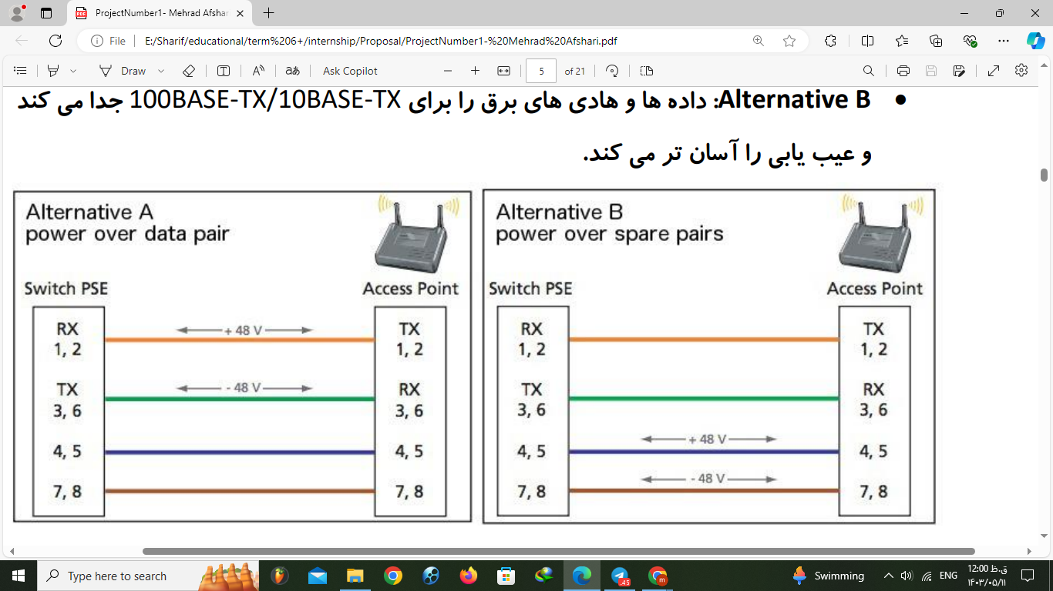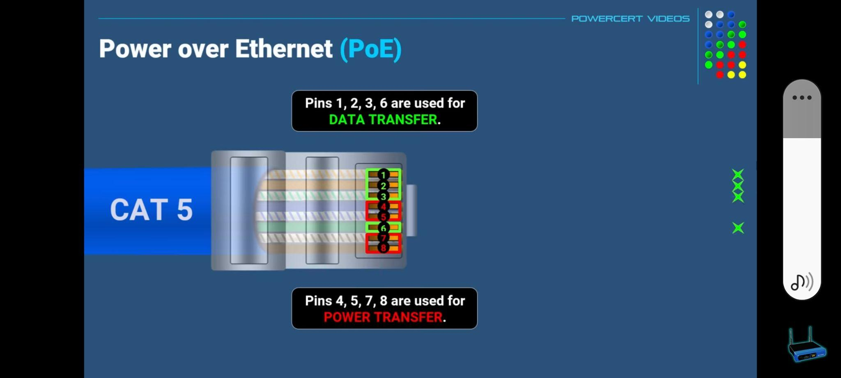

**Figure 1:** Two type of POE standard **Figure2:** Standard of wires for data and power

4PPoE uses all four twisted pairs in parallel and it is the most optimal mode.

**CAT5 cable**

Cables are divided into several categories in terms of attenuation: Category 3, Category 4 and Category 5.

Category 5 cables (abbreviated as CAT5) have less attenuation compared to Category 3 cables, which only have a speed of 16 megabits/seconds. It can be used in high-speed Ethernets.

An upgraded version of this type of cable called CAT 5e is available in the market. They have 4 pairs of wires. However, most of the time only two pairs of them are used to reduce the noise.

Also we can see the difference between UTP and STP cables that is about having or not having a protective shield.

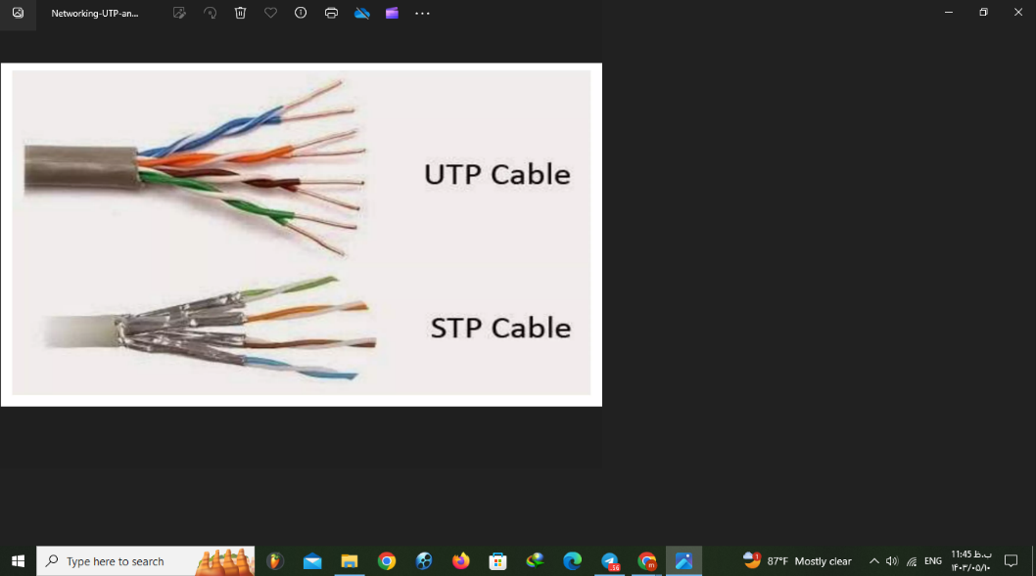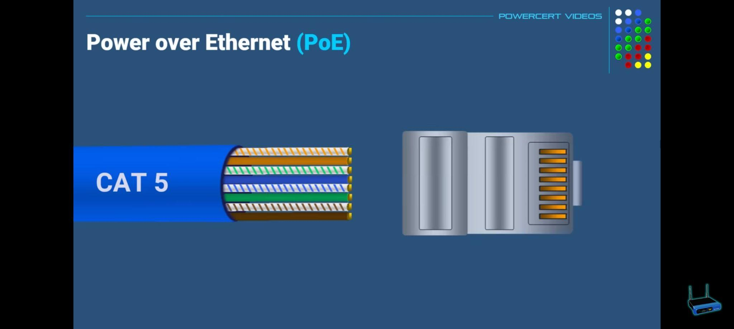

**Figure 3:** CAT5 wires with color range **Figure 4:** UTP & STP cables

**RJ45**

The most used Port that has 8 wires. Wires are twisted paired and they are arranged in color order. It is mostly used to connect computers to devices such as switch,mode, or a router.

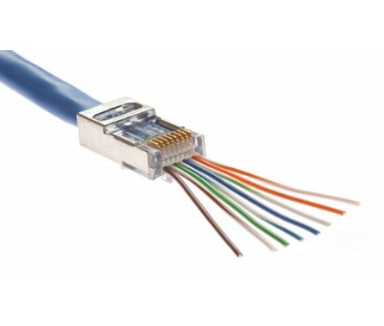

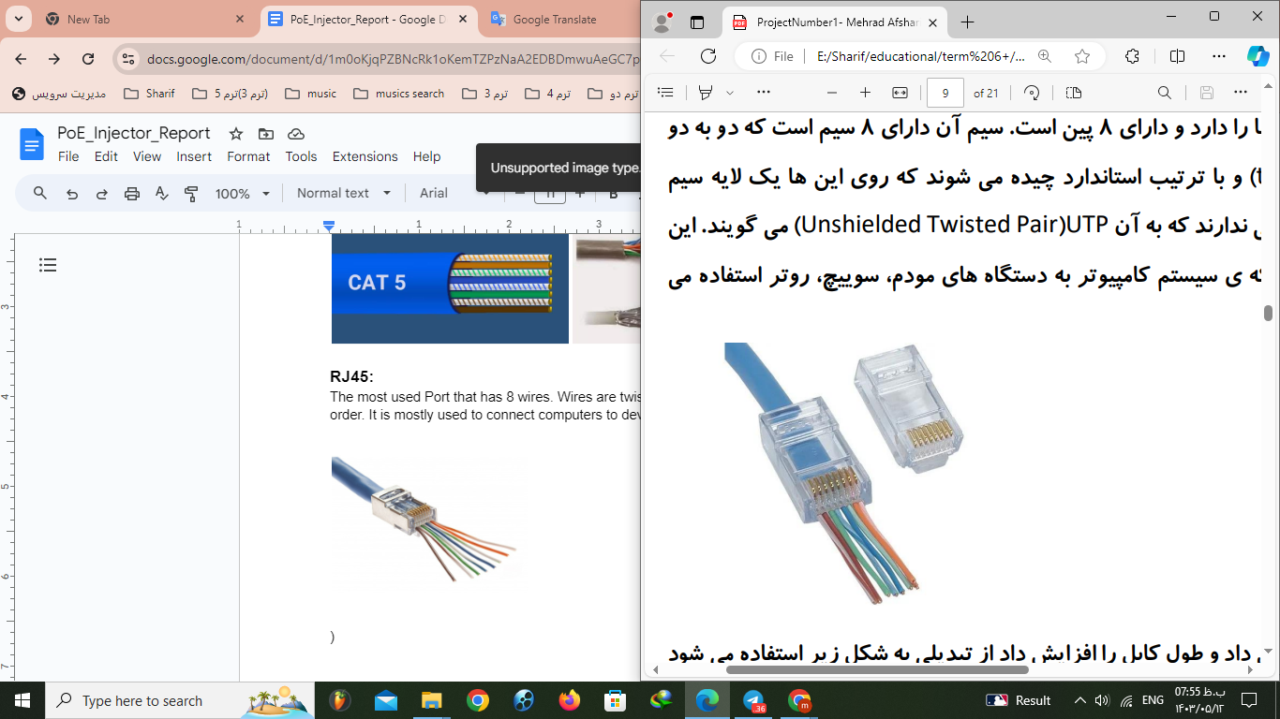

**Figure 5:** RJ45 connector

**1.2 Devices:**

**PD**

The receiver device which uses PoE to work.

**PSE**

To receive data and energy, we must use the PSE device. One of them is a POE switch that receives data and DC power by connecting to the device. Therefore, it is necessary for our switch to be POE so that it can transmit power.

**POE Injector**

If our switch is not POE, we can use POE-injector to unify power and data and send it to the device. In this way, it takes the power from the socket with the plug and receives the data from the POE-Non switch with the Lan port, and by using the POE port, we can receive the data and power output and send it to the device.

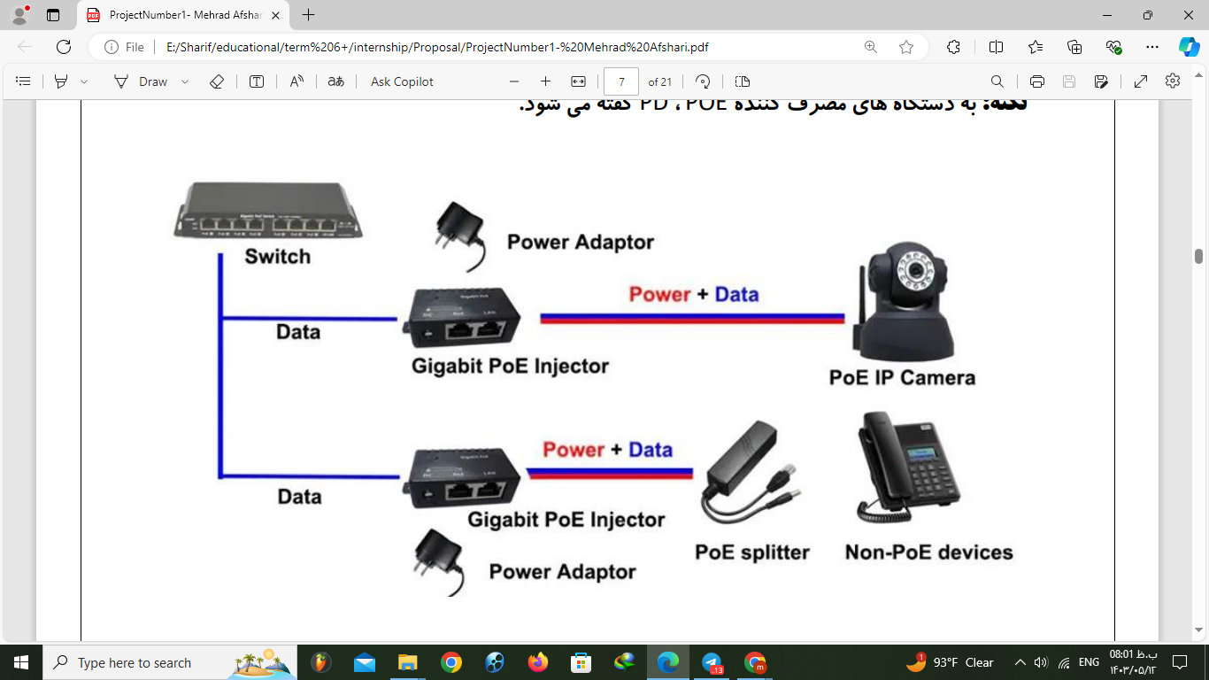

**Figure 6:** Types of POE Injector

**Types of PoEs based on the type of power application:**

**Active:** First, it measures to find the required power for the device, because if it gives too much power, the device will burn.

**Passive:** Transfers full power to the device without measuring the device's needs. So it is necessary when we use this type of POE to pay attention to the voltage of the device because the device may suffer.

**1.3 Control board:**

Our plug-in port will be connected to the main board by port and it named as micro Plugin in this block diagram

It uses I2C protocol to get data from switch board. We have regulators to convert power to range that we use in our board and IC. We have transformer to send POE signal to switch board. Our controller-board will use NPI and UART protocol to send or receive data to LEDs and RJ45 ports.

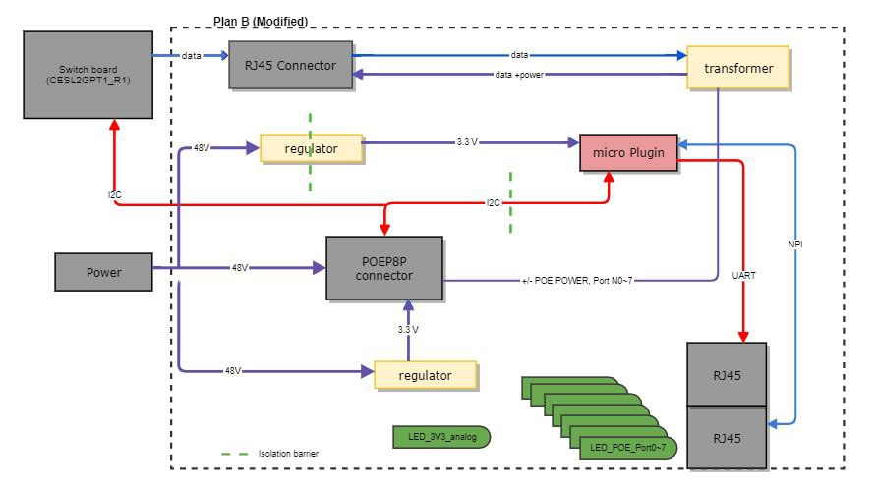

**Figure 7:** Block diagram ofmain board

It takes power from isolation barrier regulator that convert 48V to 3.3V. It takes data with I2C protocol from switch board and use UART and NPI protocol to send data to RJ45 ports.

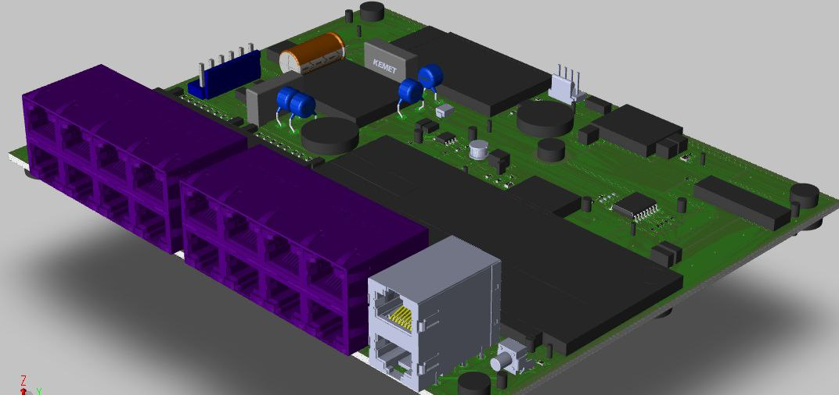

**Figure 8:** Main board 3D image

**1.4 Protocols:**

1. **UART**

**U**niversal **A**synchronous **R**eceiver **T**ransmission is one of the oldest and most reliable serial transmission protocols. In the serial transmission method, only one bit is sent at any time, but in the parallel transmission method, several bits of information are transmitted through several lines. In comparison between these two methods, it can be said that in the parallel transmission method, due to the transmission of several bits of information at a time, its speed is higher.

On the other hand, for long distances, using the parallel transmission method has a high cost due to the increase of communication wires. Therefore, it is not suitable for long distance transmission using the parallel method and the UART protocol.This protocol is being used in COM serial ports, RS-232 and modems.It is used for low speeds and convenient applications.

Many developers use UART for wireless connectivity and computer processing; because it is easy to set up and more favorable for the user.  
 **How does it work?**  
The special feature of UART is that the sending and receiving of data will be available only when the transmitter and receiver are coordinated with the following 5 settings:

**1. Speed:** Since UART is an asynchronous communication protocol, no special clock is used to set the data transfer speed. Instead of clock, baud rate (mostly 9600 bits per second) is used to set the timing of sending data and bits.

The following table lists some of the standard baud rates:

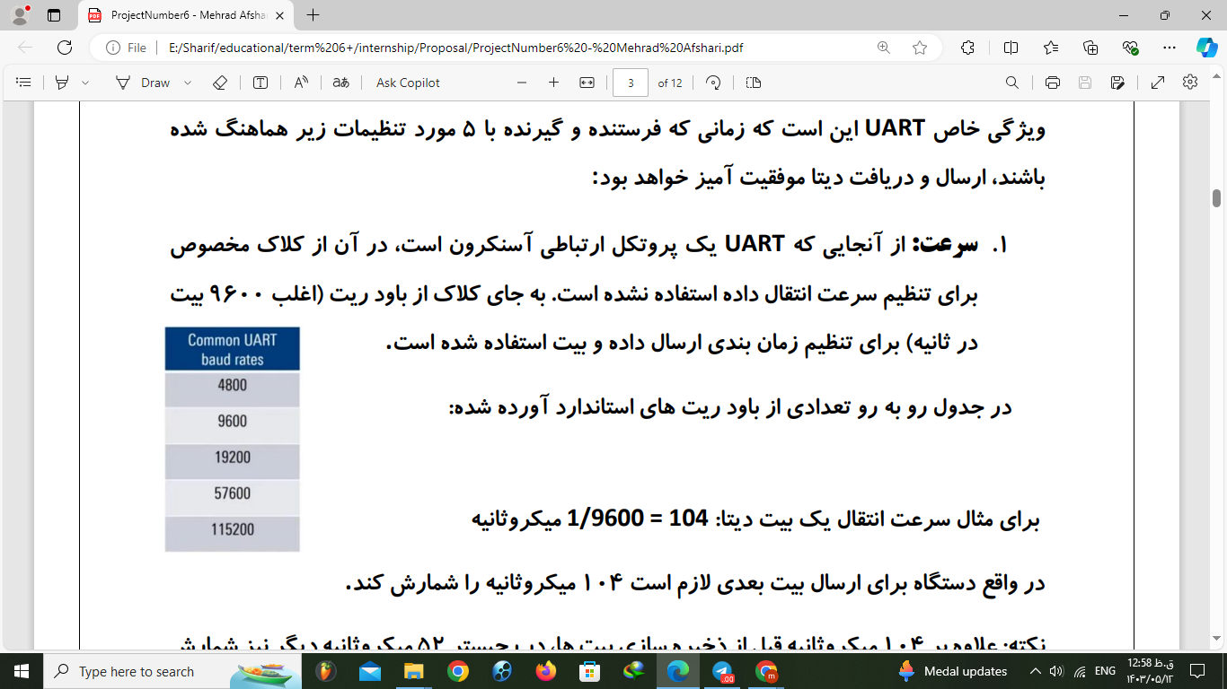

For example, the transfer speed of one data bit: 1/9600 = 104 microseconds

In fact, the device needs to count 104 microseconds to send the next bit.

**Figure 9:**Standard baud rates

**2. Data Length:**The specified number of bits that the receiver stores in its registers

which are arranged from the least significant bit (LSB) to the most significant bit (MSB). It is Usually 8 bits (1 byte)

**3. Start bit:**Using a low signal to show the time to start sending data to the receiver (zeroing should take time as one bit period)

**4. End bit:**Using a high signal to show the time of the last bit that is informed to the receiver.

We consider this bit to be the most important bit. (It should take one bit period to become one)

**5. Parity bit (or balance):**To know the correctness of sent data with help of a zero or one bit (odd and even error)

A total of 11 bits are used for data transmission. When there is no sending or receiving

the transmission line is in the “idle” state, the voltage level corresponding to a logical one is on the transmission line. Changing the status from logical one to zero means the start of transmission (start bit) and the receiver is ready to get information. After that, a data byte is sent.

After sending data, the receiver takes the balance bit which is actually the XOR of the individual data bits. If the number of 1 is odd, this value will be 1 and otherwise it will be zero.  
When the receiver gets the data it calculates the XOR once again and detects an error if it is different from the received balance bit value and the received packet is completely ignored. Finally, after confirming or rejecting the data, the status changes from zero to logical one and means the end of sending (end bit).

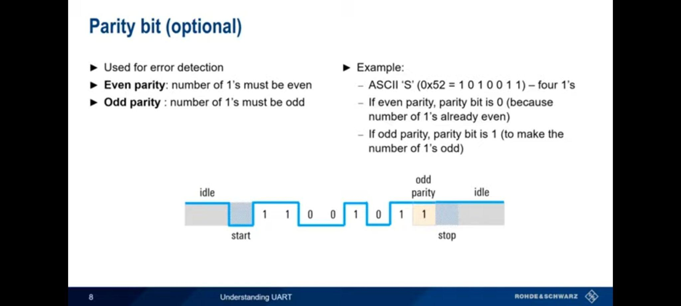

**Figure 10:** Example of UART protocol

**Type of the Errors we can have:**

**1- Overrun and Underrun:**

When the device receives more information than the memory capacity in a certain period of time (for example, 104 microseconds) or does not receive anything.

**2- Framing:**

When the receiver does not receive the end bit after 8 data bits.

3- Parity (It was explained in previous part)

**4- Break condition:**

When the input of the receiver is zero for a long time, this is almost the same as Framing error.

**Communication Process and Hardware:**

Data is sent and received using two pins Tx and Rx pin. Data in parallel from the bus Data is sent to the UART, the sender device creates a data packet by adding the start, balance and end bits of one. Next, send this packet serially and bit by bit through the TX pin and receiver device receives serial data through the RX pin and converts it to parallel mode and removes the start, balance and end bits. At the end, this data is sent to the data bus in the receiver.

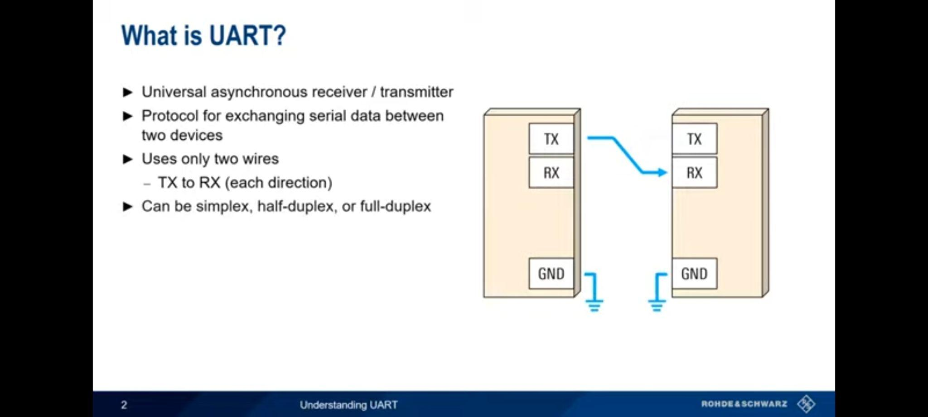

**Figure 11:** Communication Process

**In general, there are three methods for communication between sender and receiver:**

**1- One-way method (Simplex):** In this method, information is transmitted in only one direction.

**2- Half duplex method (Duplex Half):** In this method, information can be transmitted in two directions. But at any moment only one direction is possible.

**3-Two-way method (Duplex Full):** In this method, information is transmitted in both directions at the same time

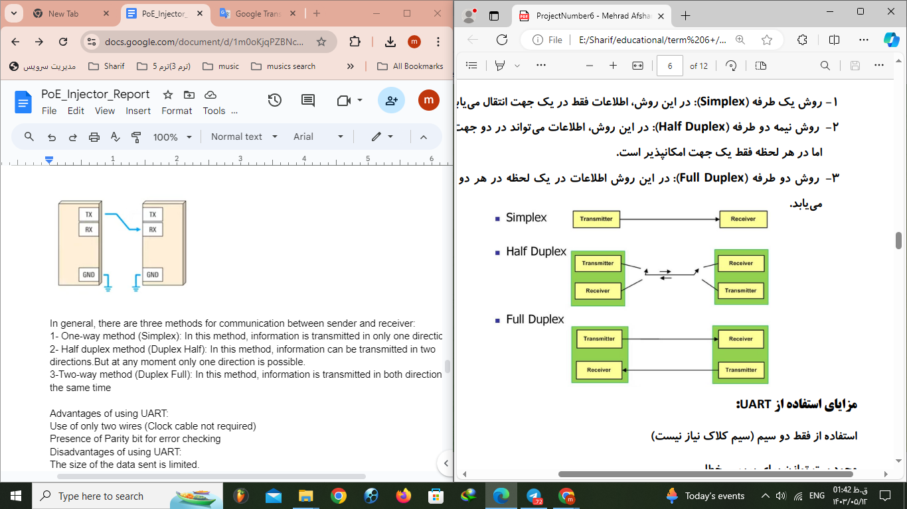

**Figure 11:** Methods for communication

**Advantages of using UART:**

Use of only two wires (Clock cable not required)

Presence of Parity bit for error checking

**Disadvantages of using UART:**

The size of the data sent is limited.

We have only one master (controller) and one slave (controlled).

The transfer rate of both sides should be close or equal (10% range).

1. **I2C**I2C (Inter-Integrated Circuit) is a synchronous, multi-master, multi-slave serial communication protocol developed by Philips Semiconductor (now NXP Semiconductors).  
   It is widely used for connecting peripherals to microcontrollers in embedded systems. I2C is favored for its simplicity and efficiency in short-distance communication within a single device or on a single board.

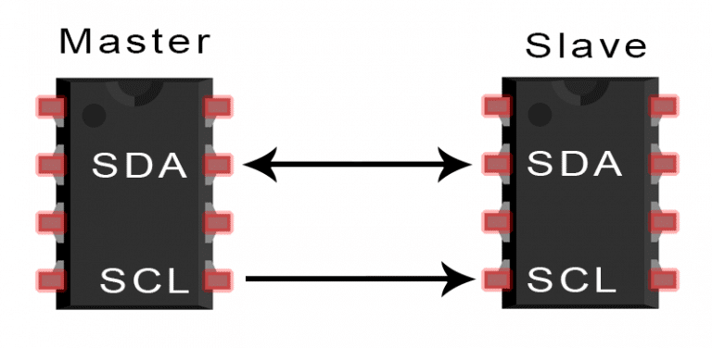

**Figure 11:** I2C Protocol Hardware

### **Key Features of I2C**

1. **Two-Wire Interface:**
   * SDA (Serial Data): Carries data between devices.
   * SCL (Serial Clock): Carries the clock signal, which synchronizes data transfer.
2. **Multi-Master and Multi-Slave:**
   * Multiple master devices can control the bus, and multiple slave devices can share the bus.
   * Only one master can control the bus at any given time to avoid conflicts.
3. **Addressing:**
   * Each device on the I2C bus has a unique address, which can be either 7-bit or 10-bit.
4. **Speed Modes:**
   * Standard Mode: Up to 100 kbps.
   * Fast Mode: Up to 400 kbps.
   * Fast Mode Plus: Up to 1 Mbps.
   * High-Speed Mode: Up to 3.4 Mbps.

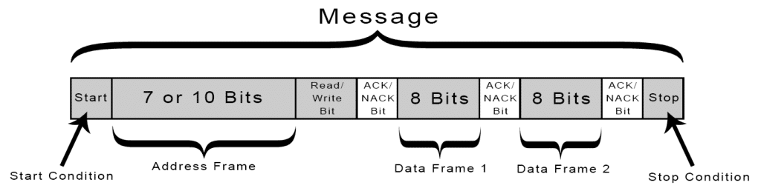

**Figure 12:** I2C Protocol

### **How I2C Works?**

#### **Data Transmission**

1. **Start Condition:**
   * Initiated by the master, this involves a high-to-low transition on the SDA line while SCL is high. It signals all connected devices that a communication session is starting.

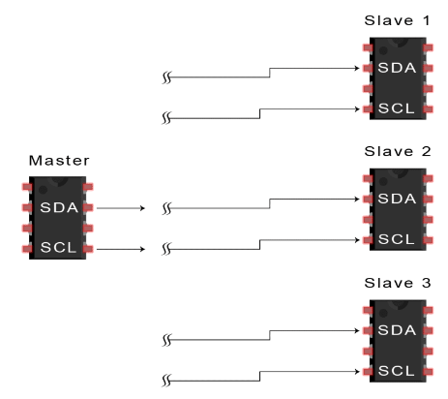

**Figure 13:** Start Condition

1. **Address Frame:**
   * The master sends a 7-bit (or 10-bit) address along with a read/write bit. The read/write bit indicates whether the master wants to read from (1) or write to (0) the slave.

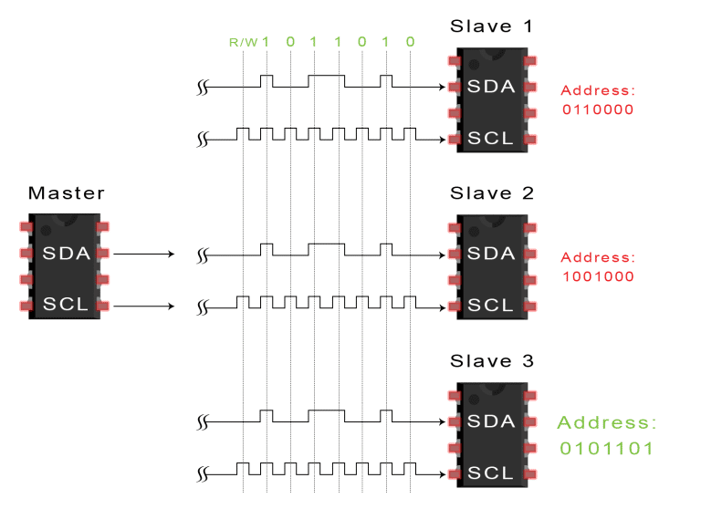

**Figure 14:** Address Frame

1. **Acknowledgment (ACK/NACK):**
   * After receiving the address, the addressed slave device sends an ACK (low signal) if it recognizes the address, or a NACK (high signal) if it does not.

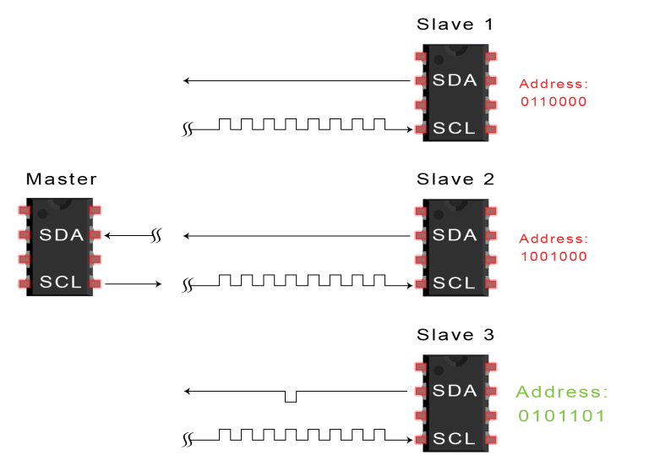

**Figure 15:** ACK/NACK

1. **Data Frames:**
   * Data is transferred in 8-bit bytes. Each byte is followed by an acknowledgment bit.
   * Data transfer can be from master to slave (write operation) or from slave to master (read operation).

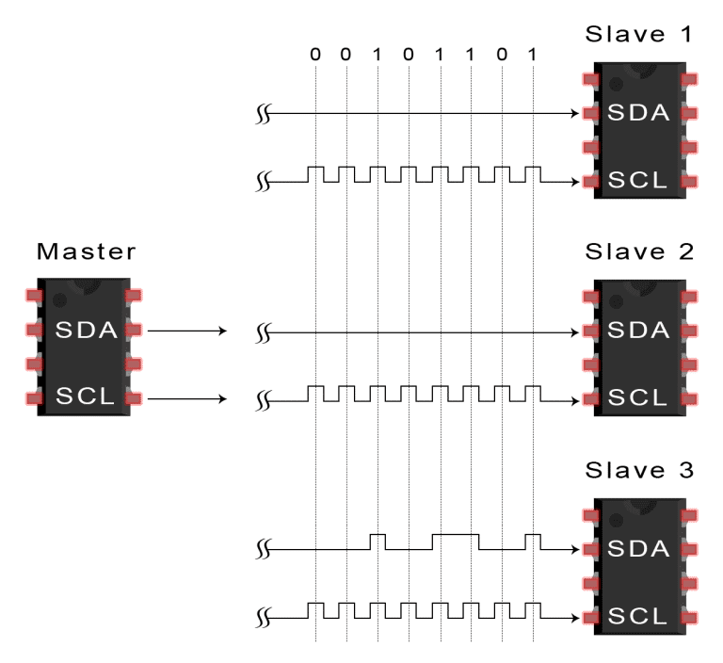

**Figure 16:** Data Frames

1. After each data frame has been transferred, the receiving device returns another ACK bit to the sender to acknowledge successful receipt of the frame

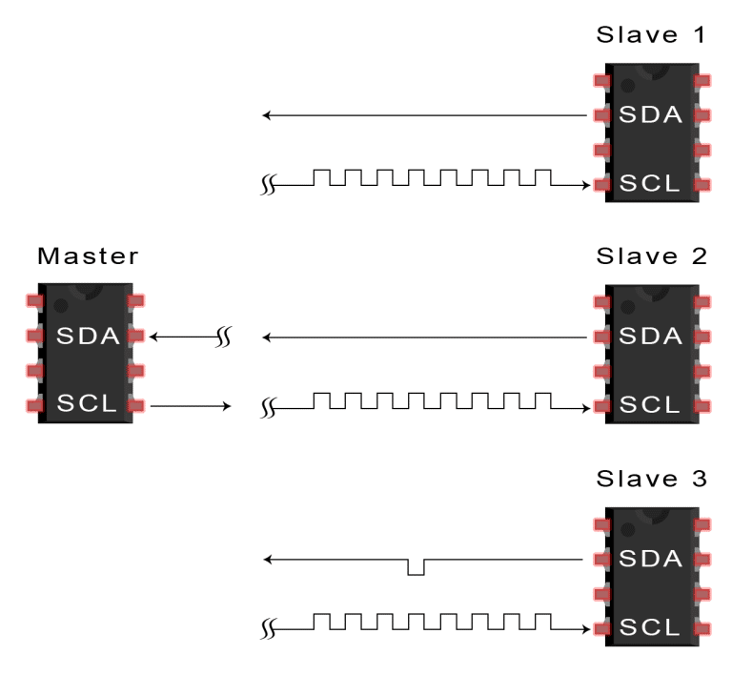

**Figure 16:** Receiption configuration

1. **Stop Condition:**
   * Indicates the end of a data transfer session. It involves a low-to-high transition on the SDA line while SCL is high.

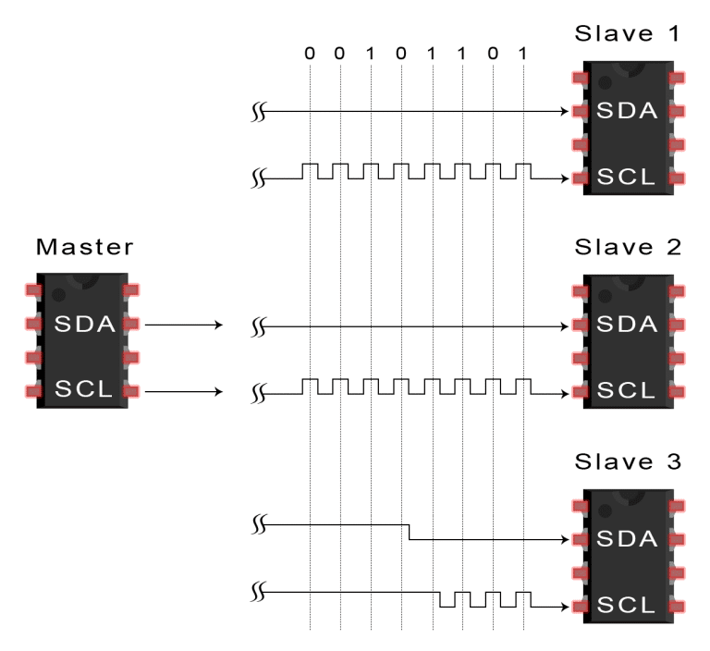

**Figure 16:** Stop Condition

### **Advantages**

* Only uses two wires
* Supports multiple masters and multiple slaves
* ACK/NACK bit gives confirmation that each frame is transferred successfully
* Hardware is less complicated than with UARTs
* Well known and widely used protocol

### **Disadvantages**

* Speed: Slower compared to protocols like SPI.
* Distance: Limited to short-distance communication due to capacitance and signal integrity issues.
* Bus Contention: Potential for conflicts if multiple masters attempt to control the bus simultaneously.
* The size of the data frame is limited to 8 bits

1. **NPI**

A common system configuration is to use the Texas Instruments CC13xx/CC26xx as a network processor (NP) where a host microcontroller (MCU) is able to control the CC13xx/CC26xx platform by sending serial commands. This requires certain power domains of the NP to be on in order to receive and handle these commands. It also requires translating serial packets into commands for the NP as well as translating responses into serial packets to be sent to the Host. The handling of these messages along with managing the power domains in an efficient manner is the responsibility of the network process interface (NPI) framework of the CC13xx/CC26xx platform. The NPI framework enables the CC13xx/CC26xx to go into low power modes when not being used and to be asynchronously woken up to respond to commands

from the host MCU.

**1.1 Introduction**

The NPI framework is shared among the following (insert marketing name) products:

* Bluetooth Smart
* Z-Stack ZigBee Network Processor (ZNP)
* TI-15.4-Stack MAC Co-Processor (MAC-CoP)

Between these different products, there are some differences in how data framed for serial communication, as well as how messages are handled within the NP. Despite these minor differences, shown in red, all products share the same basic NPI framework shown below:

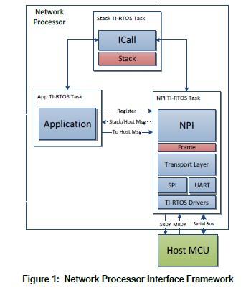

**Figure 17:** NPI Network

NPI’s functionality can be broken down into three main components: managing the serial interface between the NP and Host, managing command and responses to and from the stack, and optionally routing stack or host messages to a registered application task.

**1.2 Serial Interface**

In order to properly manage the power domains of CC13xx/CC26xx platforms, NPI must include a way for an external host to wake the network processor from low power modes. This is done through inclusion of “master ready”, MRDY, and “slave ready”, SRDY, signals. These two signals along with the respective SPI or UART serial bus signals comprise the serial interface of NPI.   
MRDY is an input pin on the network processor and when set by the Host will wake the device enabling it to receive data over the serial bus.

SRDY is an output pin on the network processor, and, when set by the NP, signals to the host that it may begin data transfer. This sequence of setting MRDY and SRDY pins comprises a “handshake” process to guarantee both devices are awake and ready to send and/or receive data.

**1.3 Command and Response Message Routing**

The common use case of the NPI framework is a basic network processor. This means that the framework is strictly acting as a sending and receiving mechanism between the host MCU and the stack task. However, there also exist use cases that include some amount of “custom” application-dependent processing.

For these cases not all messages from the host should be delivered to the stack and not all messages from the stack should be transferred directly to the host. To enable these types of applications, a mechanism to easily change the paths of inbound and outbound messages is built into NPI.  
In Figure 1, the possible message rerouting with the application task can be seen. An application can easily interject messages to the host within the command and response traffic of the stack using the NPI APIs. An application can also register with NPI to either “Intercept” or “Echo” all messages originating from the host and/or all messages originating from the stack. This allows the application to modify messages as needed or to even process certain application specific messages without sending them to either the host or stack.

**2 Interfacing with a Host Processor**

**2.1 Physical Interface**

The NPI framework currently supports two serial interfaces, SPI and UART. The CC13xx/CC26xx has two

SPI modules and only one UART module. When configured to use SPI, NPI will by default use the second SPI module (SSI1) (Note: This is due to the SmartRF06 board using SSI0 for driving LCD). For each serial interface, power management can be enabled and regardless of interface type MRDY and SRDY pins remain consistent. There are three possible configurations:

* UART with Power Management
* UART without Power Management
* SPI with Power Management

**2.1.1 UART**

NPI supports two different configurations of UART. One configuration requires only two pins, UART TX and UART RX. This is an always-on configuration that does not permit the CC13xx/CC26xx to enter into low power modes. The second configuration does allow low power modes because of the inclusion of the MRDY and SRDY pins for power management. Some UART interfaces include hardware flow control

pins, CTS and RTS, however we do not currently support hardware flow control. Instead the MRDY and SRDY pins can be used for both power management and software flow control.

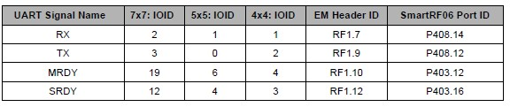

**Table1:** UART in NPI Protocol

**2.1.2 SPI**

There is only one SPI configuration which requires the use of MRDY and SRDY. The NPI framework requires the ability to asynchronously send data from NP to Host. Because of this requirement it is not possible to have a configuration with the traditional SPI signals alone (SCLK, MOSI, MISO, CS). The SRDY signal is used to signal the SPI master that a slave to master transmission is pending so the master should toggle the SPI SCLK signal to begin the transfer. Without this signal, an asynchronous NP to Host transfer is not possible. The MRDY signal performs the chip select, CS, function among other functions so the chip select signal is not needed with the SPI configuration.

**NOTE:** The signals highlighted in the table below suggest an alternative pin assignment for SPI using SSI1 to avoid a conflict with the LCD control signals on the SmartRF06.

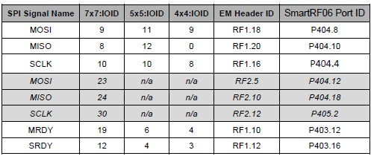

**Table1:** SPI in NPI Protocol

**2.1.3 Configuration Management**

With any network processor project that uses the NPI framework, switching between configurations can be easily managed. There are only two preprocessor defines that are needed.

* **POWER_SAVING** – If defined, MRDY/SRDY as well as low power modes are used. If

not defined, the device will be always on and NPI must use UART.

* **NPI_USE_SPI/NPI_USE_UART** – Only one of these can be defined at a time. Each

define corresponds to the underlying serial interface that will be used by NPI

* **NPI_SREQRSP** – If defined, support for synchronous REQ/RSP messaging is included.

This is currently only relevant for MT-based NPI functionality.

**2.2 NPI Messages**

NPI messages describe an ordering of events on the interface pin, not the content of the data that is sent or received. NPI frames define data content that is sent or received. In this section, the focus will first be to describe messaging and the behavior of the physical interface and then to describe how data content, or frames, are then sent over these messages.

When using power management pins, MRDY and SRDY, there are only two events whose order determines the message: assertion of MRDY and the assertion of SRDY (Note: MRDY and SRDY are active low, thus “assertion” refers to a logic value of 0). Before any data can be sent, a “handshake” must occur and this handshake can be initiated by either Host or NP. There for two messages exist: Asynchronous Request – transfer initiated by Host, and Asynchronous Indication – transfer initiated by NP. When not using power management pins, the two events that define an Asynchronous Request or Asynchronous Indication is the beginning of a data transfer on the UART Master TX pin or the UART Slave TX pin respectively.

**2.2.1 Asynchronous Request (AREQ)**

An asynchronous request is a message that is sent from Host to NP. The host must initiate the

handshake by asserting MRDY, once SRDY has been asserted, then data can be transferred Host to NP.

MRDY is de-asserted by the Host once all data has been transferred and then NP de-asserts SRDY

notifying the Host that it may be in a low power mode. The order of events is shown below:

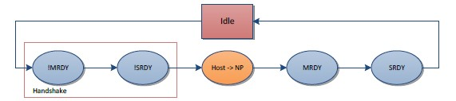

**Figure 18:** Block diagram of AREQ

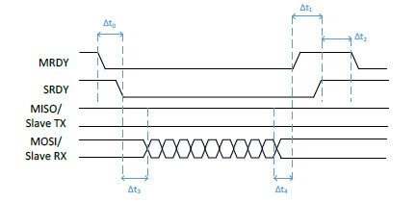

**Figure 19:** Signals of AREQ

**2.2.2 Asynchronous Indication (AIND)**

An asynchronous indication is a message that is sent from NP to Host. The only difference between this

message and AREQ is that SRDY is asserted first and the direction of the data transfer is inverted. The

order of events can be seen below:

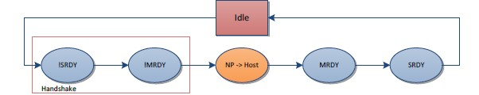

**Figure 20:** Block diagram of AIND

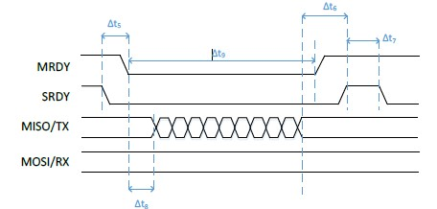

**Figure 21:** Signals of AIND

**2.2.3 Bidirectional Messaging**

With any protocol that allows asynchronous messaging, where a signal transition denotes the start of a message as with MRDY and SRDY, there are inherent collisions between messages. Instead of requiring intricate collision handling, the NPI framework allows for bidirectional messaging to occur. This means that data can be sent from the Host to NP and from NP to the Host in the same message window regardless of the handshake order.

While reducing collision handling, bidirectional messaging adds some complexity to what operations must be performed or initiated by each device. For every AIND the NP initiates, it must prepare to read as well as write when MRDY is asserted. For every AREQ, the Host must prepare to read as well as write once SRDY is asserted. Each device will also need to handle any FIFOs that could potentially be overrun during a message and check at the end of every message to see what, if anything, has been received.

The scenario where bidirectional messaging will occur is when a device’s input pin (SRDY wrt Host) has been asserted, and prior to asserting its output pin (MRDY wrt Host) the device gets a pending message to write. Below is the modified ordering of events where there exists now a partial order on the MRDY and SRDY assertions.

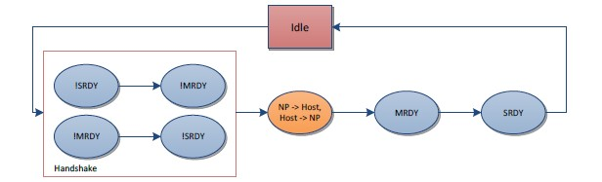

**Figure 22:** Block diagram of bidirectional massaging

### **Steps to Implement NPI**

#### **1. Hardware Setup**

1. **Select Appropriate Hardware**:
   * Choose the appropriate Texas Instruments CC13xx or CC26xx evaluation module (EM) based on your application requirements.
   * Ensure you have a compatible host MCU for communication with the CC13xx/CC26xx platform.
2. **Connect the Host MCU to CC13xx/CC26xx**:
   * Connect the host MCU to the CC13xx/CC26xx module using a serial communication interface such as UART, SPI, or I2C.
   * Make sure the power supply, ground, and other necessary signals (such as reset and interrupt lines) are correctly connected.

#### **2. Software Configuration**

1. **Install Development Tools**:
   * Download and install the TI Code Composer Studio (CCS) or any other preferred integrated development environment (IDE).
   * Install the SimpleLink CC13xx/CC26xx software development kit (SDK) from Texas Instruments.
2. **Configure the SDK for NPI**:
   * Open the project in the SDK related to the CC13xx/CC26xx platform.
   * Include the NPI libraries and dependencies in your project. The NPI libraries are typically provided within the SDK.
3. **Initialize NPI in the Application**:
   * In your application code, initialize the NPI framework. This involves setting up the serial interface, power management, and command processing.
   * Example initialization code snippet:

// Include necessary headers

#include "npi.h"

#include "npi_tl_uart.h"

#include "npi_task.h"

void npi_init(void) {

// Initialize NPI Transport Layer (UART in this case)

NPI_InitTransportLayer();

// Initialize NPI Task

NPI_Task_createTask();

}

**3. Develop Communication Protocols**

1. **Define Serial Commands and Responses**:
   * Define the set of serial commands that the host MCU will send to the network processor. This includes specifying command IDs, parameters, and response formats.
   * Implement the command handling functions on the CC13xx/CC26xx side to process these commands.
2. **Command Processing Example**:  
   void processCommand(uint8_t commandId, uint8_t *params) {

switch (commandId) {

case CMD_ID_1:

// Handle command 1

break;

case CMD_ID_2:

// Handle command 2

break;

default:

// Handle unknown command

break;

}

}

1. **Translate Serial Packets**:
   * Implement functions to translate received serial packets into internal commands for the network processor.
   * Implement functions to translate responses from the network processor into serial packets to be sent back to the host MCUZ

#### **4. Power Management**

1. **Manage Power Domains**:
   * Use the NPI framework functions to manage power domains. Ensure that necessary power domains are enabled when receiving and processing commands.
   * Implement mechanisms to enter low-power modes when the network processor is idle and wake up asynchronously when commands are received.
2. **Power Management Example**:  
   void managePower() {

// Enter low-power mode

Power_enterLowPowerMode();

// Wake-up on receiving a command

if (commandReceived) {

Power_exitLowPowerMode();

processCommand(receivedCommandId, receivedParams);

}

}

#### **5. Testing and Debugging**

1. **Debugging Tools**:
   * Use debugging tools provided by the IDE to step through the code, set breakpoints, and inspect variables.
   * Utilize serial communication analyzers to monitor the data exchange between the host MCU and the network processor.
2. **Testing**:
   * Test the entire setup by sending commands from the host MCU and verifying the responses from the network processor.
   * Ensure the power management functions are working correctly by measuring the current consumption in different power modes.

**1.5 OSI Model**

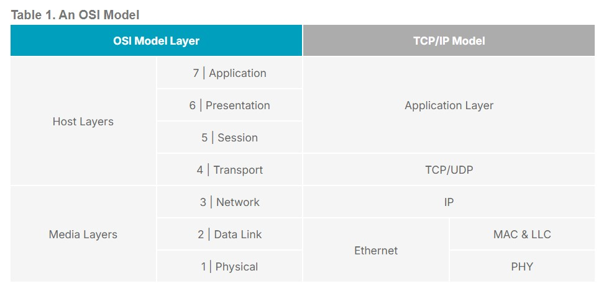

**Figure 23:** OSI Model layers

The OSI (Open Systems Interconnection) model is a conceptual framework used to understand and implement networking protocols in seven layers. Each layer serves specific functions and interacts with the layers directly above and below it. Here’s a brief overview of the OSI model:

1. Physical Layer (Layer 1)
2. Data Link Layer (Layer 2)
3. Network Layer (Layer 3)
4. Transport Layer (Layer 4)
5. Session Layer (Layer 5)
6. Presentation Layer (Layer 6)
7. Application Layer (Layer 7)

### **Layer 1: Physical Layer**

The Physical Layer is the lowest layer of the OSI model. It deals with the physical connection between devices and the transmission and reception of raw bit streams over a physical medium. Here are the key functions and characteristics:

* Transmission Media: Includes cables (e.g., twisted pair, coaxial, fiber optic) and wireless methods (e.g., radio, infrared).
* Signal Encoding: Converts digital data into electrical, optical, or radio signals.
* Bit Rate Control: Manages the rate at which data is transmitted (e.g., bits per second).
* Physical Topology: Defines the physical layout of the network devices and cabling.
* Hardware Specifications: Includes components like connectors, transceivers, and network interface cards (NICs).

The Physical Layer is responsible for ensuring that when one device sends a bit, it is received correctly by another device.

### **Layer 2: Data Link Layer**

The Data Link Layer is the second layer in the OSI model and is responsible for node-to-node data transfer and error detection and correction. It is divided into two sublayers: Logical Link Control (LLC) and Media Access Control (MAC).

#### **Sublayers of Data Link Layer:**

1. **Logical Link Control (LLC) Sublayer:**
   * Flow Control: Manages data flow to prevent the sender from overwhelming the receiver.
   * Error Detection and Correction: Uses mechanisms to detect and correct errors that may occur in the Physical Layer.
   * Interface with Network Layer: Provides a way for the Network Layer to access the services of the Data Link Layer.
2. **Media Access Control (MAC) Sublayer:**
   * MAC Addressing: Provides a unique identifier for each device on a network (e.g., Ethernet MAC addresses).
   * Access Control: Determines how devices share the medium (e.g., CSMA/CD for Ethernet).
   * Frame Delimiting: Defines the start and end of frames, and formats frames to include MAC addresses and error-checking information.

#### **Key Functions of the Data Link Layer:**

* **Framing:** Encapsulates packets from the Network Layer into frames.
* **Addressing:** Adds physical addresses (MAC addresses) to frames for proper delivery on the same network.
* **Error Detection and Correction:** Uses techniques like checksums and CRC to detect and correct errors in transmitted frames.
* **Flow Control:** Ensures that data frames are sent at a rate that matches the receiver's capacity.

The Data Link Layer provides reliable data transfer by detecting and possibly correcting errors that may occur in the Physical Layer, and by managing access to the physical medium.

### **Layer 3: Network Layer**

The Network Layer is responsible for data routing, packet forwarding, and logical addressing (IP addresses). It determines the best path to send data from source to destination across multiple networks.

* **Key Functions:**
  + Logical Addressing: Assigns IP addresses to devices.
  + Routing: Determines the best path for data to travel across a network.
  + Packet Forwarding: Moves packets from one network to another.
  + Fragmentation: Breaks down large packets into smaller ones for transmission.

### **Layer 4: Transport Layer**

The Transport Layer ensures reliable data transfer between devices. It provides error detection and correction, data flow control, and data segmentation and reassembly.

* **Key Functions:**
  + Segmentation and Reassembly: Splits data into segments and reassembles them at the destination.
  + Flow Control: Manages the rate of data transmission.
  + Error Detection and Correction: Ensures data is delivered without errors.
  + Connection Management: Establishes, maintains, and terminates connections (e.g., TCP, UDP).

### **Layer 5: Session Layer**

The Session Layer manages sessions or connections between applications. It establishes, maintains, and terminates communication sessions.

* **Key Functions:**
  + Session Management: Establishes and terminates sessions between devices.
  + Synchronization: Adds checkpoints during data transfer for recovery.
  + Dialog Control: Manages two-way communication sessions (full-duplex or half-duplex).

### **Layer 6: Presentation Layer**

The Presentation Layer translates data between the application layer and the network format. It is responsible for data encryption, compression, and translation.

* **Key Functions:**
  + Data Translation: Converts data between different formats (e.g., ASCII to EBCDIC).
  + Data Encryption: Encrypts and decrypts data for security.
  + Data Compression: Compresses data to reduce bandwidth usage.

### **Layer 7: Application Layer**

The Application Layer is the topmost layer and provides network services directly to end-user applications. It facilitates interaction between software applications and the network.

* **Key Functions:**
  + Network Services: Provides services like email (SMTP), file transfer (FTP), and web browsing (HTTP).
  + Application Interfaces: Interfaces with software applications to implement network services.
  + Resource Sharing: Allows applications to access network resources.

**Phase 2: Schematic Design   
Description:**

This board is designed to enhance the performance of the PoE main board by utilizing a microcontroller. Additionally, it provides a way to monitor the status of each PoE injector port on the main board.

The board consists of four sections:

1. **MCU (Microcontroller Unit)**
2. **Ethernet Path**
3. **Communication Path**
4. **Port**

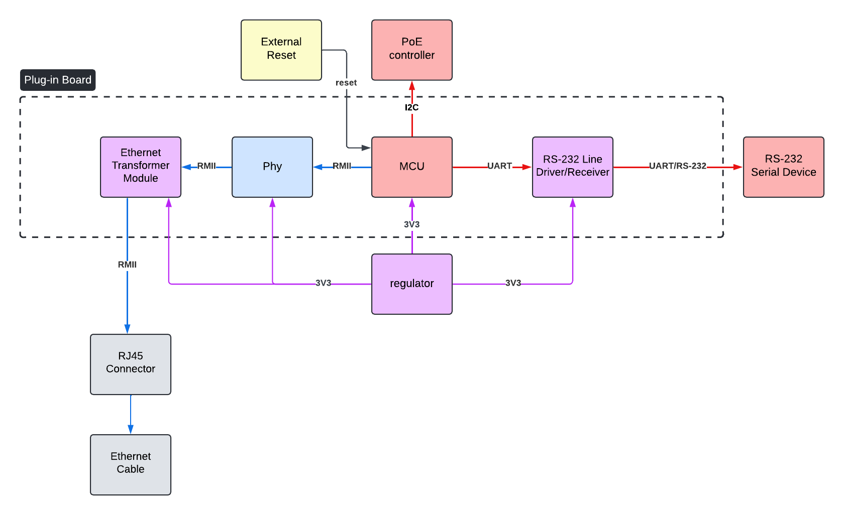

**Sections:**

**1. MCU**

This section is responsible for managing the plug-in board. For this purpose, a microcontroller has been used. The microcontroller needed to support I2C to communicate with the PoE’s main board controller and the UART protocol for communicating with the PC for programming and monitoring. Additionally, it should support an Ethernet interface for network connectivity and allow for an external reset in special cases.

Based on these requirements, we chose the STM32F765 microcontroller.

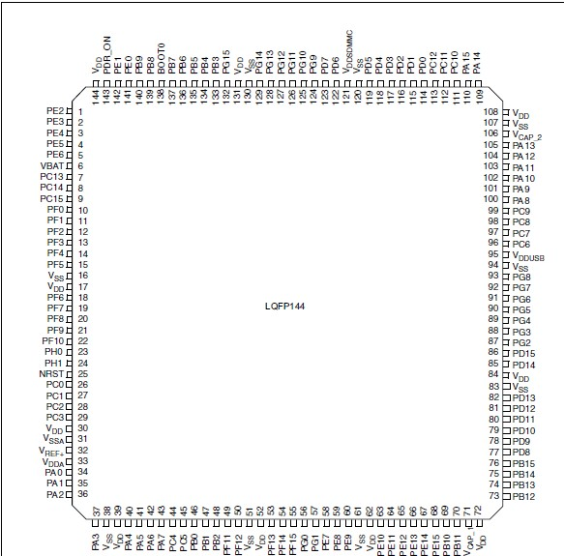

**2. Ethernet Path**

This section details the components required for establishing a network connection. Given that the MCU includes a MAC controller, a PHY component is necessary to manage the physical layer of data transmission.

The PHY component, specifically the 88E1512-A0-NNP2C000, converts digital data to signals for transmission over physical media and vice versa, ensuring synchronization, error detection, and optimal network performance.

Additionally, since the Ethernet section extends outside of the board, electrical protection and isolation are crucial. To address this, the LP82453NL Ethernet transformer module has been selected to provide the necessary protection and isolation.

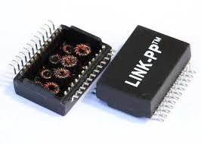

**3. Communication Path**

This section ensures a reliable and secure connection between the MCU and external devices using the UART protocol. Since the MCU will communicate with devices that adhere to the RS-232 standard, a voltage level converter is required to bridge the gap between different logic levels. To fulfill this need, we have selected the MAX3212E driver, which effectively converts the voltage levels to enable seamless communication between the MCU and RS-232 compatible devices.

**Block diagram of MAX3212E:**

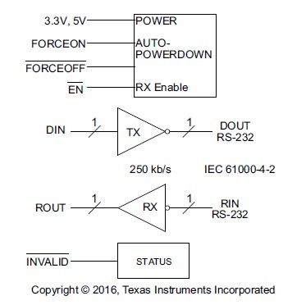

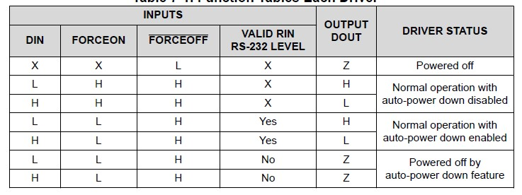

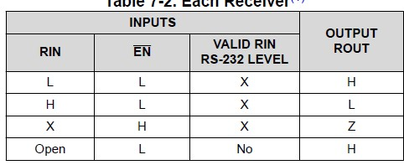

**4. Port**

To facilitate the connection of our plug-in board to the main board, we have used a male header on the plug-in board and a female header on the main board. We opted for a single male connector with 2x10 pins, which meets our requirements. This configuration includes two pins dedicated to GND, three ports for GND_EARTH, and two pins for a 3.3V power supply. This arrangement ensures adequate power conductivity and reliable connection between the main board and the plug-in board.

**Design:**

1. **Learning Cadence:**

Generally we learned about making part in cadence but mentor gave us a LIB file that has a parts we need and they were used in company and were made in the past. So we just need to put them in the pages and connect them. At the first we create our pages with a default size and then we understand that some IC s are very big and also they have part types. So if we had added all of them to one page it would have been complicated. So we planned to have 5 pages look like our sections in previous part. Then we put related parts in each page. (More details in First Design part)

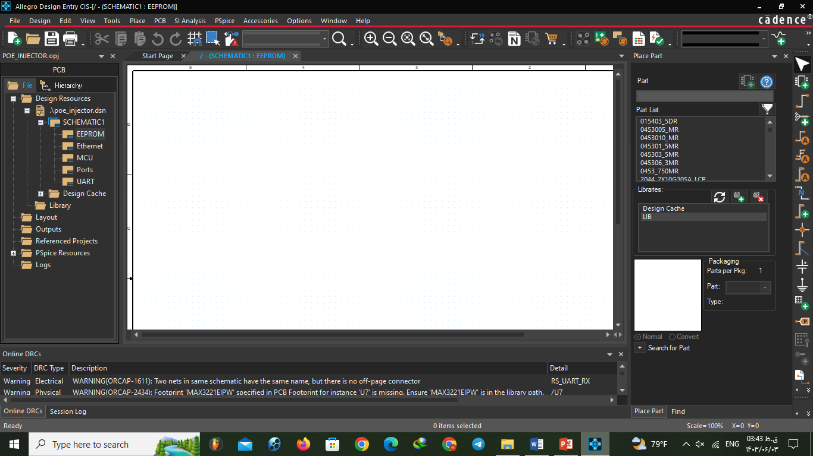There are some important features in cadence that is very useful we will tell just some of them:

1. **Place Net Alias:**

This feature is for naming parts. It has some rules that will be mentioned in standards part.

1. **Off-Page connector:**

When you are going to have more than one page for one board you need to make connection between them. Defining a net just with name will not make connection in cadence you need to use Off-Page connector to connect pins from two different pages.

But for power and ground you don’t need to define off-page connector because they are global nets. There is three type of off-page connector and it depends on pins typo: bidirectional – input – output   
(**Note:** Using one off-page connector in one page is enough. If you want to use it more than once you don’t need to add extra off-page just add it with net name)

1. **Place Bus:**

This is for defining bus in schematic. At the first we used it for our 4-bit data but then we understand that we need just two bit so we removed. (More details in First Design part)

1. **Schematic design:**

After putting parts in pages, we need to connect the pins. So we asked mentor to give us standard datasheets. We read datasheets to know which pins we need to use from our parts and type of them   
(I ,O ,I/O). And also we need to know which pins coupling capacitors or any resistor between GND or VCC.

We got pictures of our part’s connections from previous products as a help.

After that we connected our pins and go through checking it more. (More details in Milestones part)

1. **Standards:**

Mentor sent us some naming rules that related to companies rules to make it standard. Because it should be understandable for team and also another person out of the project team who maybe wants to make changes in design in the future.

Some important points of naming:

1. Try as much as you can to not use specific letter (/ or + or …) space in your names and also in directories. (Use underline instead of space)
2. Put numbers for your pages and parts.
3. Try not to use global nets with same voltage and different names.
4. Put numbers on elements like capacitors or resistors in the way that is more understandable. (We numbered them in this template: (Page number + number or letter like R313: resistor 13 of page 3)
5. You should name your design file in standard way with date of edit. (Like: POEICPT1_R1_2024_8_13_3)

We have another rules that mentioned in this images:

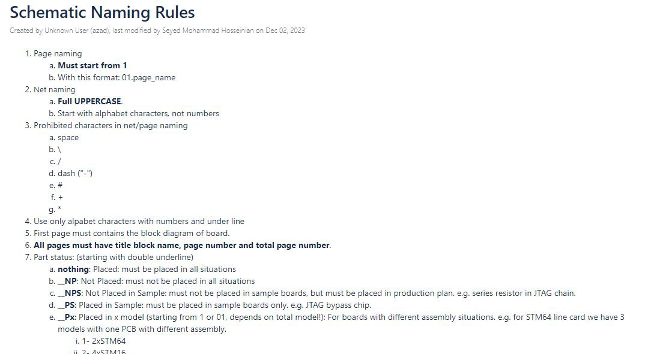

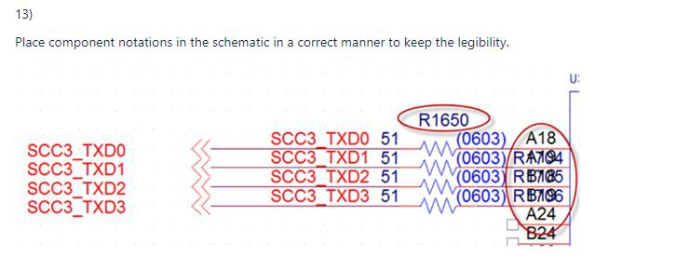

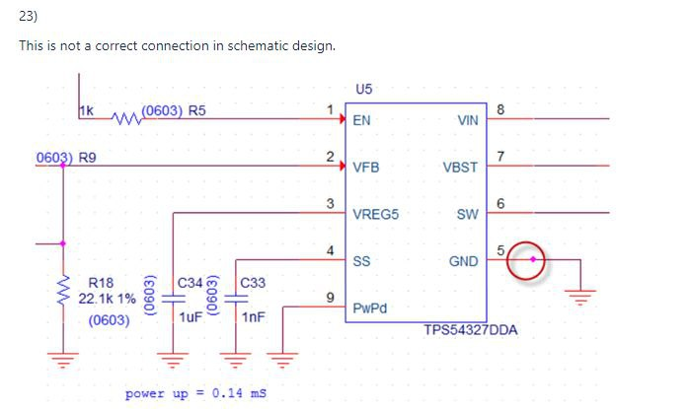

**First Design:**

**Our first design is for 23 of mordad:**

**1: EEPROM**

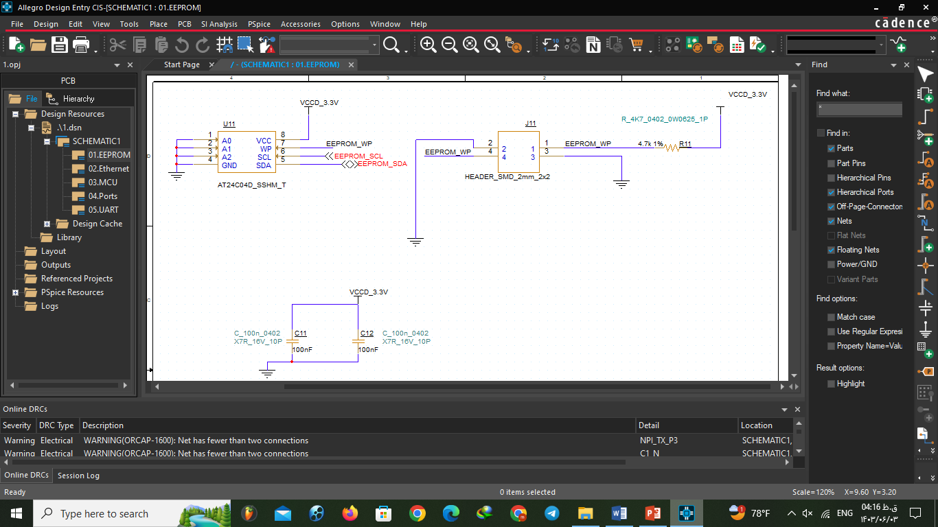

**2: Ethernet**

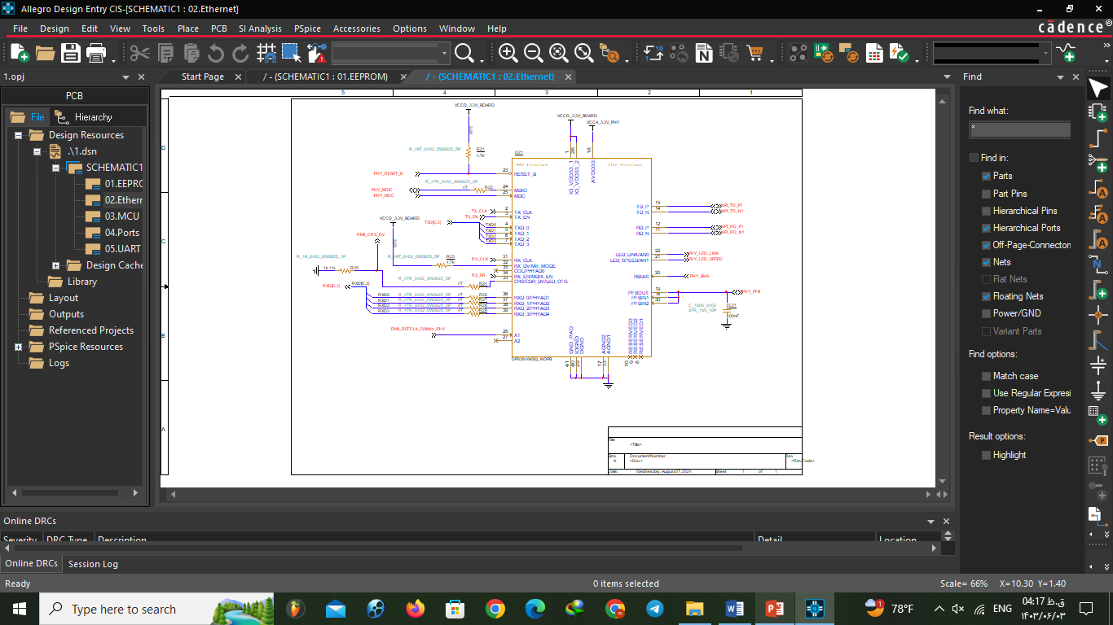

**3: MCU**

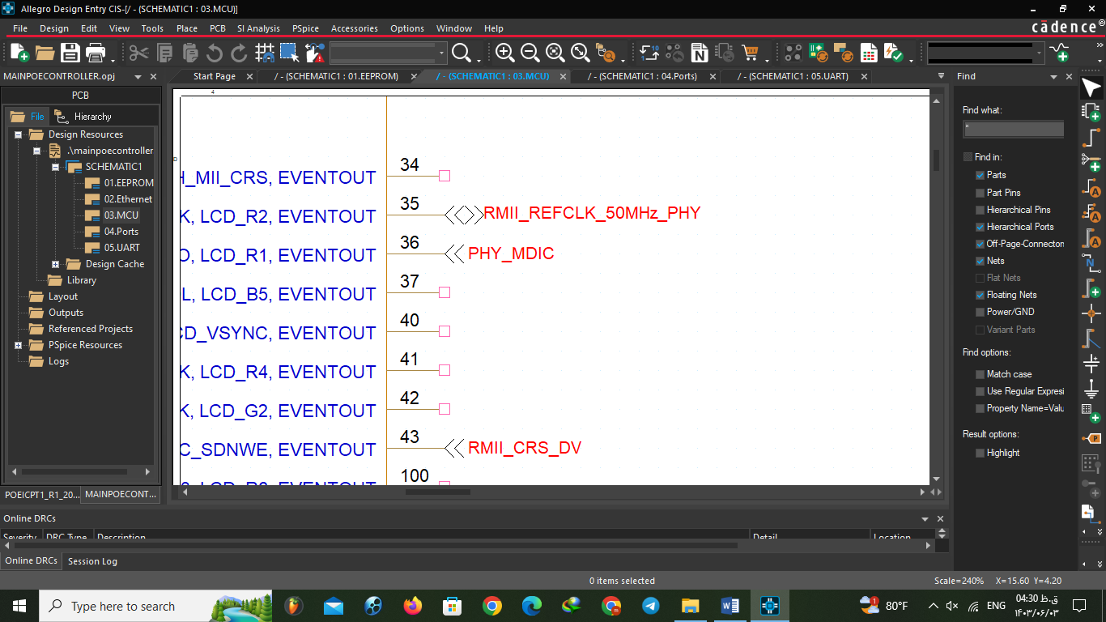

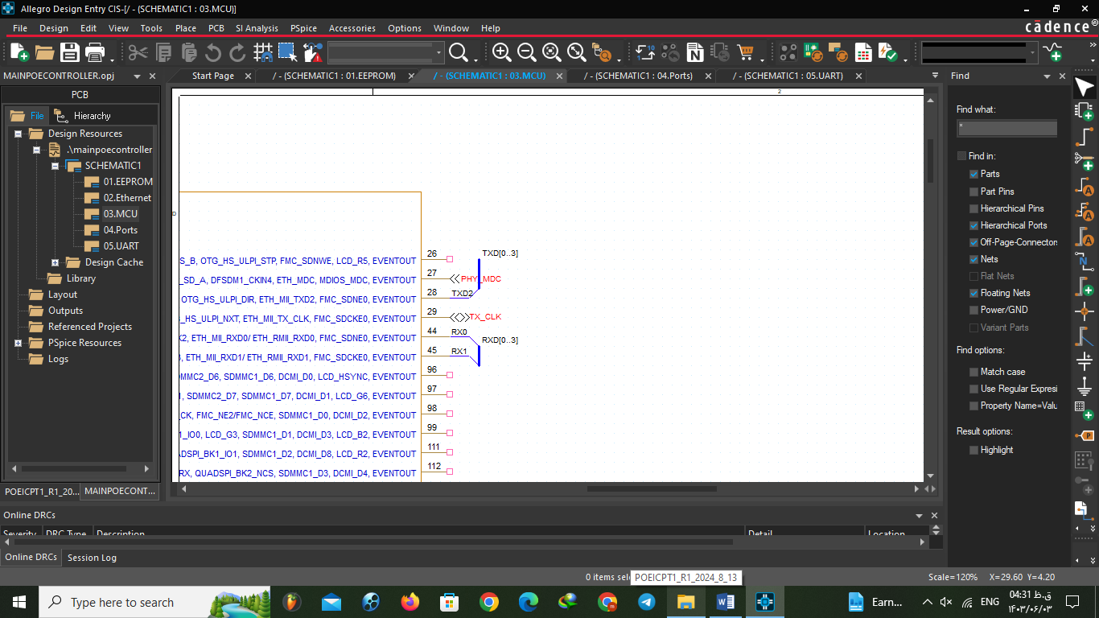

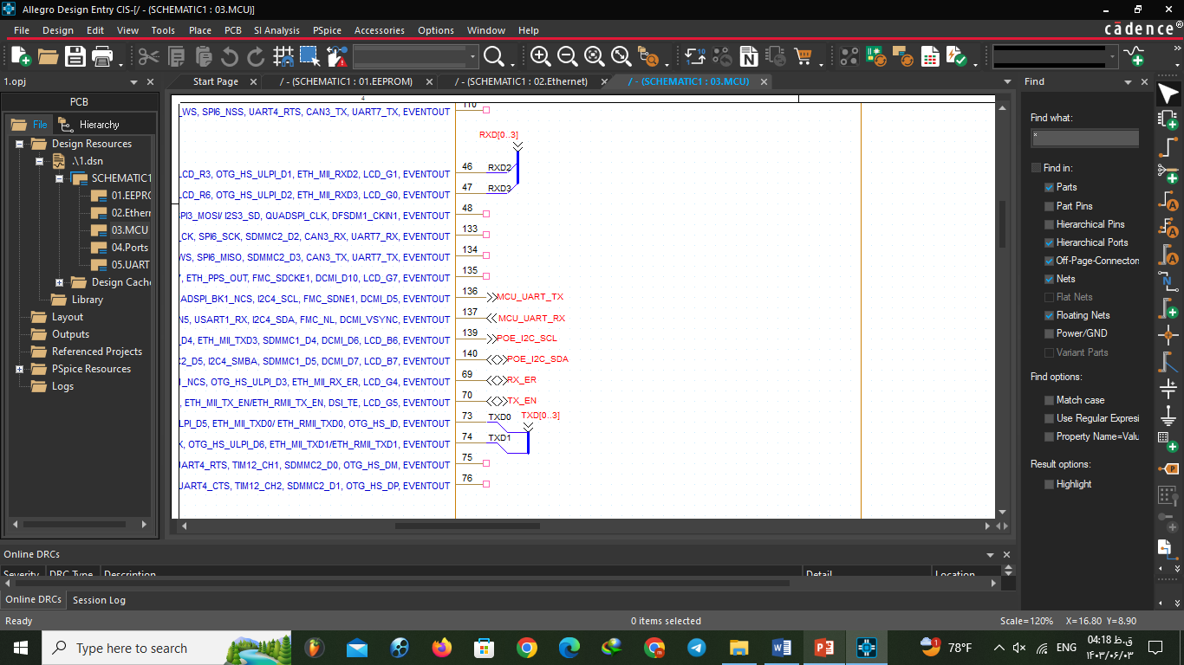 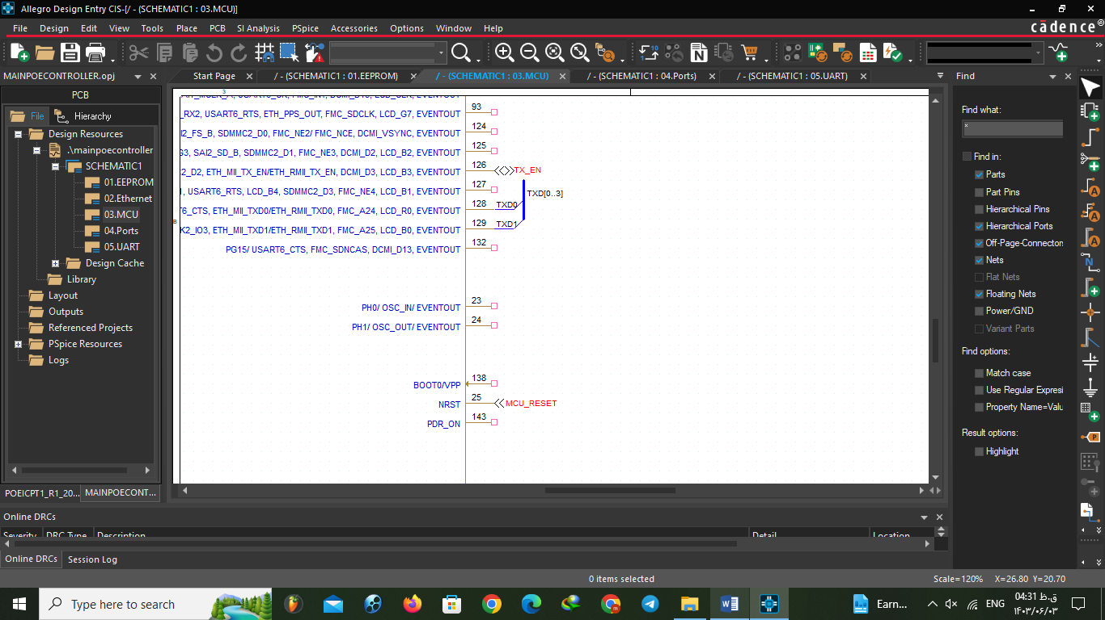 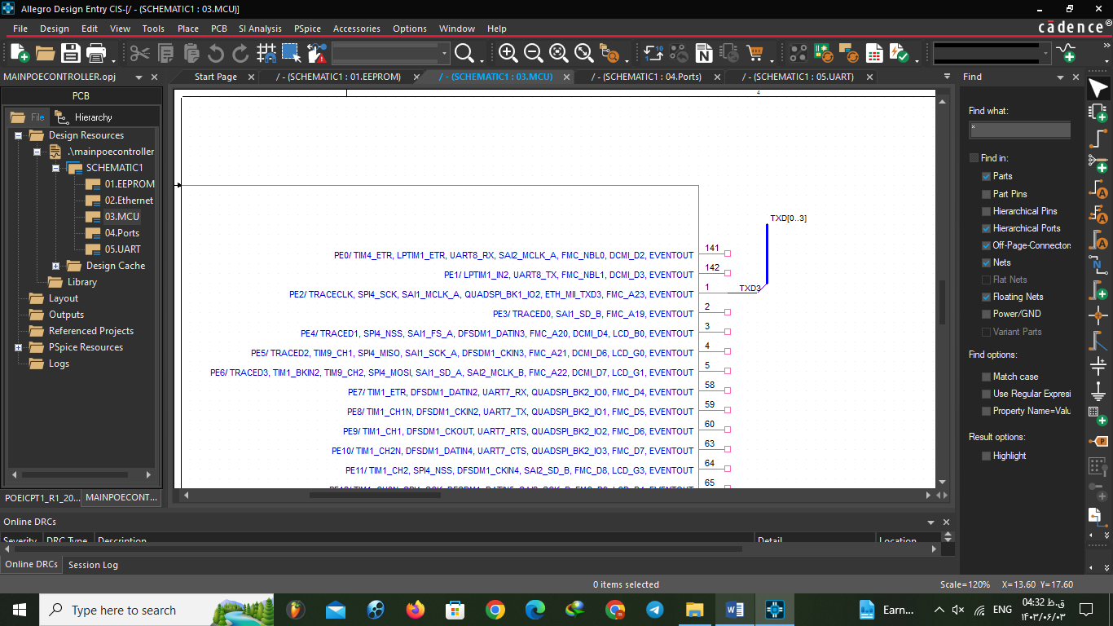

This time power pins of MCU were not connected.

**4: Ports**

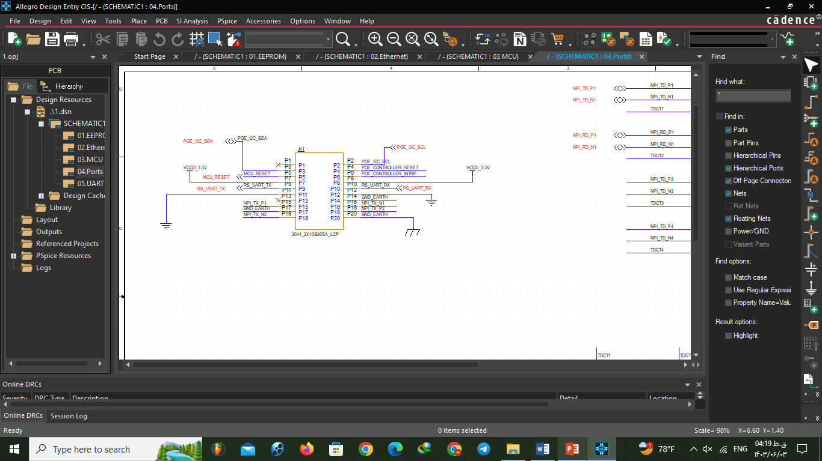

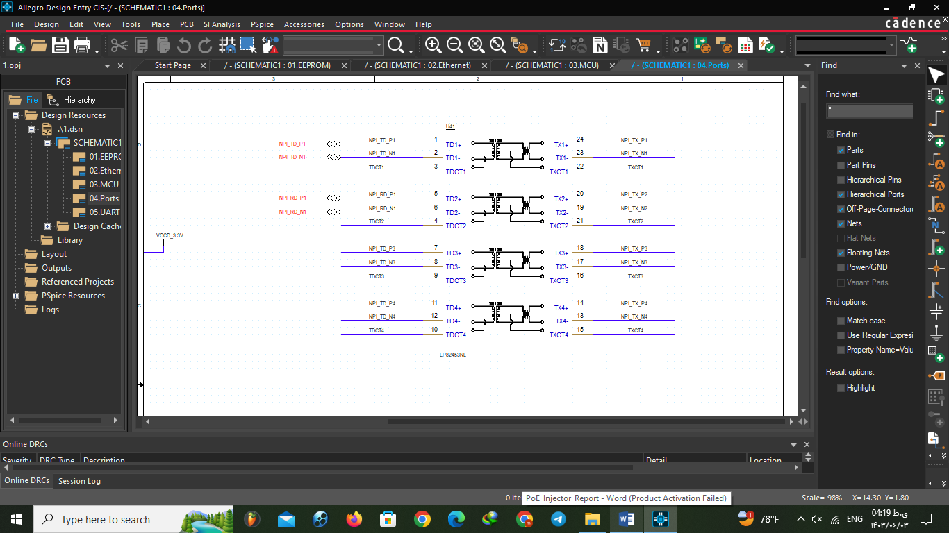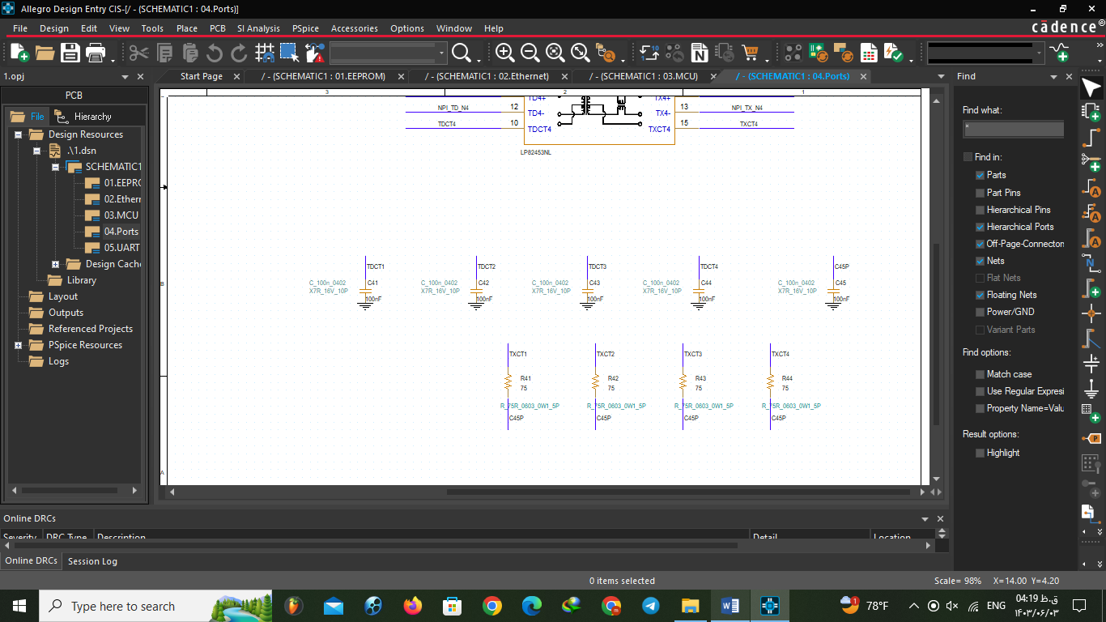

**5:URT**

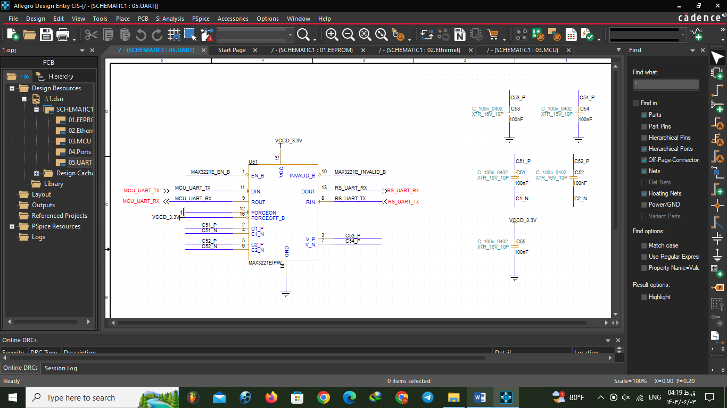

**Milestones:**

For this part we used a creative method. We made a google doc with our mentor and we asked our questions there with picture and she answered us with red color. Again we asked new questions with blue color and mentor answered. It was very efficient way.

**EEPROM:**

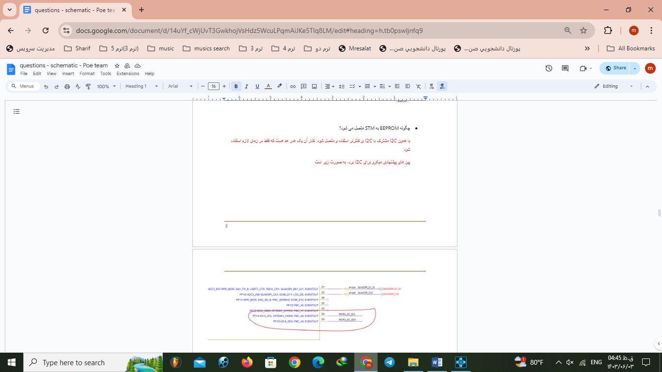





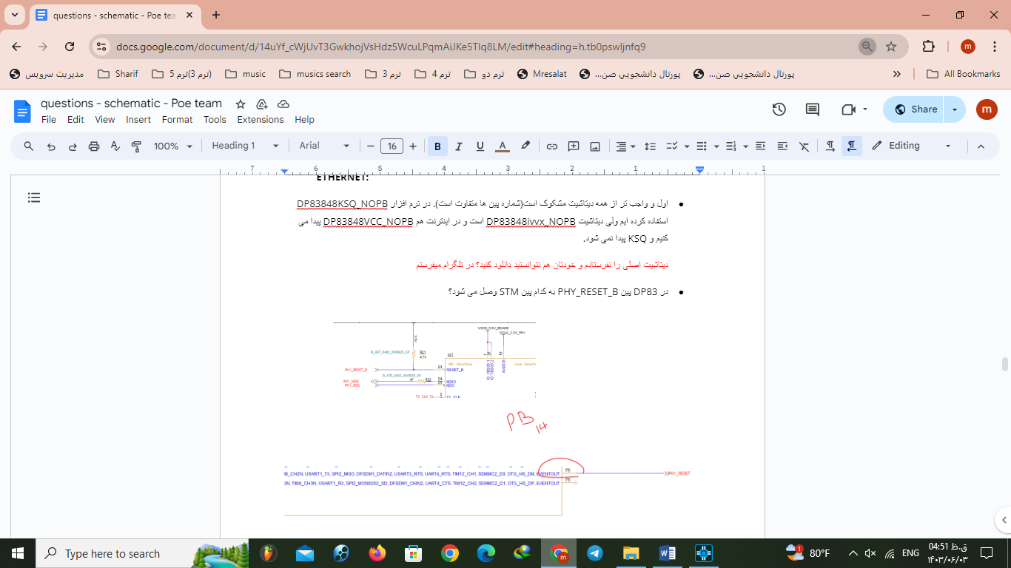**Ethernet:**

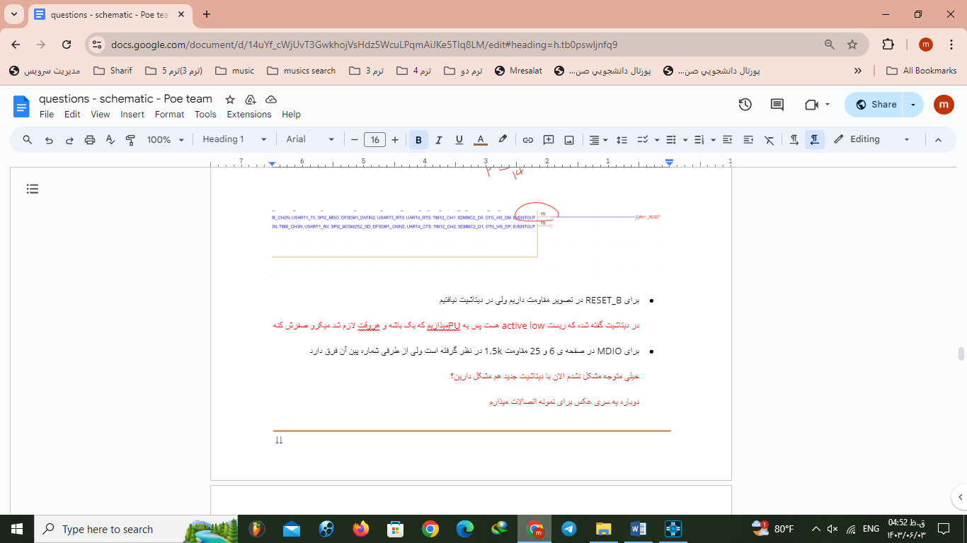

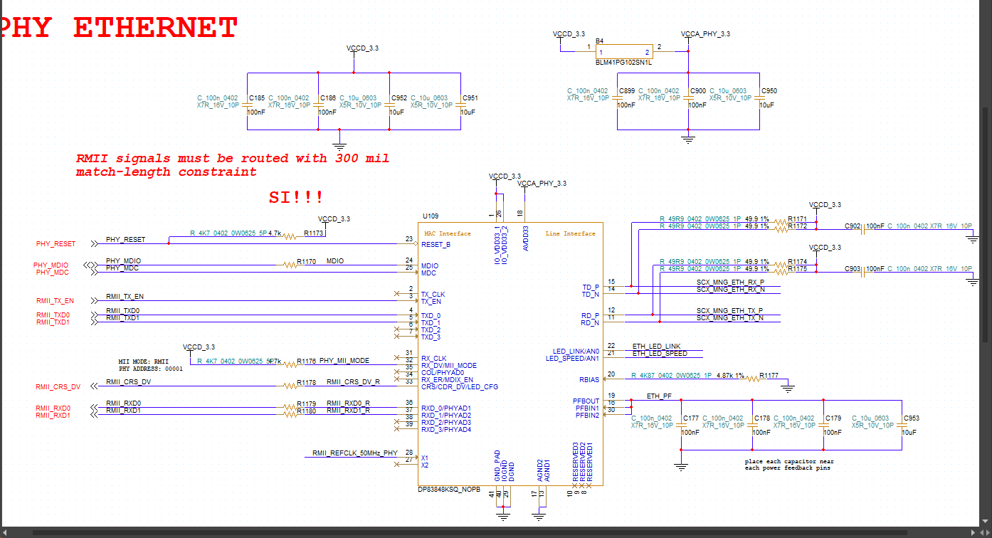

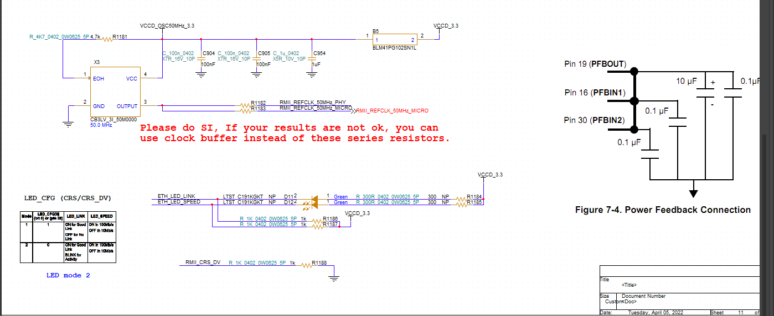

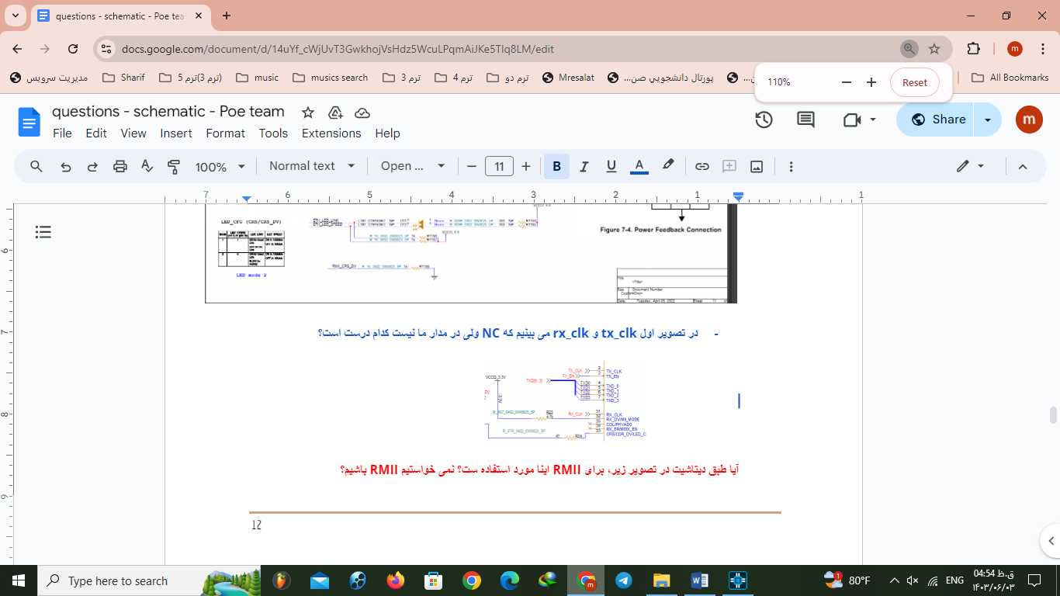

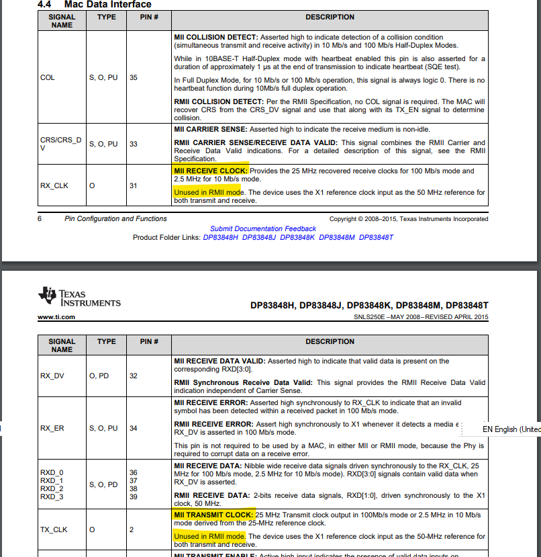

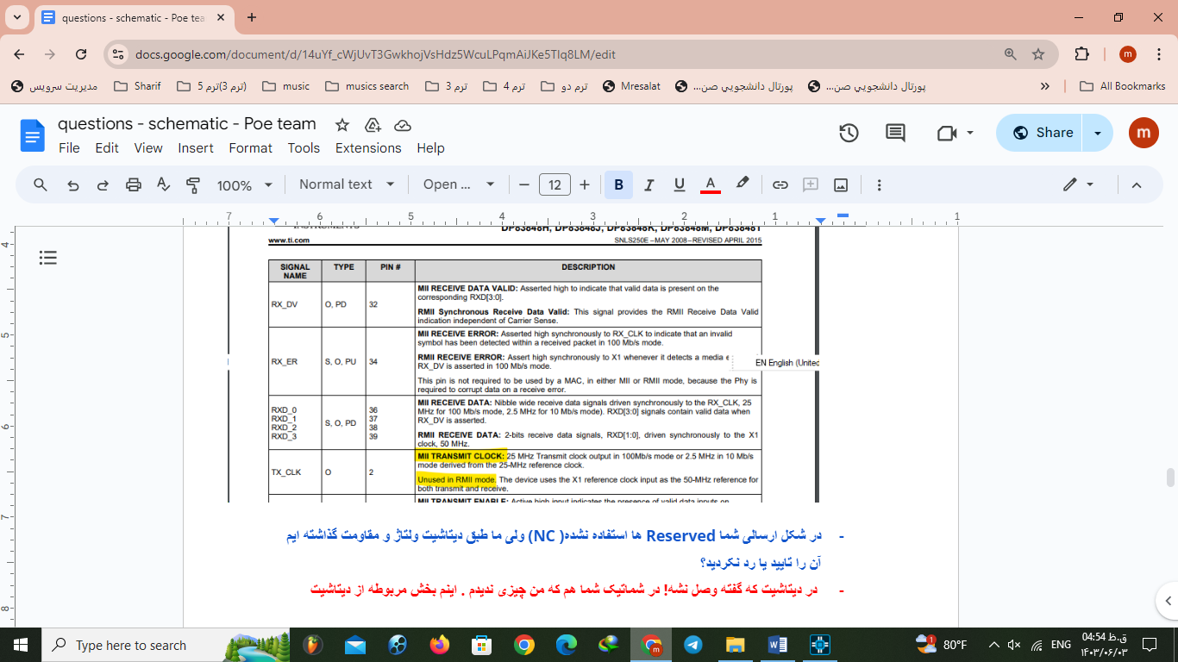

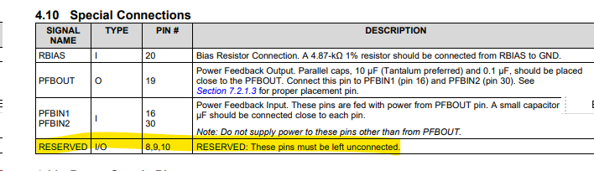



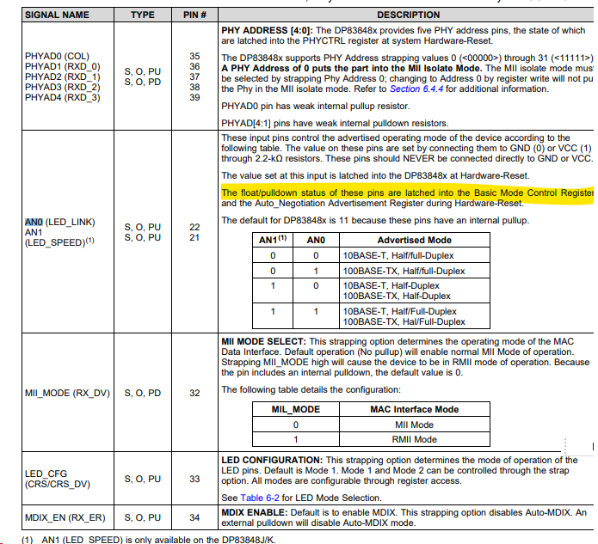

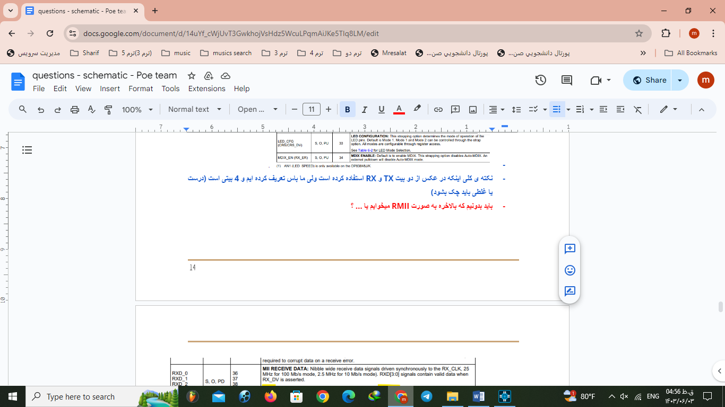

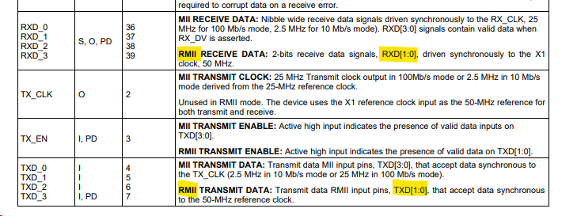



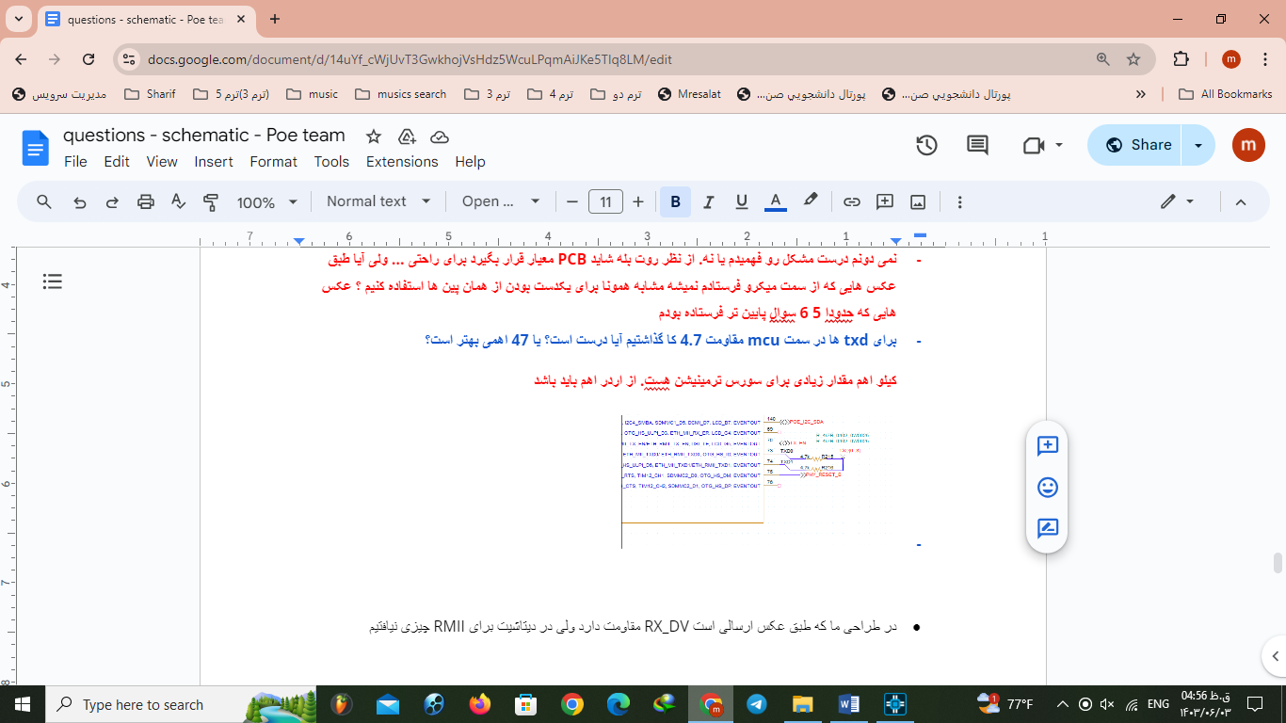

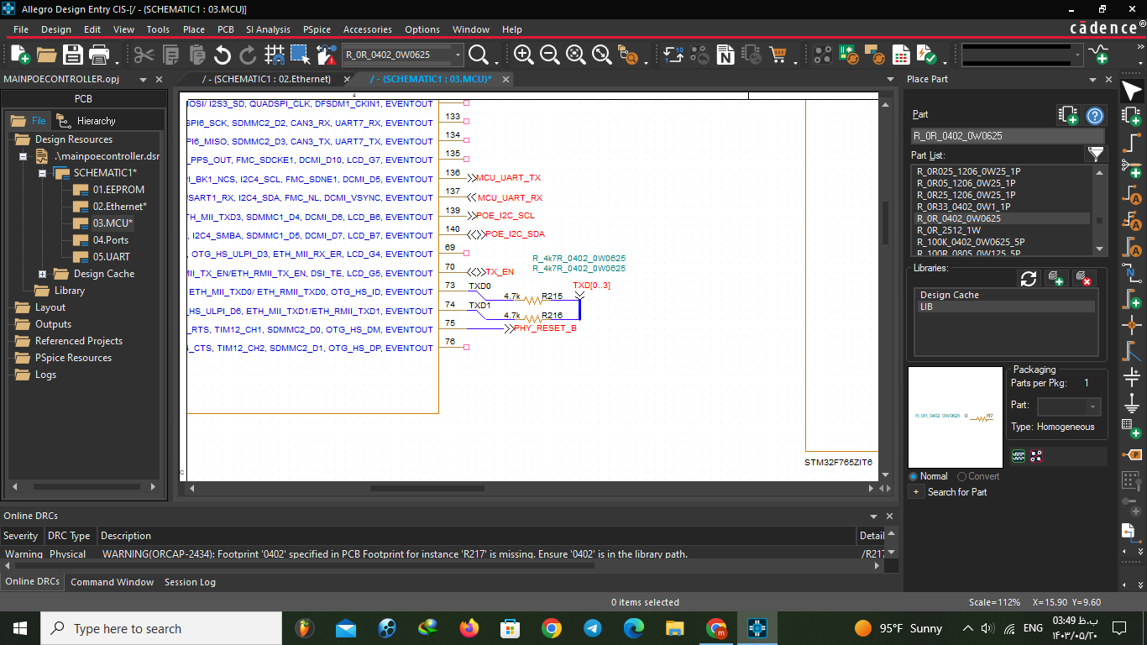

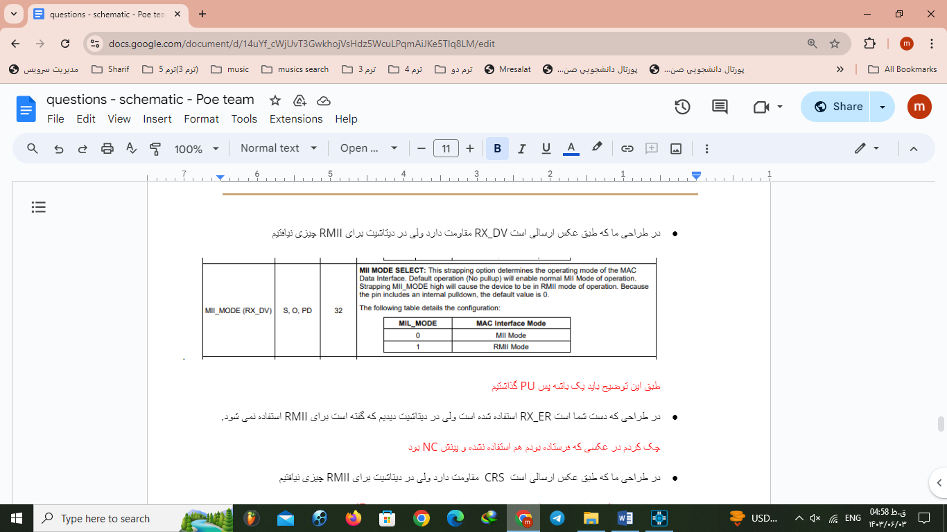

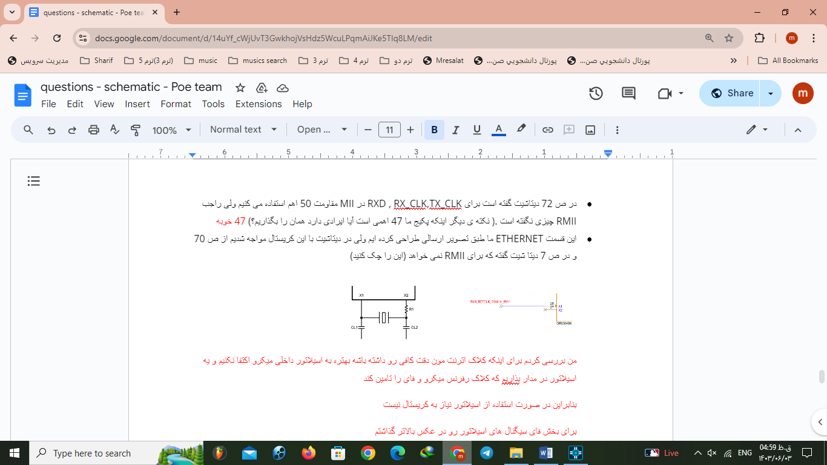

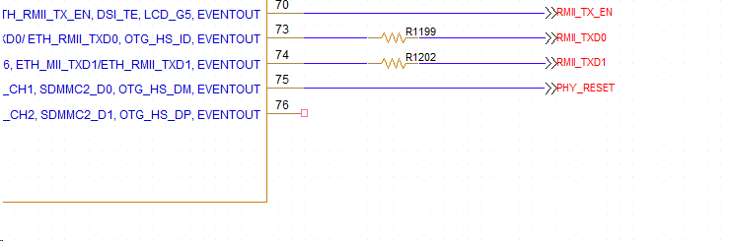

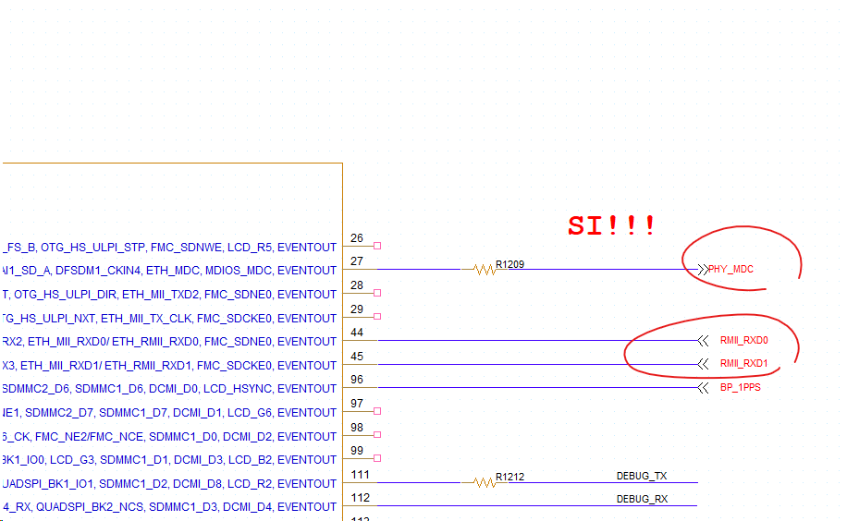

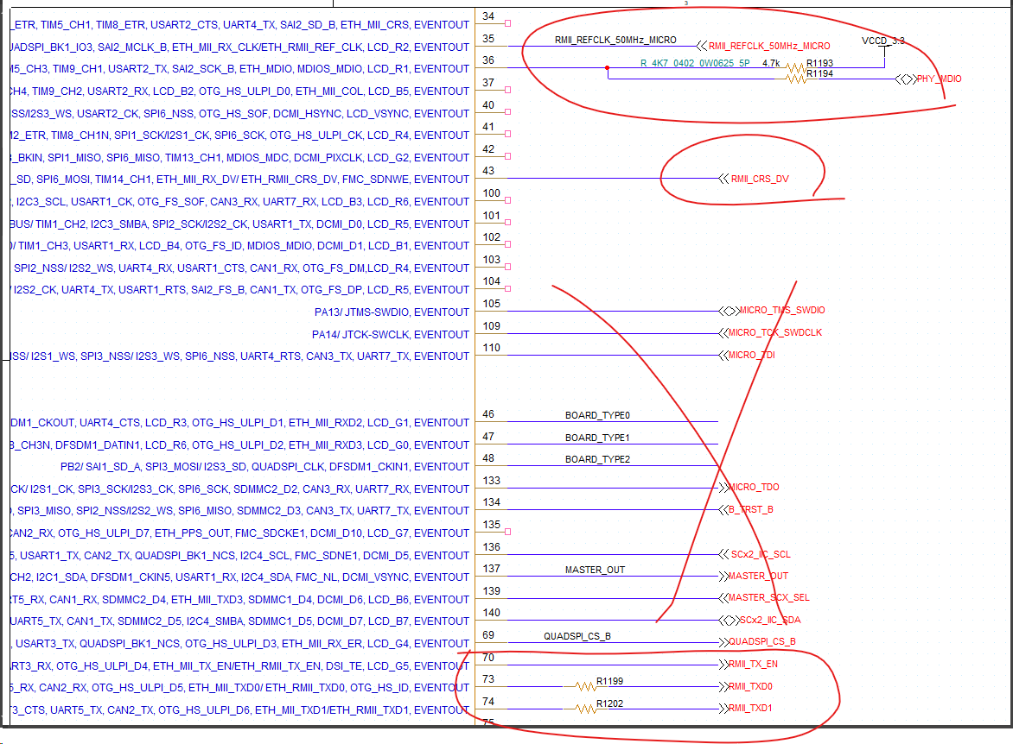

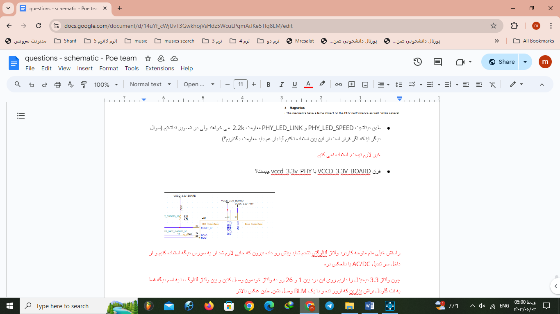

**3:MCU:**

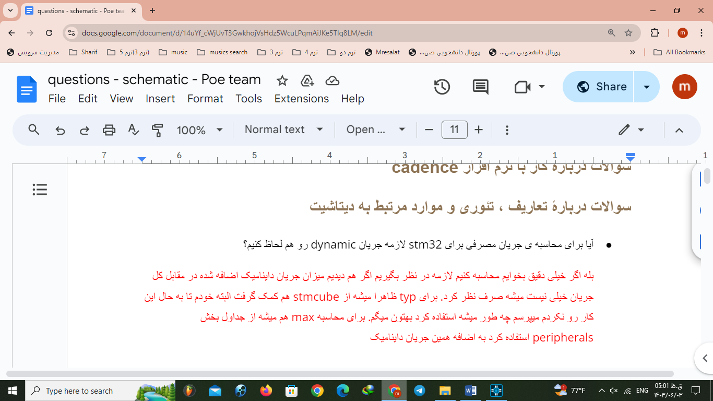

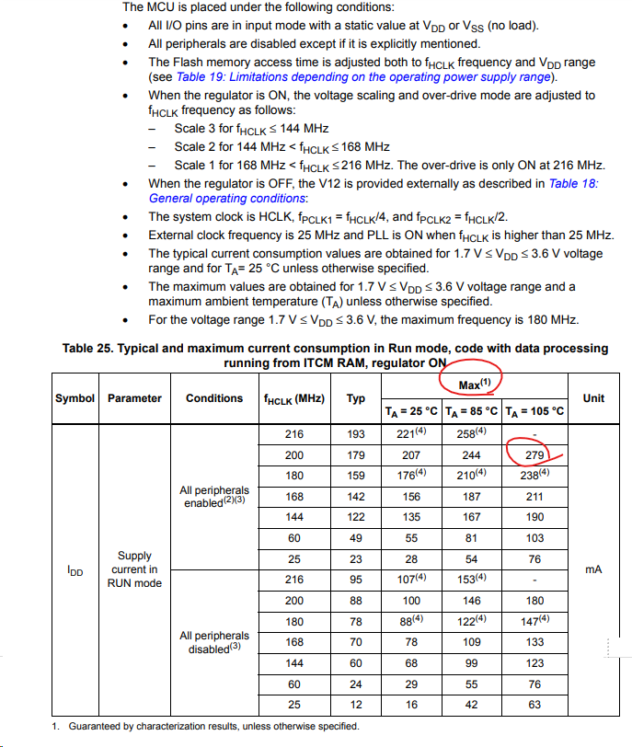 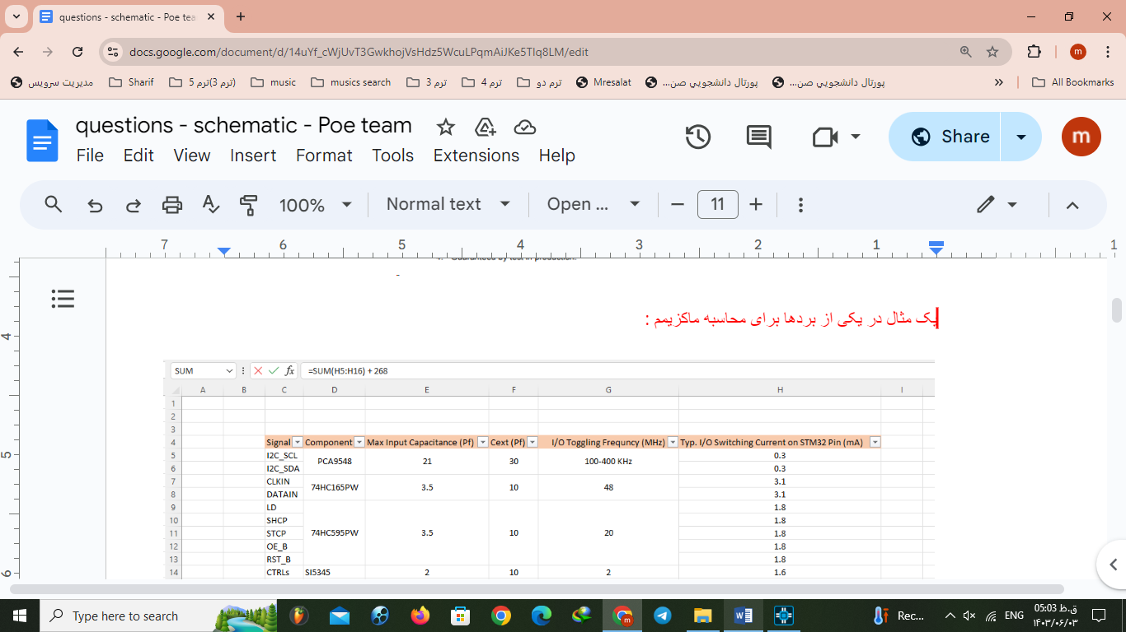 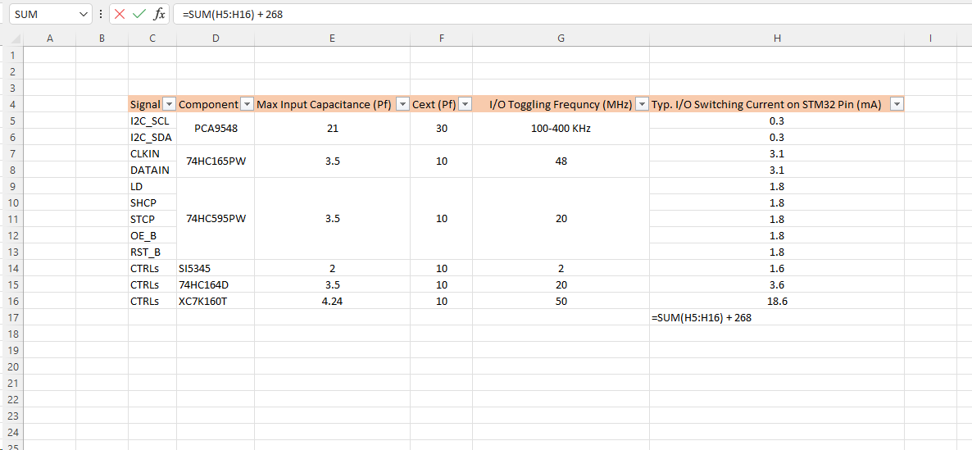

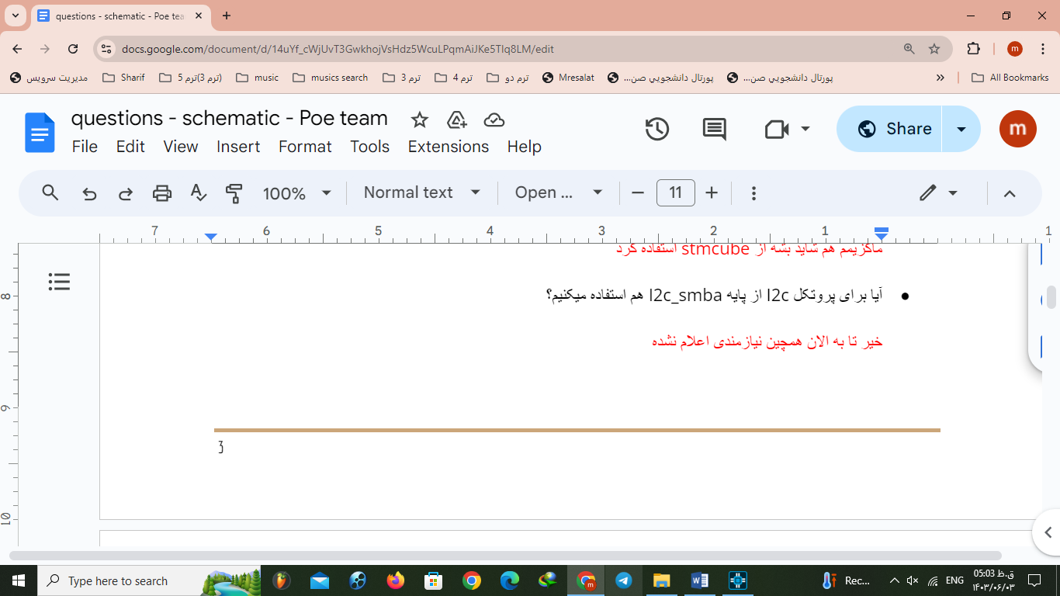



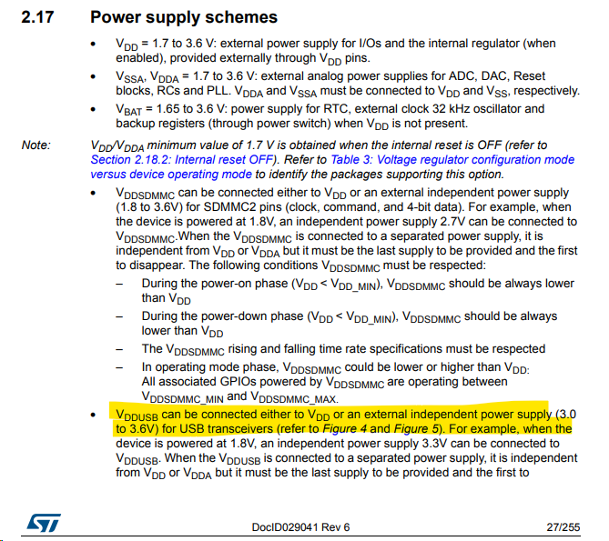

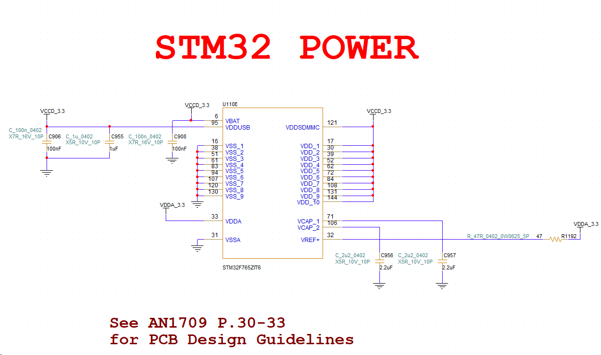

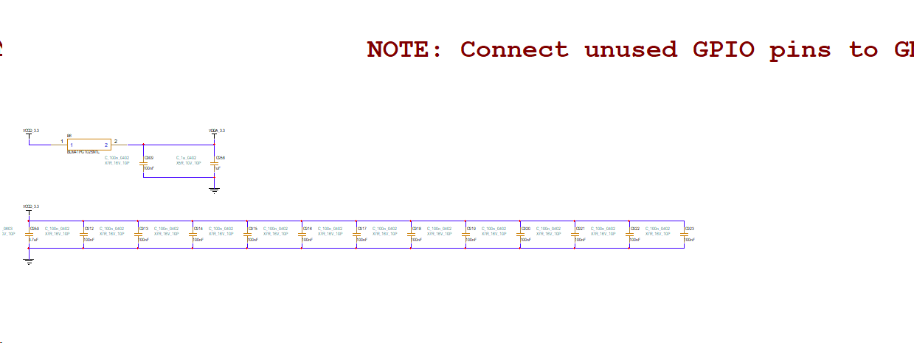 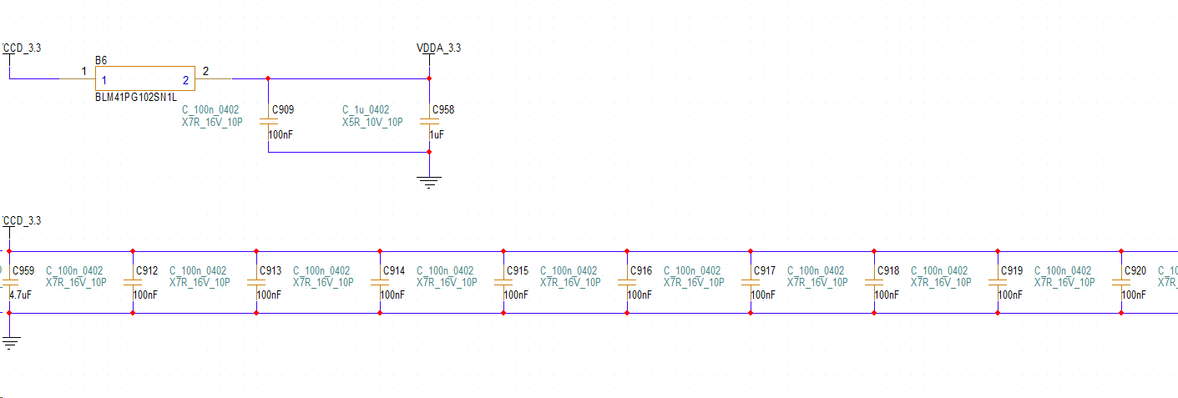  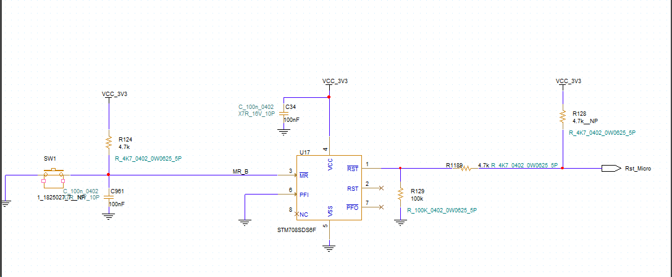

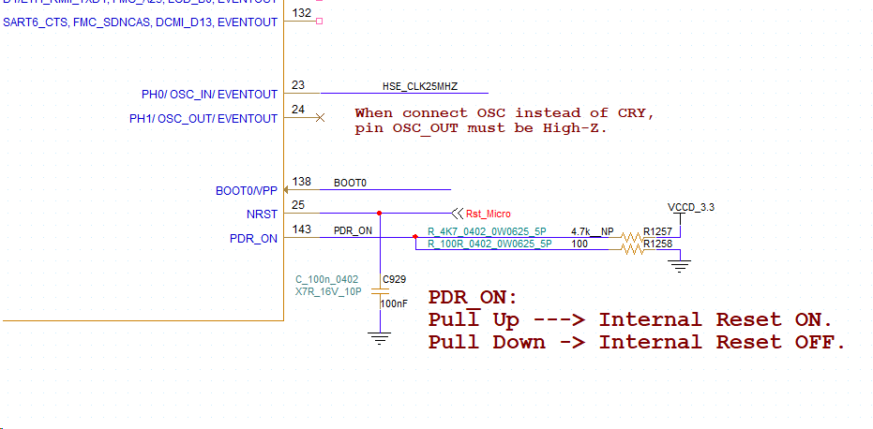

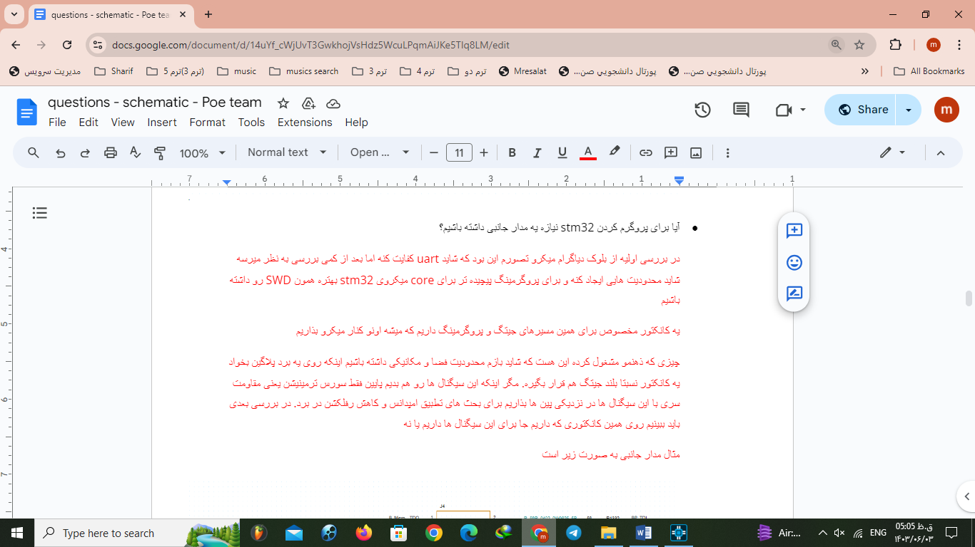

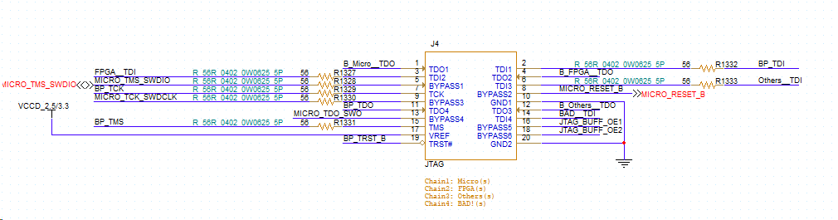



**Here we decided to add sixth page as an JTAG Page**

**4: Ports**

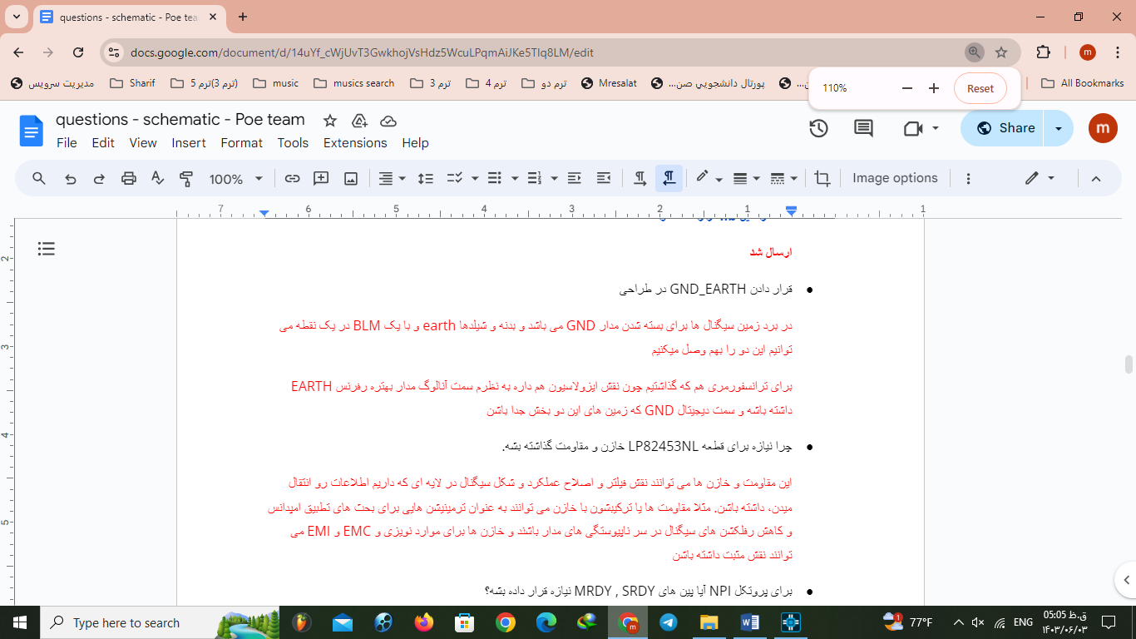

**5: URT**



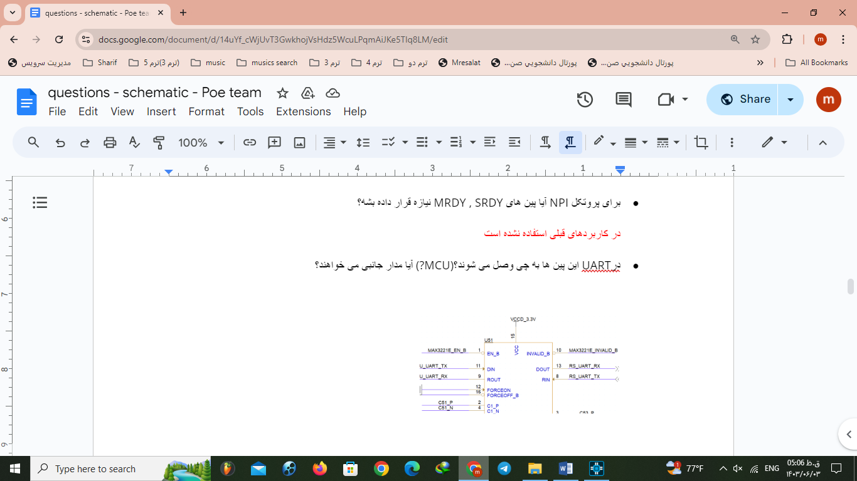

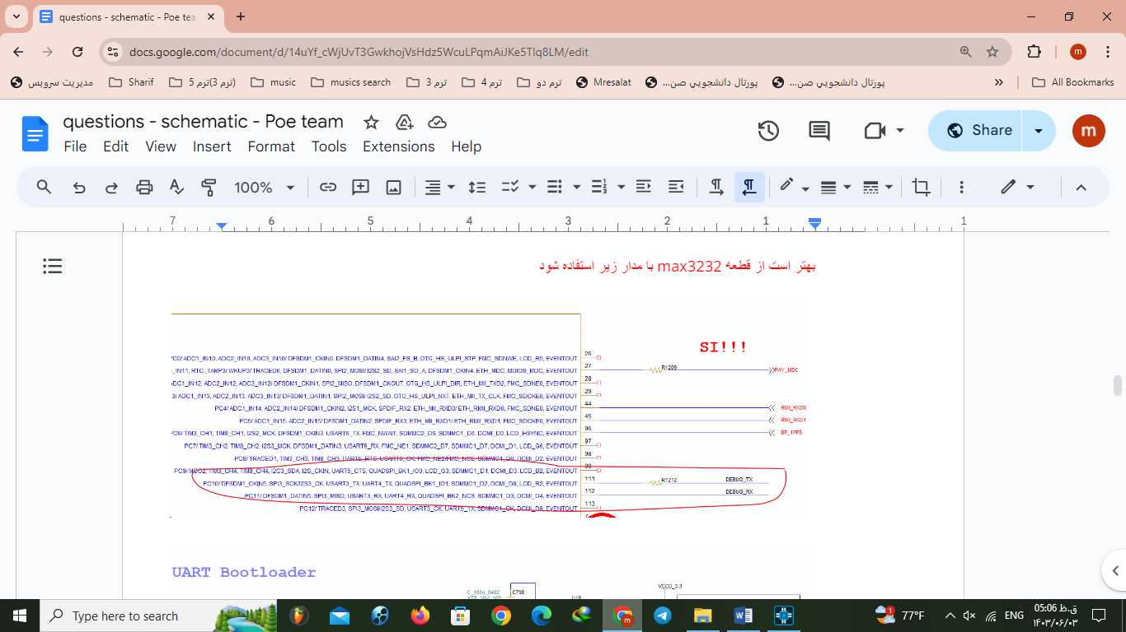 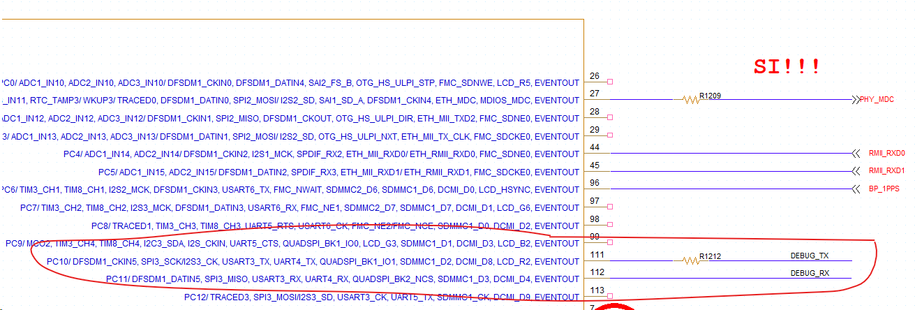 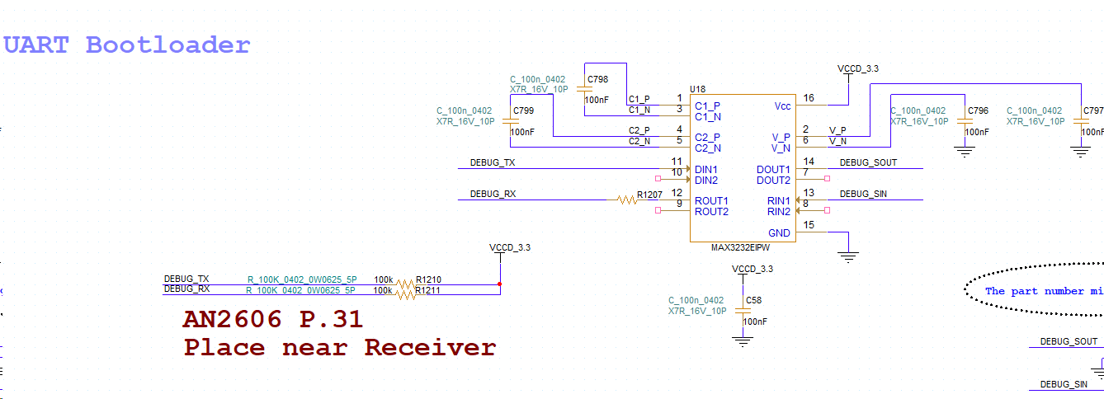

Here we decided to change URT page

**Second Design:**

**EEPROM: Not changed**

**Ethernet:**

**We deleted TXD bus because we just need two bites for RMII.**

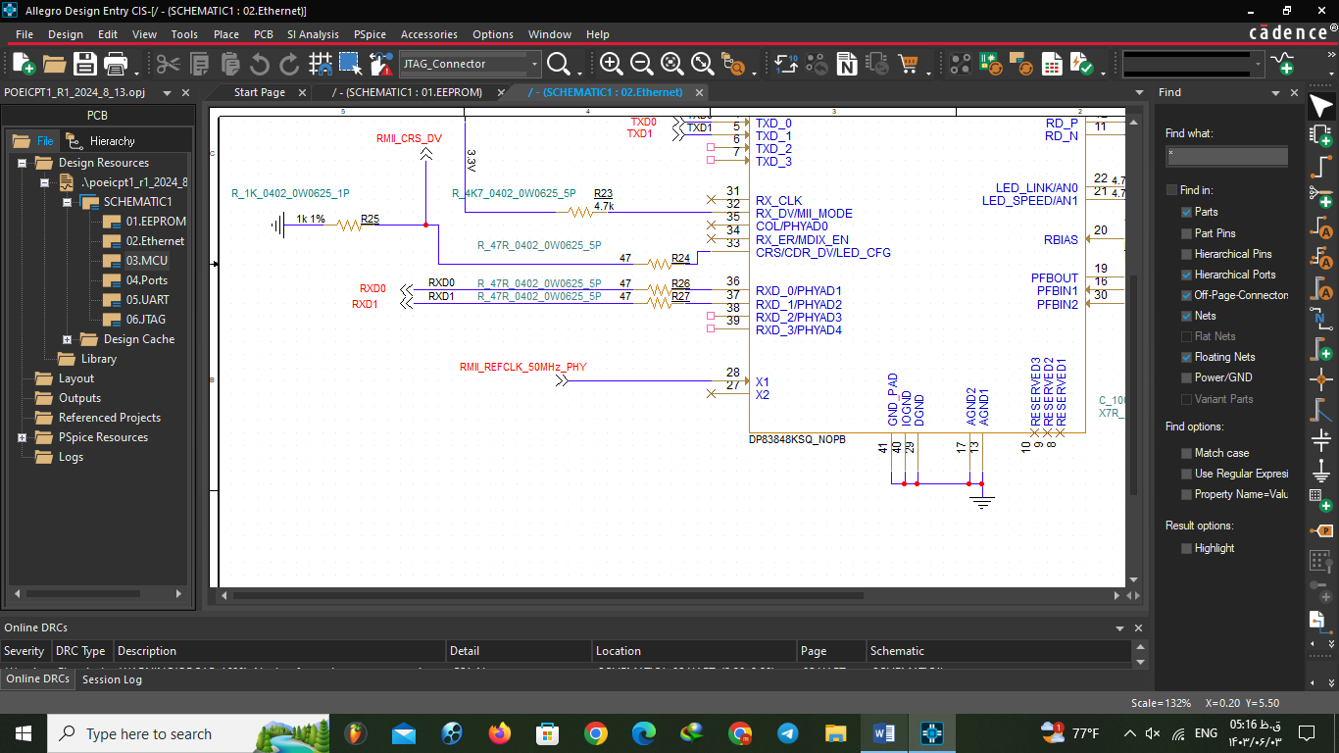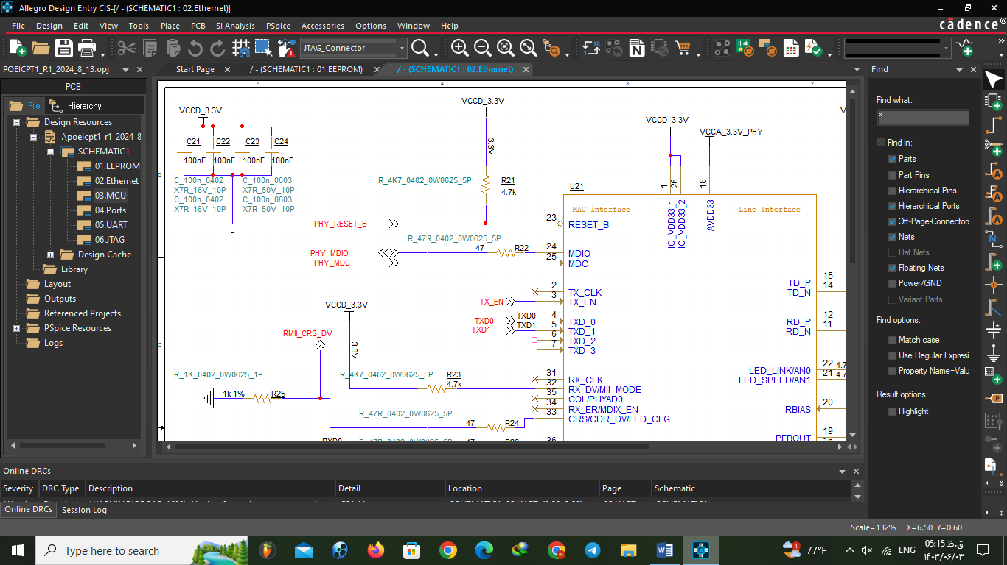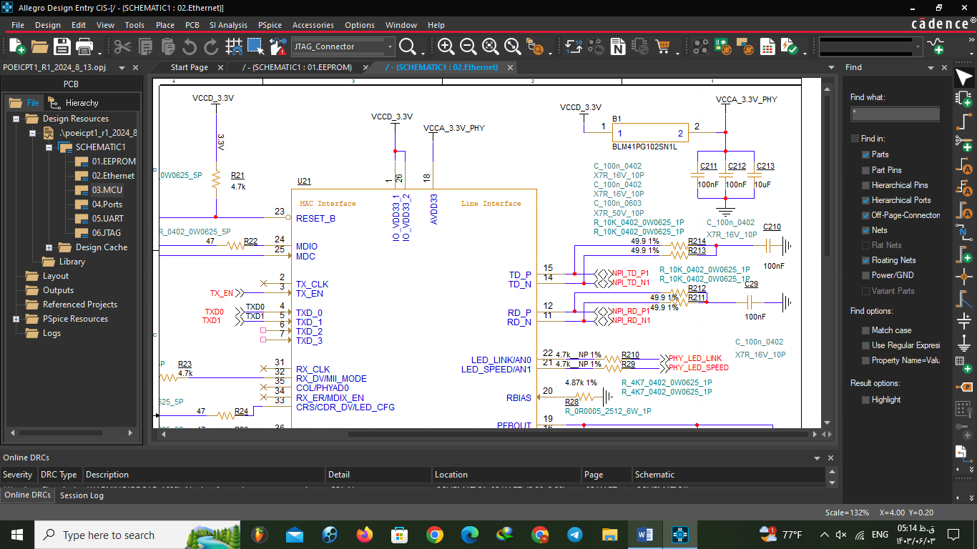

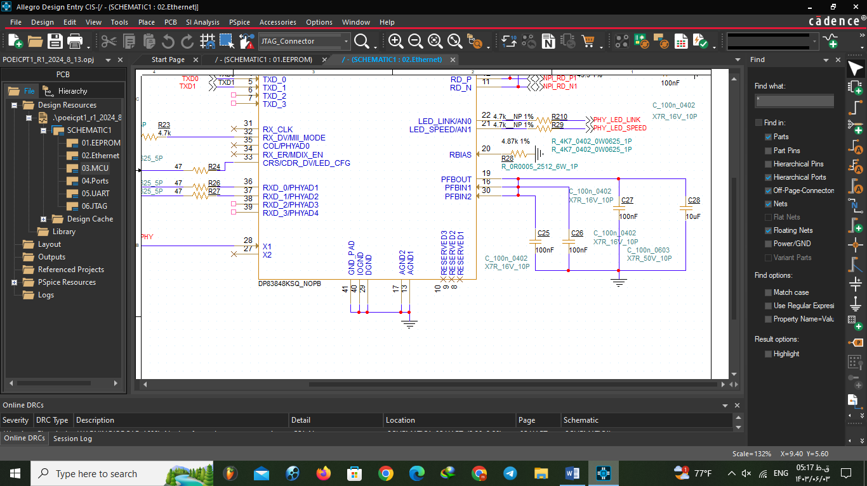

**MCU:**

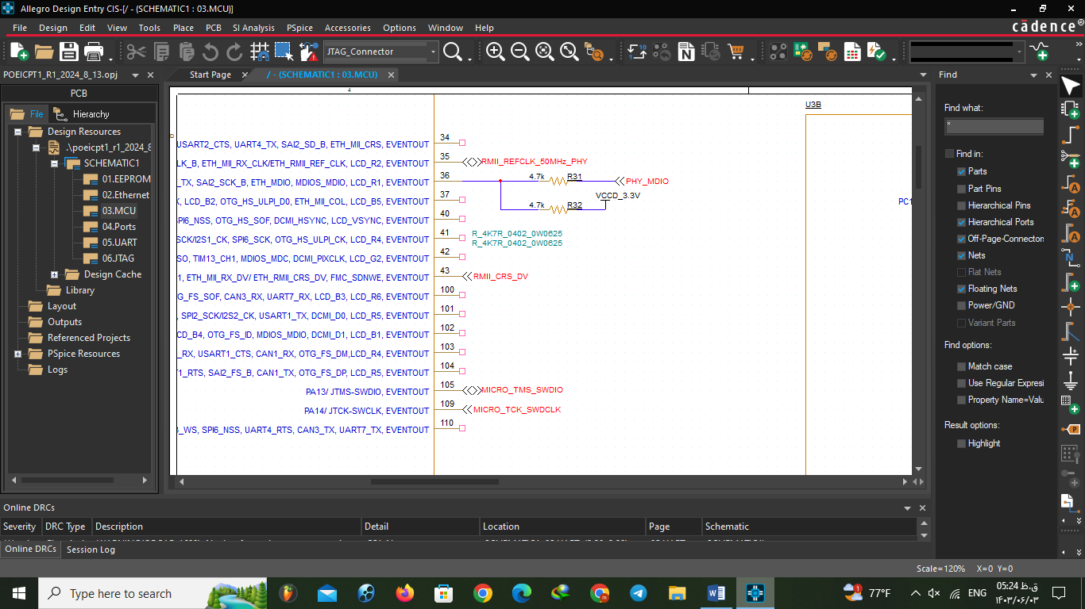 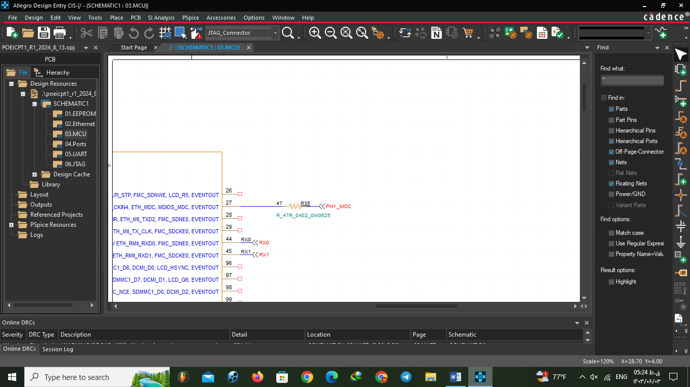

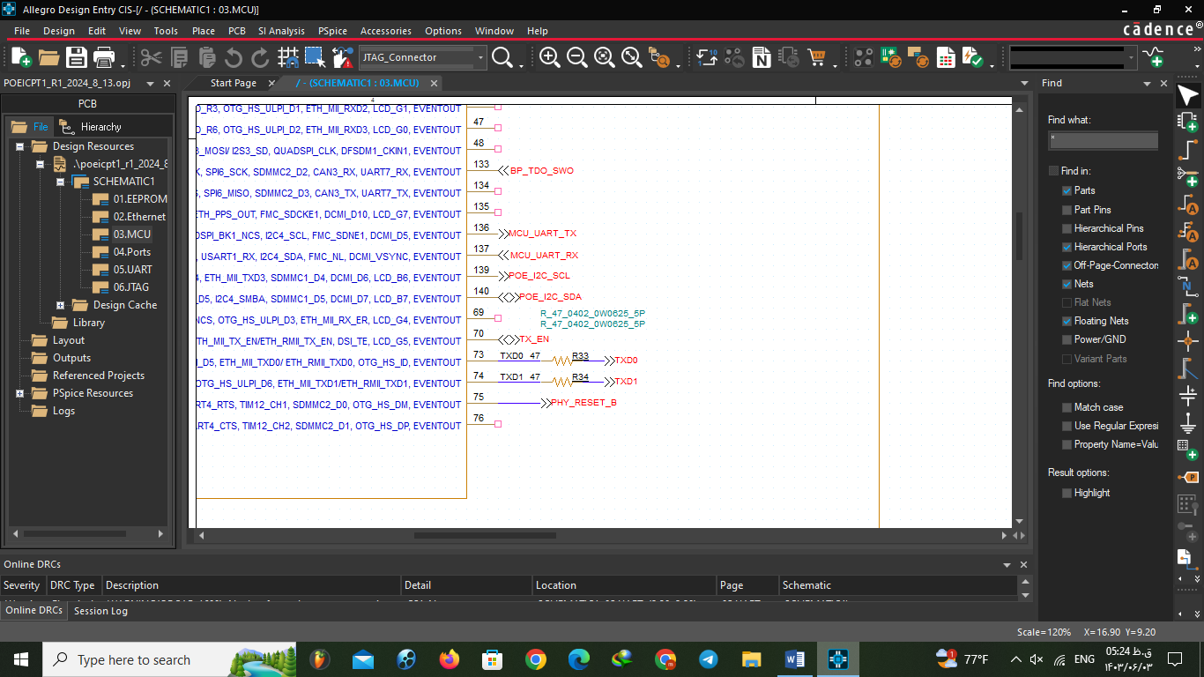 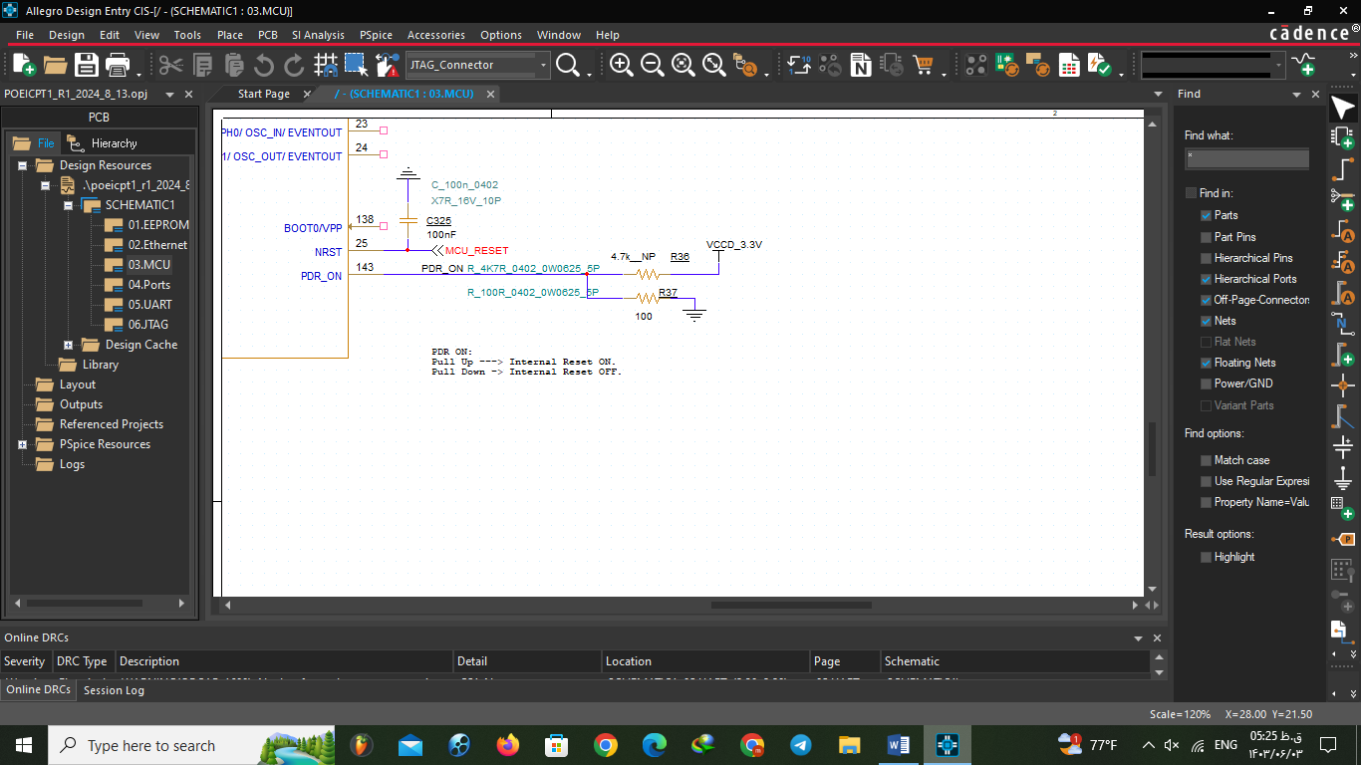

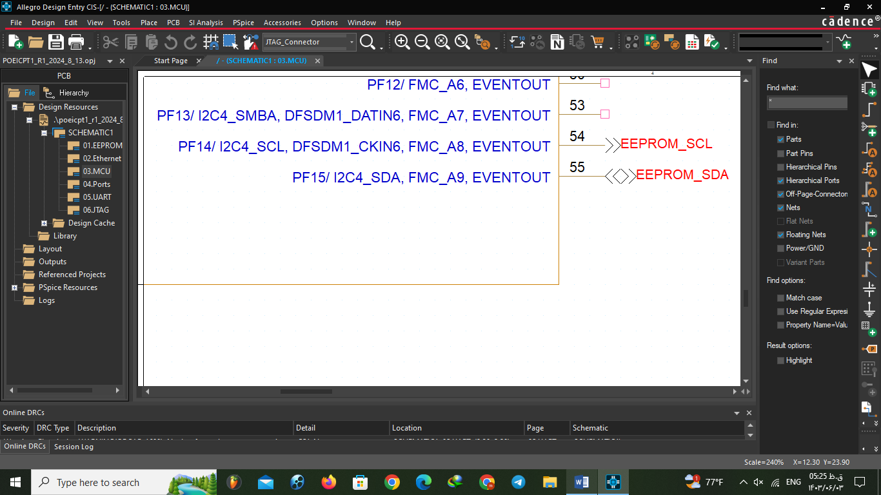

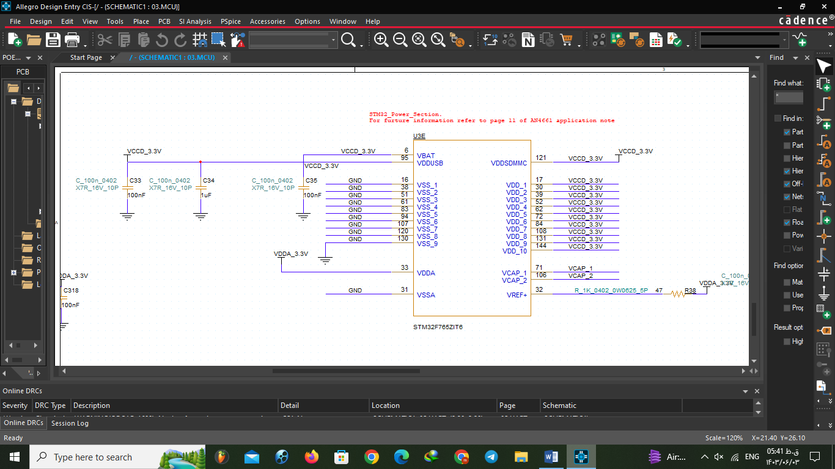

**We didn’t put picture of coupling capacitors but it’s as the picture in the milestone part.**

**Ports: Not changed**

**UART:**

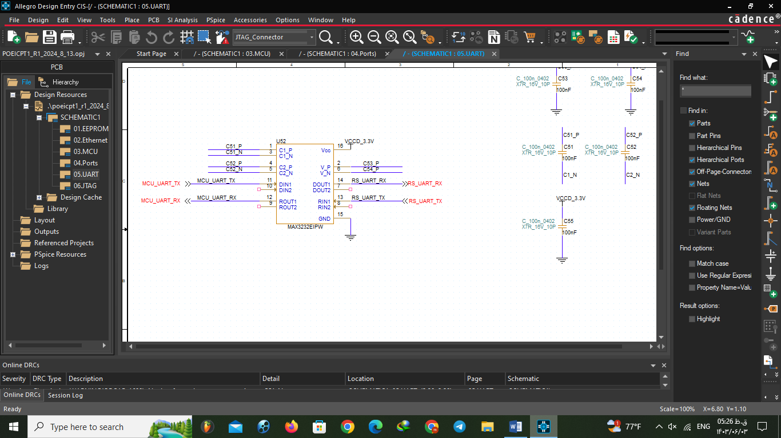

**JTAG:**

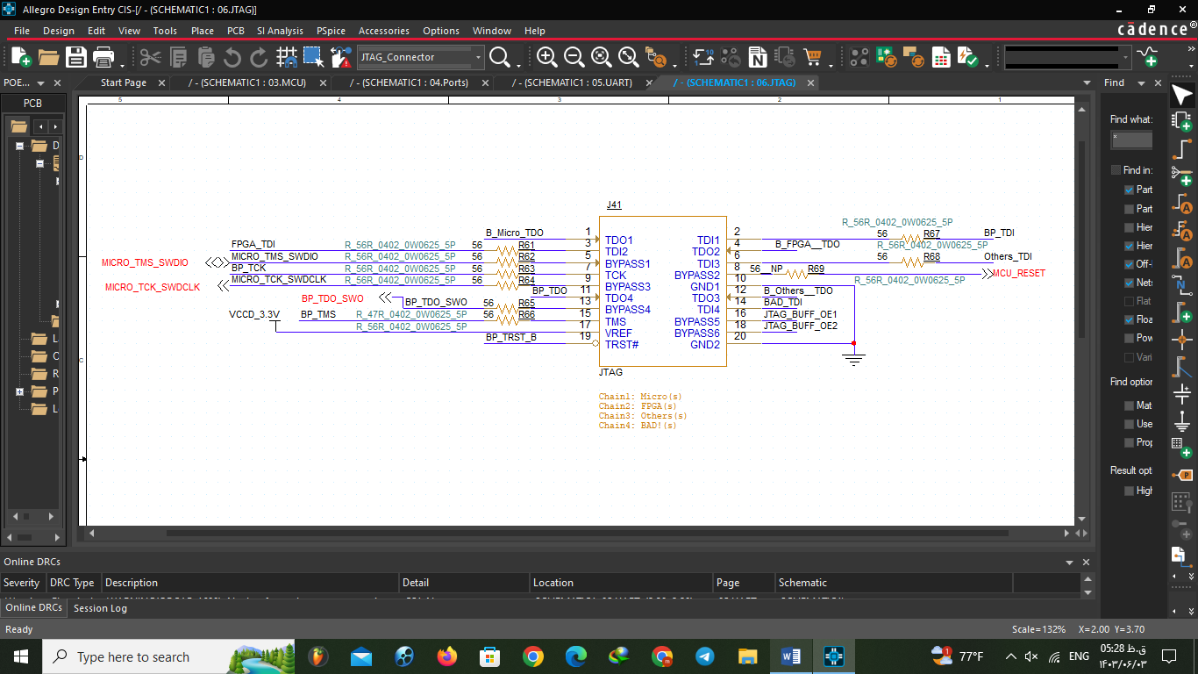

**Review:**

)

**Ethernet:**

* **We checked between MCU and Ethernet for Resistors because they should be in input side.**
* **LED off-pages Removed and the pins connected to the earth**

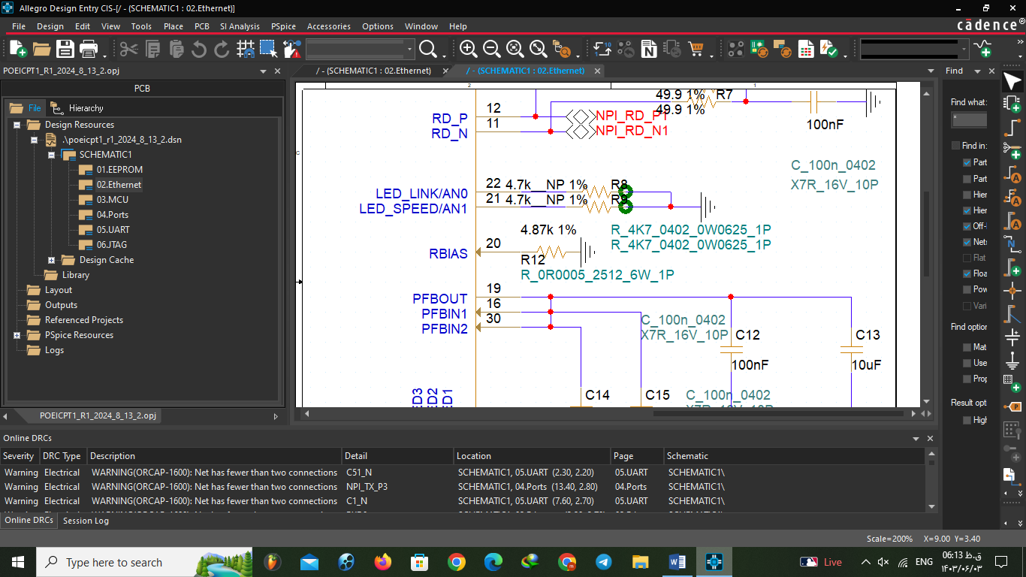

**MCU:**

* **We connected all unused pins to GND as the datasheet told.**

**For example:**

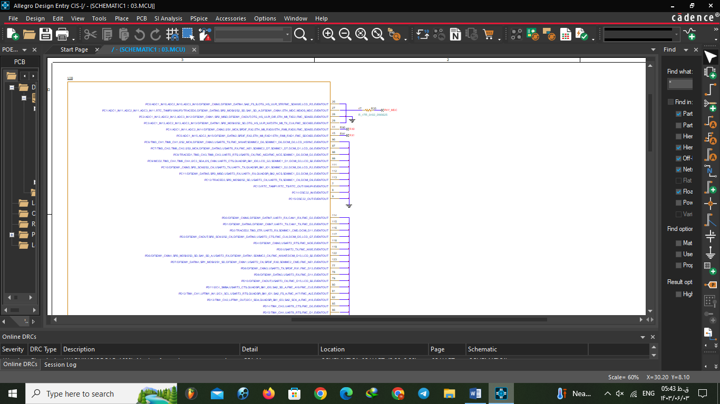

)

**Final Designing in cadence:**

**Phase 3: PCB Design**

(

**Learning Cadence and PCB design and rules:**

**Debugging schematic with first place:**

**Ethernet:**

* **Resistor type was not right and it was very big for our board and power**

**Wrong:**

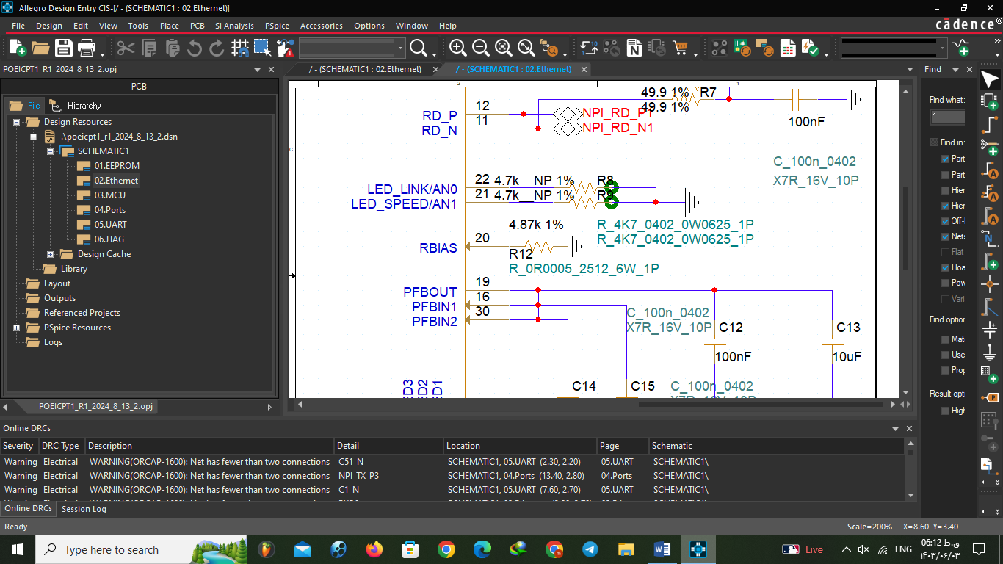

**Correct:**

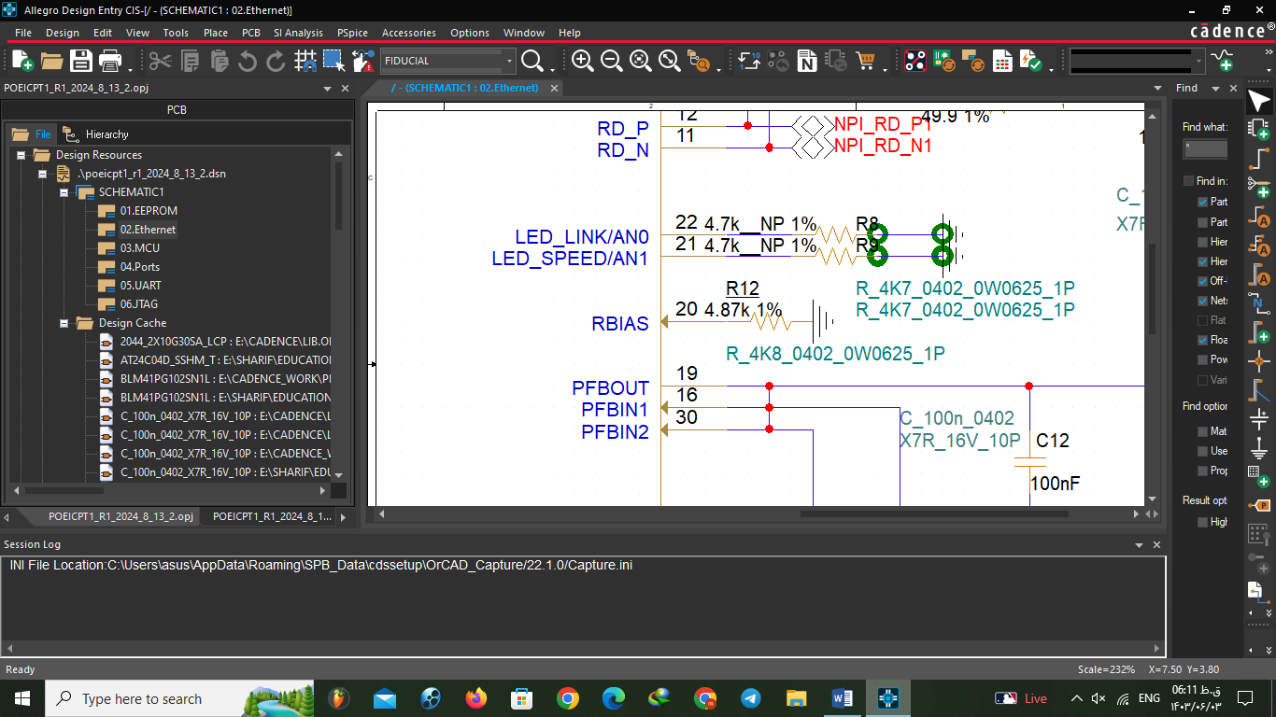

* **We had extra part in Ethernet page that was planted but is hidden because of the page size**

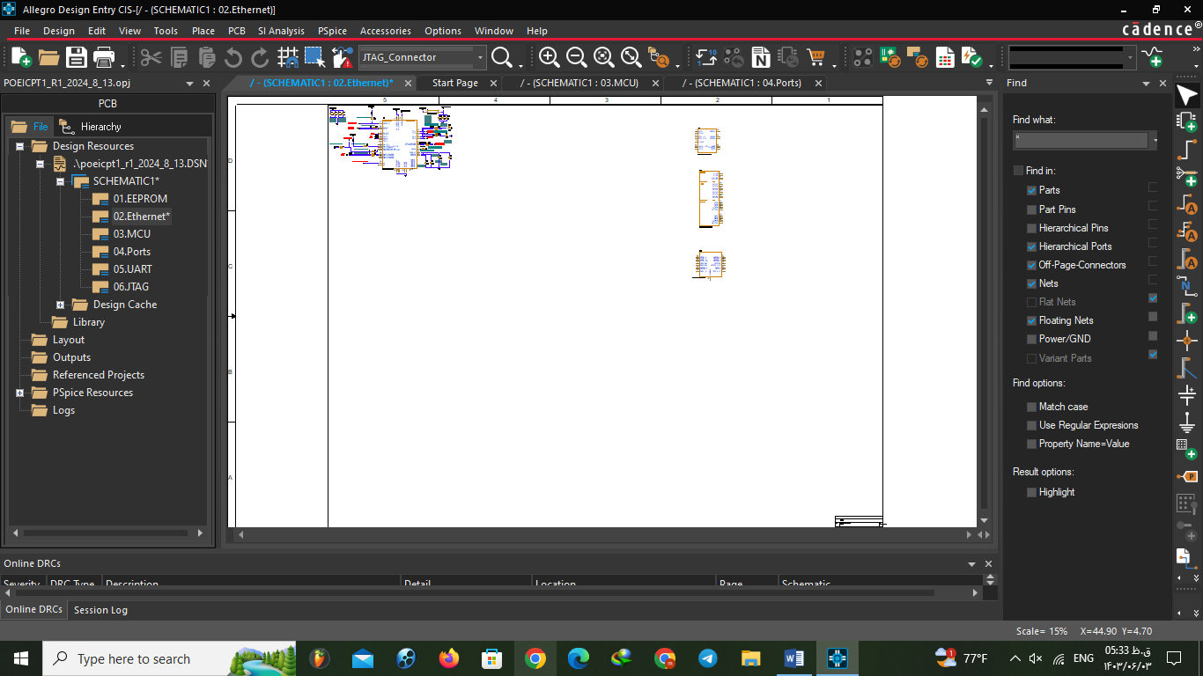

**MCU:**

* **Naming of TXD was wrong (both side of resistor is same voltage)**

**Wrong:**

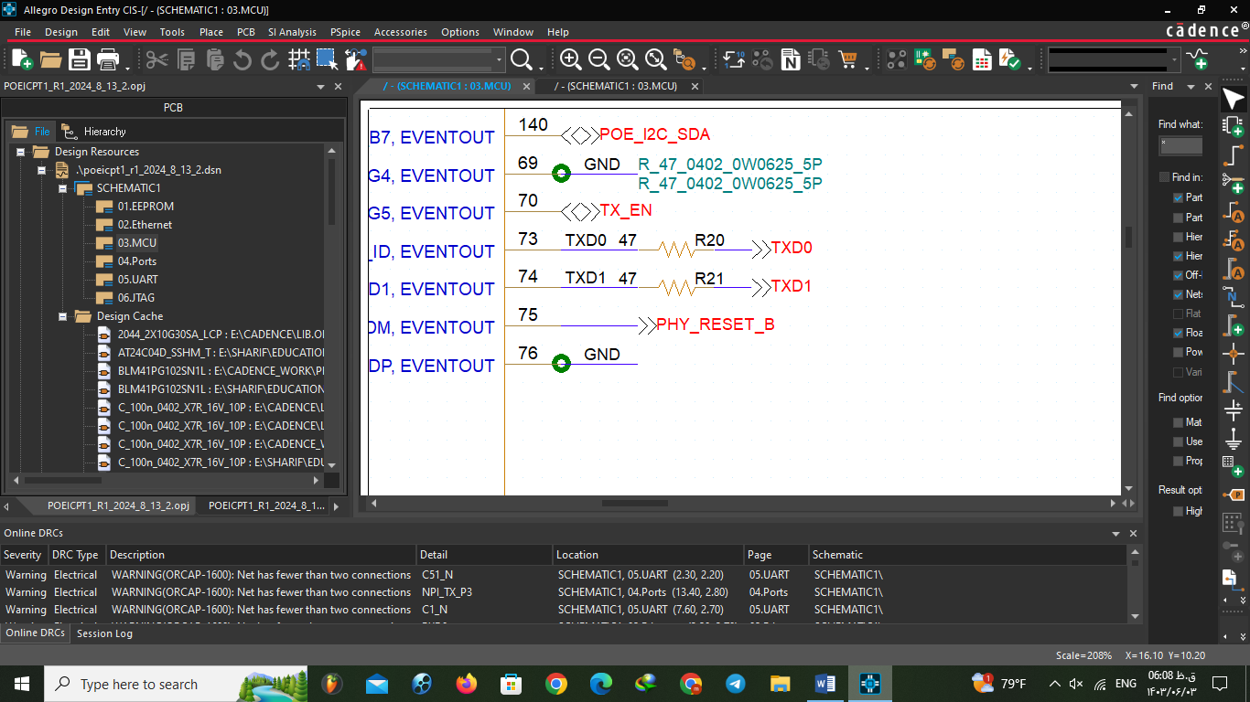

**Correct:**

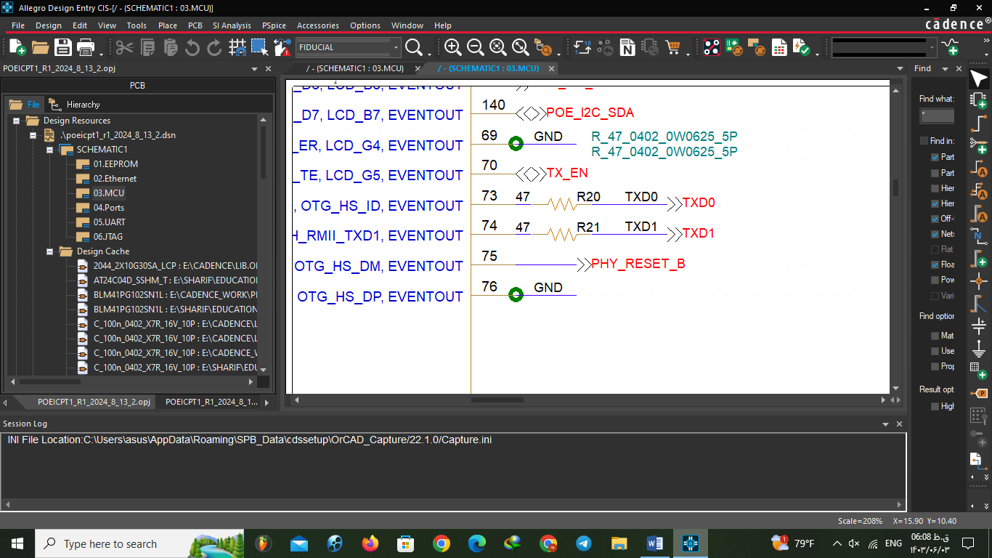

**UART:**

* **Name of the nets was wrong (C51_N , C52_N)**

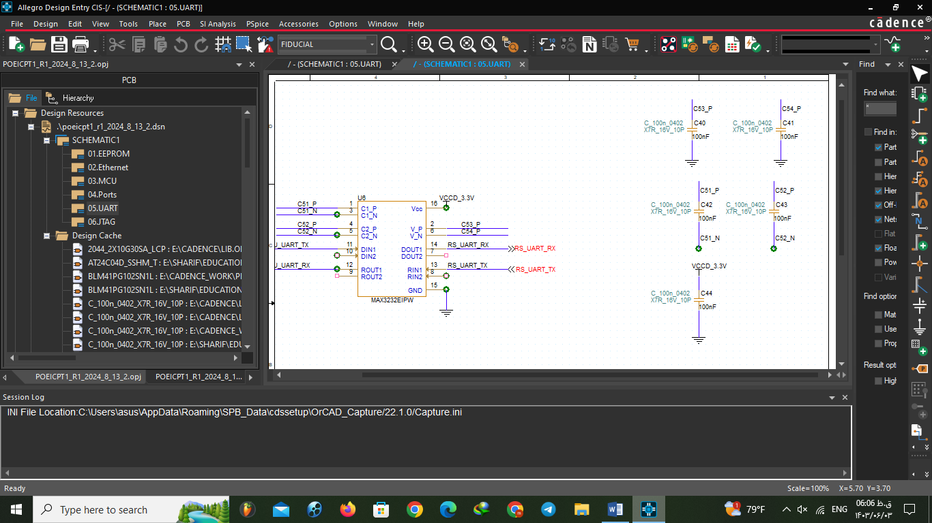

**Ports:**

* **We added fiducials and screw to this page**

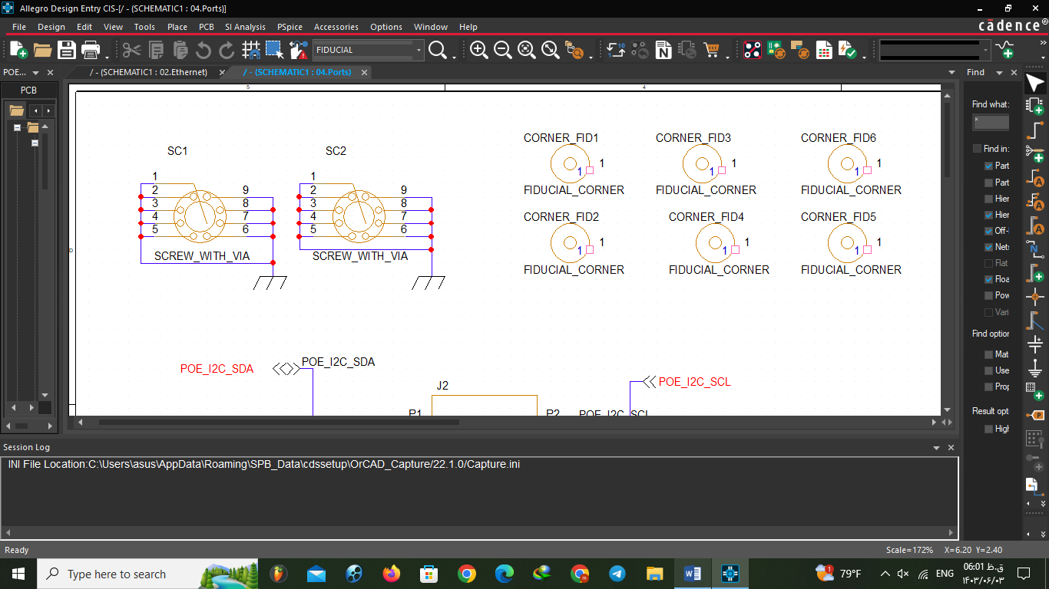

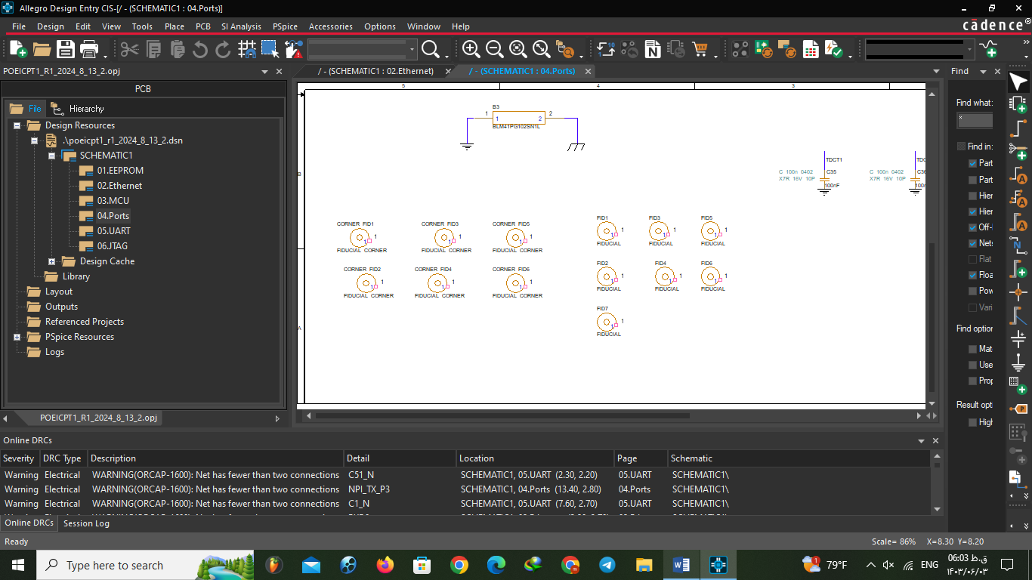

**First Designing in cadence:**

**Review:**

**Final Designing in cadence:**

**Project Planning:**

**Phases history:**

**Phase 1:**

**Duration:** 5 mordad to 12 mordad

**Task:** Find theoretical informations and design primary circuit for controller on the paper

**Phase 2:**

**Duration:** 13 mordad to 6 shahrivar

**Task:** Design primary schematic on the cadence

**Phase 3:  
Duration:** 7 shahrivar to 17 shahrivar

**Task:** Debug schematic and design PCB on the cadence

**Agile working:**

## **Scrum team:**

The scrum team is a fundamental aspect of the scrum framework . It typically consists of the following roles:  
**Development team:** These are professionals with the skills required to deliver a potentially shippable product increment. The development team is responsible for the actual work of creating the product.   
**Product owner:** The product owner represents the interests of the stakeholders and is responsible for managing the product backlog and prioritizing work.  
**Scrum master:** The scrum master is pivotal in facilitating the scrum process and ensuring that the team adheres to scrum principles.  
**Scrum master vs. project manager:**The scrum master’s non-technical counterpart is the project manager. Both roles focus on the “how” of getting work done and solving workflow problems through process improvement. Are both roles required to manage agile projects successfully? The short answer is no.  
While a traditional project manager and a professional scrum master are responsible for helping their teams get work done, their approaches are vastly different. Project managers set project milestones, report on team progress, and facilitate effective communication. However, they do so from a place of control. Conversely, scrum masters help teams enhance and streamline the processes by which they achieve their goals. They do so as a team member or collaborator—not by exerting total control. The best scrum teams are self-organizing and, therefore, don’t react well to micromanagement.  
These are just a few of the possible configurations of [scrum team management](https://www.atlassian.com/en/agile/teams). Some companies make do with all of these roles, some have one or none at all.

**Scrum master (Mehrad Afshari Nazari):**

**Who is Scrum master?**Scrum Masters do a lot of critical work that helps the team and the organization.

Scrum Master's main responsibility is to organize the development team to make progress based on the project's main priorities. In other words, the Scrum Master guides the team in the right direction.

To be successful, Scrum Master must wear different hats that depend on the situation or challenge the team is facing. In any given situation, a Scrum Master utilizes their important soft skills to act as a Servant Leader, Facilitator, Coach, Manager, Mentor, Teacher, Impediment Remover or Change Agent, depending on the situation at hand.

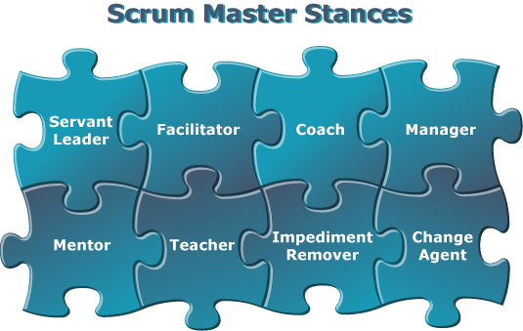

**As a servant leader:**

May aim to share positive energy and motivation with others and encourage the development and growth of others.This trait can extend to listening to followers carefully to understand their needs better, but it also involves leaders holding themselves and others accountable for their words and actions.

**As a facilitator:**  
Planning, guiding and managing a group meeting or event to ensure that it meets its goals. To facilitate effectively, you must be objective and focus on the "group process." That is, how groups work together to perform tasks, make decisions, and solve problems.

**As a couch:**  
They help the team members in self-management and cross-functionality. And they should inform, train and guide the whole team to know what to do and how to do it.

When a team member faces a challenge that stops work from completing a sprint, it is up to the Scrum Master to remove the obstacles. The interruptions and challenges created in this situation for the development process make the path to reach the goals uneven.   
The Scrum Master must remove obstacles so that the team can continue to function in the best possible way in all situations.

**As a teacher and mentor:**Maybe They have some technical experiences and scientific knowledge about the project.  
They can also help team members in problems and they can give a hint.  
**As an impediment remover:**  
The Scrum Master helps the team to resolve conflicts and work together. It also helps to remove obstacles that block the team's progress. This can include anything from technical problems to communication issues. The Scrum Master is responsible for removing impediments to ensure that the team can work effectively and efficiently.  
**As a change Agent:**  
Acts as a catalyst for the change management process. They help an organization, or part of an organization, transform how it operates by inspiring and influencing others.

**As a program manager:**They should ensure that all Scrum events take place and are positive, productive, and kept within the time box. They find techniques for effective product goal definition and product backlog management. Scrum Master can hold sprint planning meetings to facilitate Scrum events.

The Scrum Master is required to hold short and precise meetings so that useful information can be transferred to the team members in a short period of time. So the remarkable thing about this is that the Scrum Master has a very important role during all meetings.

For example, this person leads the team's daily stand-up so that people talk about what they've done and present their daily schedule.

## **Scrum framework**

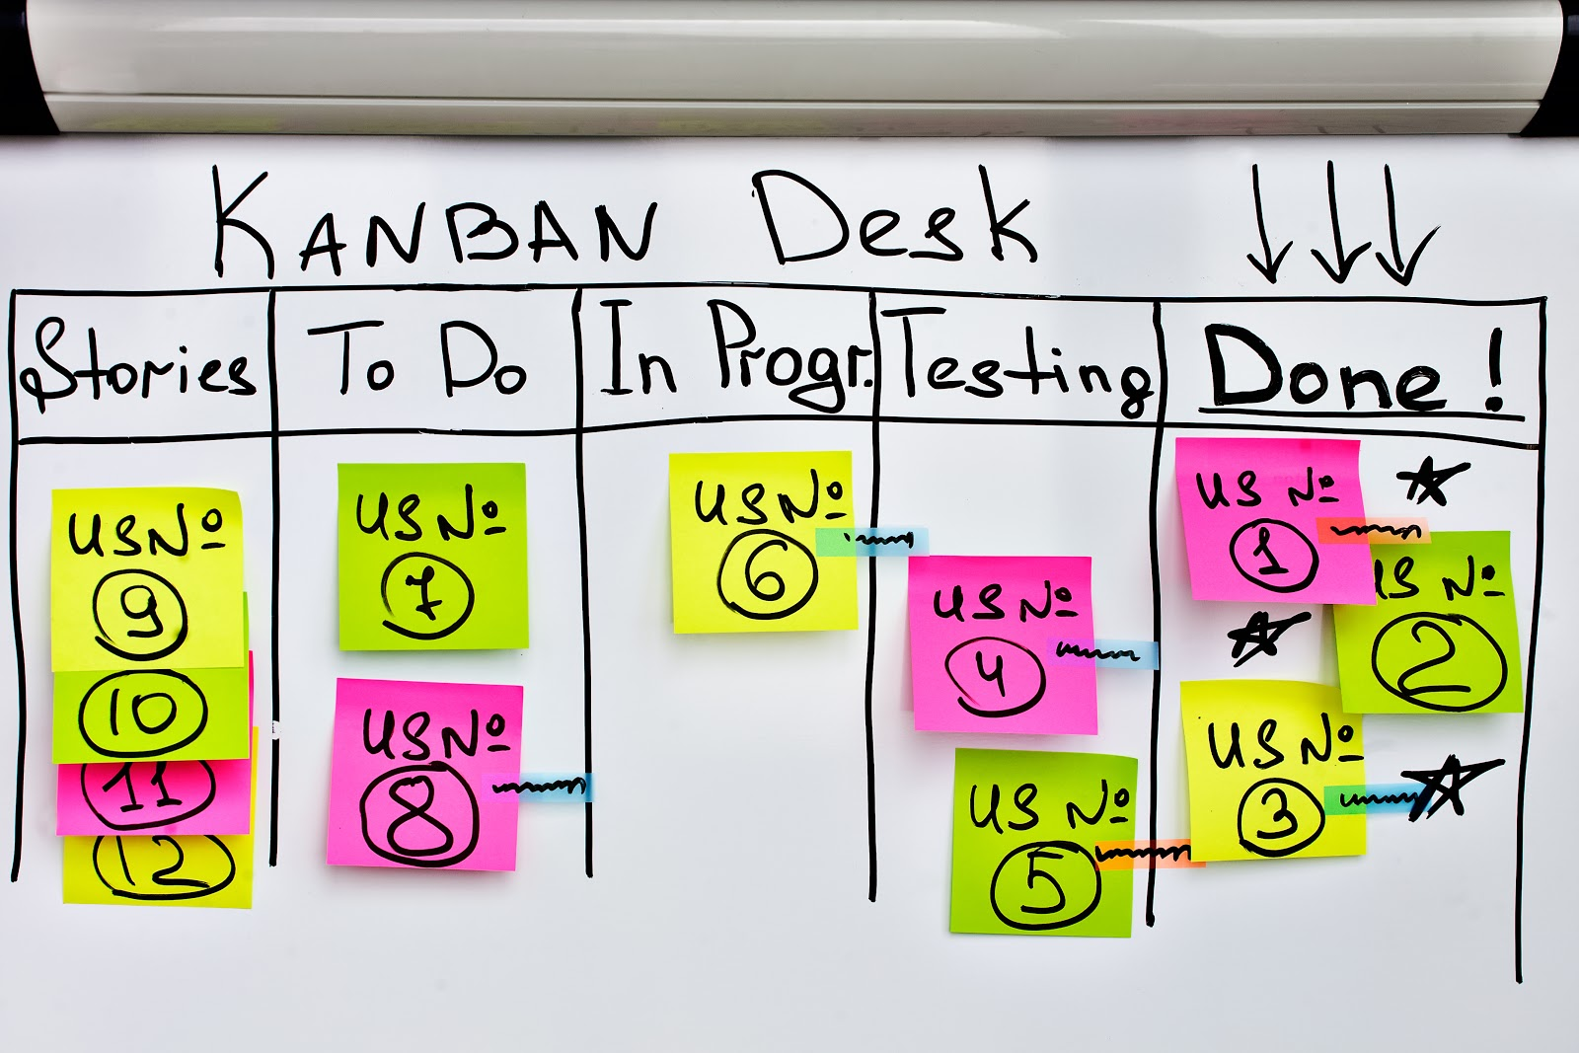The scrum framework is a structured approach to agile project management methodology. It consists of several components:  
**Sprints:** [Sprints](https://www.atlassian.com/en/agile/scrum/sprints) are time-boxed iterations, typically two-to-four weeks in length, where the development team works to complete a set of planned work items.  
**Product backlog:** The [product backlog](https://www.atlassian.com/en/agile/scrum/backlogs) is a prioritized list of all the features, enhancements, and bug fixes the product needs to address. The product owner manages and maintains this backlog.  
**Sprint backlog:** The [sprint backlog](https://www.atlassian.com/en/agile/project-management/sprint-backlog) is a subset of the product backlog, containing the work items selected for a specific sprint.(**To do list**)  
Here we have a format of table it names as Kanban Table which is for writing and grouping your task.

**Scrum artifacts:** Scrum employs various artifacts, such as burndown charts and task boards, to track progress and make the work visible to the team and stakeholders.  
**Scrum events:** Scrum events, including sprint planning, daily stand-ups, sprint reviews, and sprint retrospectives, provide structure and opportunities for collaboration within the team.  
**Daily standups:** This is a short meeting that is held every day at a fixed time and place. The purpose of the daily standing meeting is to check in with the team and see how they are doing. Team members each briefly report on what they worked on yesterday, what they are working on today, and what obstacles they are facing. The Scrum Master facilitates the meeting and helps it stay on track.  
**Sprint planning meeting:** This is a meeting that is held at the beginning of each sprint. The purpose of the sprint planning meeting is to decide what work will be done in the sprint. The team works together to estimate the work and create a sprint backlog. The scrum master facilitates the meeting and helps the team stay focused on the sprint goals.  
**Sprint review meeting:** This is a meeting held at the end of each sprint. The purpose of the sprint review meeting is to show the stakeholders the work done in the sprint. The team presents the work and stakeholders provide feedback. The Scrum Master facilitates the meeting and helps it stay on track. (But in small groups the scrum master himself can be stakeholder)  
**Sprint retrospective meeting:** This is a meeting held at the end of each sprint. The purpose of the sprint review meeting is to review the sprint and identify ways to improve.

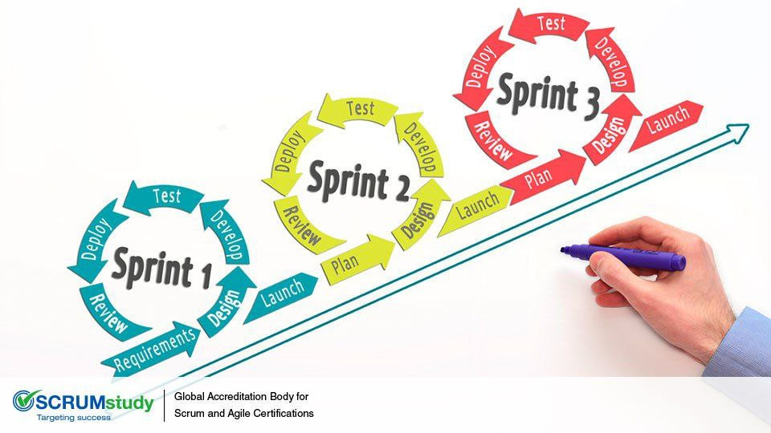

The team will discuss what went well, what could have been better, and what they plan to do differently in the next sprint. The Scrum Master facilitates the meeting and helps the team stay focused on continuous improvement.

The scrum framework emphasizes flexibility, adaptability, and continuous improvement, making it a popular choice for managing complex projects in an agile manner.

**There are other roles that is important for scrum master worth to say:  
As a Product manufacturer:**The Scrum Master must communicate with the Product Owner to ensure a complete understanding of the project goals and scope of activities. These people explore different techniques for work with the product owner to maximize value and also they have liability to the product owner. because he or she needs to establish empirical product planning for a complex environment in some cases.

**As a leader:  
Team Empowerment:** The Scrum Master helps the team take ownership of their work and make their own decisions. They help the team understand their responsibilities and feel confident in their ability to deliver.  
**Create a positive environment:** Creates a safe and supportive environment in which the team can thrive. They help create a collaborative environment where everyone feels valued and respected.  
**Promote transparency:** Ensures the team is transparent about their work and progress. They ensure that the team is transparent about their work and progress, and they help create an environment where everyone feels comfortable sharing information.  
**Team Support:**   
Supports the team against the rest of the organization. They help ensure that the team has the resources they need to succeed and that their work is valued.

**How I did it:**First we made a Telegram group with our mentor,Mrs Shatterzadeh. After that, we talked about meeting times in the company department. We decided to come on Saturdays and wednesdays. Then we tried to write sprints and tasks for our deadlines.   
**Sprints:**We have two weekly sprints for every week in phases: 1- Saturday to wednesday 2-Wednesday to saturday.   
End of the meeting day, we check our situation and we approve some remote tasks to do until the next meeting. Here is a list of our sprints in order:  
**1- 3 Mordad to 6 Mordad:**  
**At Office:** Get the installation files of Cadence 22.1  
**At Home:** Install Cadence 22.1 + Search about parts of controller  
**2- 7 Mordad to 10 Mordad:**  
**At Office:** Debug installation problems + Learn designing schematic in Cadence 22.1 + Talk about theoretical things (parts and devices) with mentor.  
**At Home:** Learn designing schematic in Cadence 22.1 + Try to design primary diagram blocks.  
**3- 11 Mordad to 13 Mordad:**   
**At Office:** Find more information about ICs and datasheets to improve primary diagram blocks + Planning for next week and first demo deadline.  
**At Home:** Prepare a report for the last present which is also helpful for the demo's presentation.  
**4- 14 Mordad to 17 Mordad:   
At Office:** Starting to design schematic in Cadence and improve it with mentor  
**At Home:** Complete phase two of the report and get ready for the first demo presentation + completing schematic design

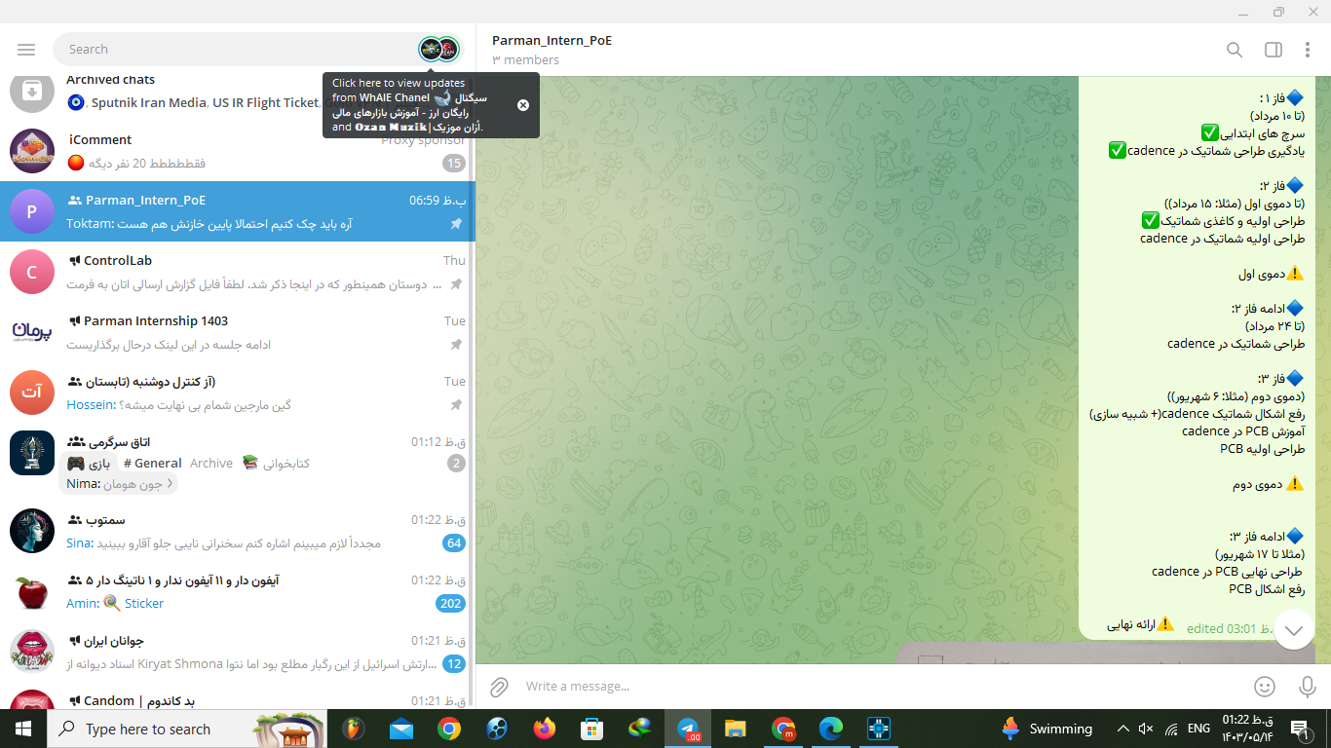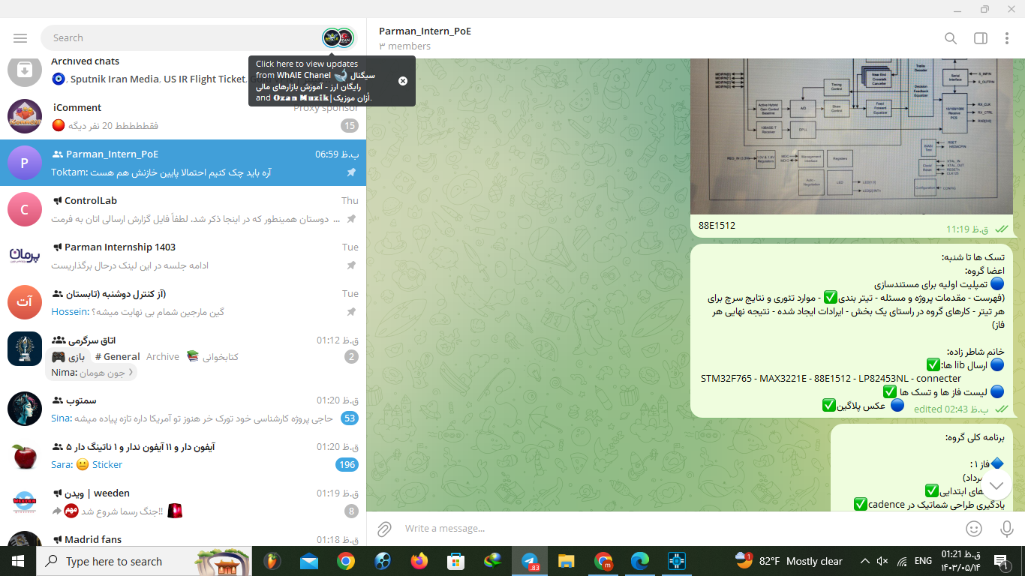**To do list:**It needs to be said that we were writing a task list and our theoretical results in the telegram group.First, We made agreements on structure and some symbols for writing our tasks list. To prioritize our tasks, we put warning sign for important ones and also have some colors. Also we write our needs and questions as a task for a mentor and that was not a bad idea.  
For example:

**Our sprints and to do list as kanban table:**

|  |  |  |  |  |
| --- | --- | --- | --- | --- |
| **Week1(Sprint 1&2)** | **To Do** | **Doing** | **Test and debug** | **Done** |
| **Savlani** | -Instal cadence -Search about PoE  -Finish proposals | -Installing cadence -Search about PoE  -Writing proposals | Problem in zip file  -  - | No Yes  Yes |
| **Afshari** | -Instal cadence -Search about PoE | -Clearing storage -Search about PoE | Problem in zip file  - | No  Yes |
| **Mrs.Shaterzadeh** | - Send educational content for cadence | - | - | Yes |

|  |  |  |  |  |
| --- | --- | --- | --- | --- |
| **Week2(Sprint 3&4)** | **To Do** | **Doing** | **Test and debug** | **Done** |
| **Savlani** | -Watch contents of cadence  -Search about components of block diagram and design | finished cadence schematic videos | Drawn schematic in paper | Yes  Yes |
| **Afshari** | -Watch contents of cadence -Search about components of block diagram and design | finished cadence schematic videos | Wrote informations about chips | Yes  Yes |
| **Mrs.Shaterzadeh** | -Install cadence for team  -Help theoriticaly for block diagram | - Sending datasheets and block diagram | - | Yes  Yes |

|  |  |  |  |  |
| --- | --- | --- | --- | --- |
| **Week3(Sprint 5&6)** | **To Do** | **Doing** | **Test and debug** | **Done** |
| **Savlani** | -write report for project  - Power point of Demo 1 -design schematic in cadence | -Designing  ports, UART | Complete connections and STM32 | Yes |
| **Afshari** | -write report for project -design schematic in cadence | -Designing  Ethernet | Complete connections and STM32 | Yes |
| **Mrs. Shaterzadeh** | - sending libraries and standards of designing | - | Checking designed circuit in the group and meeting | Yes |

|  |  |  |  |  |
| --- | --- | --- | --- | --- |
| **Week4(Sprint 7&8)** | **To Do** | **Doing** | **Test and debug** | **Done** |
| **Savlani** | -Power stm32 -Update URT  -Update MCU | -Power stm32 -Update URT | Checking with question doc | Yes  Yes  No |
| **Afshari** | -Update Ethernet  -Update MCU | -Update Ethernet | Checking with question doc | Yes  NO |
| **Mrs. Shaterzadeh** | - Answering question docs | Answering questions | Finished all the questions | Yes |

|  |  |  |  |  |
| --- | --- | --- | --- | --- |
| **Week5(Sprint 9&10)** | **To Do** | **Doing** | **Test and debug** | **Done** |
| **Savlani** | -Power stm32 -Update URT  - Add EEPROM to report | -Update URT | Schematic finished  PCB started | Yes  Yes  NO |
| **Afshari** | -JTAG -Update Ethernet  -Reset internal stm32  -Write control board part in report  - Write Phase2 of report | -JTAG  -Reset internal stm32  -Writing control board part in report  - Writing Phase2 of report | Schematic finished  PCB started | Yes  Yes  Yes  Yes  Yes |
| **Mrs. Shaterzadeh** | PCB footprint | Updating footprints | Debug PCB | Yes |

|  |  |  |  |  |
| --- | --- | --- | --- | --- |
| **Week6&7(Sprint 11 to 14)** | **To Do** | **Doing** | **Test and debug** | **Done** |
| **Savlani** | - Debug Report phase 1 and 2  - Add EEPROM to report  - PCB design  - Add couching part to report | -Wires of PCB  - Add EEPROM to report  - PCB design |  |  |
| **Afshari** | - Install polar and work  - Port schematic debugging - Write Phase2 of report  - Add couching part to report  - Power point of Demo 2  - PCB design | -Install polar and work  -Port schematic debugging - Write Phase2 of report  - Power point of Demo 2  - PCB designed | - Completing Phase2 of report and power point  - PCB debugging |  |
| **Mrs. Shaterzadeh** | Answering question | - | - | Yes |

**Reviews:**

**Daily:** Everyday 10 PM on Telegram group

**Sprints:**  End of the meeting days

**Weekly:** After 2 sprints left in one week

**Product Owner (Arezoo Savlani):**

A Product Owner is a key role in a project, particularly within Agile frameworks like Scrum. The Product Owner acts as the bridge between the development team and the stakeholders, ensuring that the final product meets the needs of the users and the business. Here are the main responsibilities and attributes of a Product Owner:

### **Responsibilities:**

1. Defining the Product Vision:
   * Articulate the overall vision and direction for the product.
   * Ensure the team and stakeholders have a clear understanding of the goals and the desired outcomes.
2. Managing the Product Backlog:
   * Create, prioritize, and maintain the product backlog, a dynamic list of tasks, features, and improvements.
   * Ensure that the backlog items are clearly defined, well-understood, and prioritized based on business value, customer needs, and feasibility.
3. Stakeholder Engagement:
   * Act as the main point of contact for stakeholders, gathering requirements, feedback, and ensuring their needs are met.
   * Communicate the product vision and progress to stakeholders, managing their expectations and involvement.
4. Collaboration with the Development Team:
   * Work closely with the development team to ensure they understand the product backlog items.
   * Participate in Sprint Planning, Reviews, and Retrospectives to provide clarity and feedback.
5. Maximizing Product Value:
   * Make decisions about the product's direction, features, and release plans to maximize the value delivered.
   * Balance the needs of users, the business, and technical feasibility.
6. Accepting Work:
   * Review and accept the work completed by the development team, ensuring it meets the acceptance criteria and the definition of done.

### **Attributes:**

Customer-Centric: Focused on understanding and addressing the needs and problems of the users.

Decisive: Capable of making tough decisions quickly to keep the project moving forward.

Communicative: Excellent at communicating with both technical and non-technical stakeholders.

Analytical: Able to analyze data and feedback to make informed decisions about the product's direction.

Visionary: Capable of seeing the big picture while also managing the details.

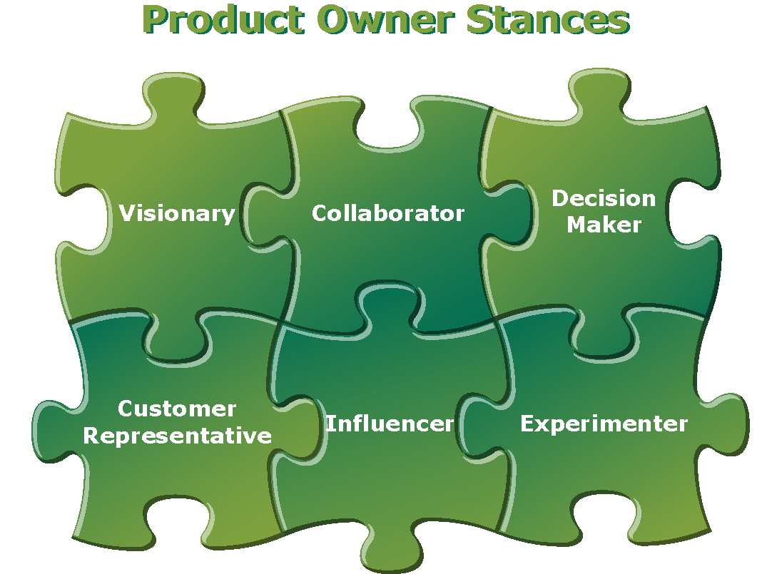

### **Importance in Agile Projects:**

* Adaptability: The Product Owner helps the team adapt to changes in requirements or market conditions.
* Continuous Improvement: By constantly refining the backlog based on feedback, the Product Owner ensures the product evolves effectively.
* Ownership and Accountability: The Product Owner is responsible for the success of the product, which drives them to make decisions that align with business goals and user needs.

**Actions Taken by Product owner**

* Ensure clarity about the project's purpose, customer needs, and the tools and devices to be used through sessions with the mentor.
* Review the project with another member in the presence of the mentor to reach a common understanding.
* Understand the timeline and expectations of the mentor for implementing the project.
* Provide useful articles to bring the team's knowledge to an appropriate level.
* Obtain the Cadence file, an application for designing boards, and follow the steps for installation. Watch educational videos and ensure all team members can follow them. In case of misunderstandings or lack of knowledge about hardware definitions or app functions, clarify the situation and solve the problems.
* Check project planning with the Scrum Master to ensure that the overall plan provides enough time for implementing each sprint, and reorder some tasks to maintain a smooth workflow.

**Development team:**Because our group has just two people and we are not too many, scrum master and product owner are developers too.

**Sessions with mentor:**

**At Hardware Office:** Saturdays and Wedndays

**Remotely:** Telegram group in daily reviews

**Demos:**

**First: (17 Mordad)**

**Phase 1 completely Done and presented**

**Phase 2 only up to first design presented**

**Second: (6 Shahrivar)**

**Couching:**

**Conclusion:**

**Appendix:**

* Site for making Block diagram:

[Block Diagram Maker | Free Block Diagram Online | Lucidchart](https://www.lucidchart.com/pages/examples/block-diagram-maker)

**thanks:**